# Abstract

Atherosclerosis is a chronic artery disease that affects millions of people worldwide, leading to heart attack and strokes. It tends to develop at locations where disturbed flow patterns occur, such as carotid artery, left coronary artery and abdominal aorta. The causative factors leading to atherosclerosis still remain relatively poorly understood. The conventional diagnosis of arterial disease relies on a combination of history, clinical examination and clinical imaging derived from CT, MRI, etc. To address some of the important factors related to arterial haemodynamics, Computational Fluid Dynamics (CFD) studies and Particle Image Velocimetry (PIV) experiments are performed for in-vitro models in physiologically relevant conditions. The flow disturbances in terms of wall shear stress, oscillator index, turbulence intensity are examined both numerically and experimentally. Based on the current research, new insights from the haemodynamics point of view are provided. This study will enrich and complement the current arterial disease research, and contribute to promoting the diagnosis accuracy and efficiency in the future.

This study is composed by six parts of work. Firstly, a comprehensive literature review was performed to find out the research gaps between the current relevant numerical studies with real clinical application. Secondly, the proposed CFD model was validated with a published experimental work using PIV approach. After that, a downstream impedance model was developed to improve numerical simulation accuracy for image-based artery bifurcations. In addition, the numerical simulation results were correlated with a clinical indicator to make the numerical results to be more meaningful for treating physicians. Lastly, complex fluid-structure interaction (FSI) modelling over left coronary artery models with different bifurcation angles was conducted. The relationship between the mechanical force (first principle stress), the hemodynamic force (wall shear stress), and the bifurcation angle was revealed.

In summary, this study developed a new downstream artery impedance model, and converted the numerical simulation results into clinical indicators, which can improve the current simulation accuracy and contribute more meaningful results to assist a better clinical diagnosis. Furthermore, through performing FSI simulation over left coronary artery bifurcation models, the bifurcation angle influence on the progress of atherosclerosis is addressed, and the left circumflex side bifurcation shoulder is found to be more vulnerable to develop atherosclerosis.

# Declarations

*This is to certify that:*

1. *except where due acknowledgement has been made, the work is that of the author alone;*
2. *the work has not been submitted previously, in whole or in part, to qualify for any other academic award;*
3. *the content of the thesis is the result of work which has been carried out since the official commencement date of the approved research program;*
4. *any editorial work, paid or unpaid, carried out by a third party is acknowledged;*
5. *ethics procedures and guidelines have been followed.*

Signature:

JINGLIANG DONG

S3289470

# Publications

**Refereed Journal Articles**

**Jingliang Dong**, Z. Sun, K. Inthavong, J.Y. Tu. “Fluid-structure interaction analysis of the left coronary artery with variable angulation”, Computer Methods in Biomechanics and Biomedical Engineering, Vol. 5 (2014): 1-9.

**Jingliang Dong**, K. Inthavong, J.Y. Tu. “Image-based computational hemodynamics evaluation of atherosclerotic carotid bifurcation models”, Computers in Biology and Medicine, Vol. 43 (2013):1353-1362.

**Jingliang Dong**, KKL Wong, J.Y. Tu. “Hemodynamics analysis of patient‐specific carotid bifurcation: A CFD model of downstream peripheral vascular impedance”, International Journal for Numerical Methods in Biomedical Engineering, Vol. 29 (2013): 476-491.

**Refereed Conference Articles**

**Jingliang Dong**, Z. Sun, K. Inthavong, J.Y. Tu. “Fluid-structure interaction analysis of representative left coronary artery models with different angulations”, Computing in Cardiology, 2013, 5-8.

**Jingliang Dong**, K. Wong, J.Y. Tu. “Effect of local wall shear stress on low-density lipoprotein transportation in atherosclerotic carotid bifurcation”, International Proceedings of Chemical, Biological & Environmental Engineering, Vol. 34 (2012): 62-67.

K. Wong, **Jingliang Dong**, J.Y. Tu. “Numerical study of stenosed carotid bifurcation models based on wall shear stress distribution”, International Proceedings of Chemical, Biological & Environmental Engineering, Vol. 34 (2012): 40-44.

**Jingliang Dong**, K. Wong, Z. Sun, J.Y. Tu. “Numerical analysis of stent porosity and strut geometry for intra-saccular aneurysmal flow”, Computing in Cardiology, 2011, 477-480.

K. Wong, **Jingliang Dong**, SCP Cheung, J.Y. Tu. “Hemodynamic analysis of virtual stent design for atherosclerotic carotid artery”, Computing in Cardiology, 2011, 157-160.

# Acknowledgements

Four years PhD study is a recycle of fell down-stand up-move on. Experience the process is much more important than a PhD degree result itself. The completion of PhD brings with it many unforgettable memories, not only the happiness and joys that makes it meaningful but more importantly is the sweat, disappointment, complain and the courage to overcome difficulties which polished the whole travel. Thanks for those who travelled this journey with me together.

First of all, I would like to express my great gratitude to my supervisor Professor Jiyuan Tu who is one of the best people I’ve ever known. Not to mention his invaluable guidance, generous investment to my research but also he has always been understanding and considerate. Besides, my supervisor’s serous scientific attitude, rigorous scholarship to improving work style also deeply infected and inspired me.

Second, the accomplishment of my PhD cannot be achieved without the help of my second supervisor Dr. Kiao Inthavong, who spared his valuable time on discussing my project and paper manuscripts time after time.

Then, I would like to acknowledge Dr. Sherman Chi Pok Cheung for his invaluable help during the early start period of my PhD research. Thanks Dr. Rasidi Rasani and Dr. Jeff Man Chiu Fung for their assistants and valuable instructions.

To all of the RMIT CFD research group members, thanks for all of the laughs and wonderful times we had shared over the past years. I was so lucky to be in part of this group. Thanks RMIT University and China Scholarship Council support by way of scholarship tuition fee and living expenses for the whole duration of my PhD study, and also thanks the financial assistant from SAMME to allow me attending overseas conference in Spain.

Finally, I’d like to thank my parents, relatives, and friends for their constant encouragement. My greatest thanks goes to my fiancée Shuang Wang. Thank you for your enduring love and endless support and patience during my PhD research. Your love, support, understanding and encouragement make this thesis become a reality. You are my forever love.

Table of Contents

Abstract I

Declarations III

Acknowledgements IV

List of Figures IX

List of Tables X

Nomenclature XI

CHAPTER 1 1

Introduction 1

1. 1 Research Background 1

1. 2 Motivation and Objectives 3

1. 3 Research Overview 5

1. 5 Thesis Outline 6

CHAPTER 2 8

Literature Review 8

2. 1 Endothelial Biology 8

2. 2 The Role of Haemodynamic Forces in Atherosclerosis 9

2. 3 Flow Measurements of Blood Flow 12

2. 4 Numerical Modelling of Blood Flow 13

CHAPTER 3 15

Geometric Model Reconstruction 15

3. 1 Introduction 15

3. 2 Non-invasive Medical Imaging 15

3. 3 Image Segmentation 17

3. 4 Segmentation Approaches 18

3. 5 Surface and Volume Reconstruction 18

3. 6 Summary 19

CHAPTER 4 21

Mesh Generation 21

4. 1 Introduction 21

4. 2 Mesh Design Strategy 21

4. 3 Mesh Quality 22

4. 4 Mesh Types 24

4. 5 Blocking Strategies 25

4. 6 Meshing Examples 26

4.6. 1 Stenosed artery step-by-step 26

4.6. 2 Left coronary artery bifurcation step-by-step 27

CHAPTER 5 31

Fundamentals of CFD and FSI 31

5. 1 Computational Fluid Dynamics 31

5.1. 1 Mass conservation 31

5.1. 2 Momentum conservation 32

5.1. 3 Turbulence modelling 33

5. 2 Fluid-Structure Interaction 36

5.2. 1 Elasticity 36

5.2. 2 Elastic properties of arteries 38

5.2. 3 Coupling 40

5.2. 4 Stability and convergence 43

CHAPTER 6 45

Validation against PIV Measurements 45

6. 1 Introduction 45

6. 2 Methods 46

6.2. 1 Phantom geometry 46

6.2. 2 Flow circuit setup 47

6.2. 3 PIV data acquisition 48

6.2. 4 Numerical model setup 48

6.2. 5 Turbulence modelling 50

6. 3 Results and Discussion 50

CHAPTER 7 53

A CFD Model for Representing Downstream Peripheral Vascular Impedance 53

7. 1 Introduction 53

7. 2 Methods 55

7.2. 1 Three-dimensional artery reconstruction 55

7.2. 2 Non-Newtonian model 57

7.2. 3 Downstream peripheral impedance model 58

7.2. 4 Numerical model setup 60

7.2. 5 Results visualization 61

7. 3 Results and Discussion 62

7.3. 1 Model verification 62

7.3. 2 Analysis of the effect of downstream peripheral impedance 64

7. 4 Conclusion 68

CHAPTER 8 70

Image-based Computational Haemodynamics Evaluation of Atherosclerotic Carotid Arteries 70

8. 1 Introduction 70

8. 2 Methodology 72

8.2. 1 Imaging 73

8.2. 2 Arterial model reconstruction 73

8.2. 3 Anatomical assessment 74

8.2. 4 Computational mesh generation 76

8.2. 5 Boundary conditions and fluid properties 77

8.2. 6 Turbulence modelling 80

8. 3 Results and Discussion 81

8.3. 1 Haemodynamics assessment with WSS based parameters 81

8.3. 2 Haemodynamics assessment with clinical trials used indicators 84

8.3. 3 Computational efficiency assessment 87

8. 4 Conclusion 88

CHAPTER 9 90

Fluid-structure interaction analysis of the left coronary artery with variable angulation 90

9. 1 Introduction 90

9. 2 Methods 92

9.2. 1 Geometry reconstruction of arterial models 92

9.2. 2 Mesh generation and physiological boundary conditions 93

9.2. 3 Fluid-Structure interaction simulation 96

9. 3 Results 97

9.3. 1 Mechanical results analysis 97

9.3. 2 Hemodynamic results analysis 100

9. 4 Discussion and Conclusion 102

CHAPTER 10 106

Closing Remarks 106

10. 1 Conclusions 106

10.1. 1 Validation against PIV measurements outcomes 107

10.1. 2 Development of downstream vascular impedance model outcomes 107

10.1. 3 Image-based computational haemodynamics analysis of carotid artery bifurcations outcomes 108

10.1. 4 Fluid-structure interaction analysis of left coronary artery outcomes 109

10. 2 Future Directions 111

10.2. 1 Multiphase Flow 112

10.2. 2 Imaging for physiological flow boundary conditions 113

10.2. 3 Simulations based surgical interventions 113

References 115

# List of Figures

Figure 1. 1 Dissection of the multi-layer tissues that constitute the artery wall. The components of the artery consist of the endothelium, basement membrane, elastic layers, smooth muscle, and connective tissue in a configuration that provides elasticity to the vessel and low resistance to flow through it. 1

Figure 1. 2 Narrowing of lumen based on build-up of plaque over time. The localization of plaque and its growth takes place over time and results in lumen narrowing. This further aggravates the growth of plaque. When plaque ruptures, the platelets of the blood tend to adhere to the cytokines at the arterial wall at the injury site to form a clot that blocks the flow completely. Eventually, a complete blockage results to obstruct the entire blood supply. 2

Figure 2. 1 In vivo, vascular walls are exposed to three main haemodynamic forces: (1) wall shear stress (WSS), a tangential frictional drag force due to blood viscosity; (2) transmural pressure, a perpendicular cyclic force due to blood pressure; (3) mechanical stretch, a cyclic tensile stress of pulsatile flow. 10

Figure 2. 2 A schematic diagram of the early progression of atherosclerosis. The decreased shear stress affects cellular morphology and cell functions, several of which are atherogenic. In addition, in the presence of some risk factors as listed, there is an increased likelihood of atherosclerotic plaque formation at these sites (Cunningham and Gotlieb, 2005). 11

Figure 3. 1 A greyscale image represents digitally by row (*x*) and column (*y*), and the greyscale function *f*(*x,y*) applied over each pixel. 17

Figure 3. 2 Flow chart showing the segmentation process to extract and export a region of interest into a 3D computer model (commonly referred to as a Computer-Aided-Drawing (CAD) model). 19

Figure 3. 3 Reconstruction procedure of an patient-specific carotid artery sample. 20

Figure 4. 1 Definition of mesh spacing, Δ*x* and Δ*y* and an angle of *θ* between the grid lines of a quadrilateral cell, and examples of high aspect ratio elements. 22

Figure 4. 2 An example of a highly skewed triangular cell, and a quadrilateral cell. 23

Figure 4. 3 A triangular cell having an angle of *β* between the surfaces normal to the triangular parts of the faces connected to two adjacent triangles. 24

Figure 4. 4 Meshing outcomes using different mesh strategies on a cross-sectional slice of an artery vessel. 25

Figure 4. 5 Blocking strategies examples: a) bend geometry, b) bifurcating geometry. 26

Figure 4. 6 Multi-Block structured mesh flow chart for a stenosed artery. 27

Figure 4. 7 Multi-Block structured mesh flow chart for a left coronary artery bifurcation. 29

Figure 4. 8 Schematic mesh procedures for an image-based aortic artery: (a) aortic arch, (b) aortic abdominal aneurysm. 30

Figure 5. 1 Main artery bifurcations in the body which include: (a) carotid arteries, (b) coronary arteries, and (c) abdominal aorta artery. 31

Figure 5. 2 Schematic of an idealised bifurcation network having one main inlet and subsequent bifurcations to produce eight outlet branches. 32

Figure 5. 3 Deformed fluid element due to the action of the surface forces, in the form of normal and tangential stresses. 33

Figure 5. 4 (a) Schematic of instantaneous flow fluctuations in a blood vessel. (b) Velocity measurement taken at Point X over time displaying a averaged value with random deviations from the averaged value at any moment in time. 34

Figure 5. 5 A body such as a wall structure subjected to a force load. (a) The initial length is *L*o and the deflection caused by the force load is *d*. For elastic materials (b) the stress-strain relationship is governed by Hooke’s Law producing a linear line that is the Young’s modulus. (c) For non-linear elastic deformation the Young’s modulus is found by taking the incremental gradient. 37

Figure 5. 6 Deformation in all three directions of an elastic material subjected to a force in tension along the *x*-axis. The initial body shape expands in the *x-*direction but contracts in the *y-* and *z-*directions. 37

Figure 5. 7 Solution strategies for FSI simulations: (a) Monolithic methods (b) Partitioned methods. 39

Figure 5. 8 Fluid-structure coupling flowchart. 40

Figure 6. 1 Schematic representation of the carotid artery models: dashed line represents the healthy model, and the solid line represents the 63% ICA stenosed model. 45

Figure 6. 2 Schematic representation of the experimental facility. 47

Figure 6. 3 Structured mesh result of the 63% ICA stenosed ST-AHCB model. 48

Figure 6. 4 Comparison between numerical and referred PIV experimental results at different Reynolds numbers: (a) healthy artery bifurcation using laminar model (b) stenotic artery bifurcation using transitional model. 51

Figure 7. 1 Three-dimensional reconstruction of carotid bifurcations: (a) the healthy model, (b) the atherosclerotic model. 55

Figure 7. 2 Pulsatile waveforms of healthy carotid bifurcation: (a) volume flow rate profiles at the outlet of both ICA and ECA, (b) pressure waveform at the inlet of CCA. 58

Figure 7. 3 Domains configuration for the computational haemodynamics of carotid bifurcation model. 59

Figure 7. 4 Numerical results of the healthy carotid bifurcation haemodynamics with downstream peripheral impedance model. 61

Figure 7. 5 Numerical results of the healthy carotid bifurcation haemodynamics with prescribed boundary conditions. 62

Figure 7. 6 Absolute TAWSS difference of the healthy carotid bifurcation simulations with prescribed boundary conditions and downstream peripheral impedance model. 63

Figure 7. 7 Numerical results of the atherosclerotic carotid bifurcation hemodynamics with constant flow division. 64

Figure 7. 8 Numerical results of the atherosclerotic carotid bifurcation hemodynamics with downstream peripheral impedance model. 65

Figure 7. 9 Absolute TAWSS difference of the diseased carotid bifurcation simulations based on fixed flow division and downstream peripheral impedance model. 66

Figure 7. 10 Transient flow division variation for the atherosclerotic carotid bifurcation. 67

Figure 8. 1 Reconstructed patient-specific carotid artery models. 73

Figure 8. 2 Simplified schematic diagram of artery stenotic region. 75

Figure 8. 3 Structured mesh result of the patient-specific model 2. 76

Figure 8. 4 Volume flow rates of a healthy carotid model. 77

Figure 8. 5 A schematic diagram of the DPVI modeling method. 78

Figure 8. 6 Time-averaged WSS distributions of the ten studied carotid bifurcation models. 81

Figure 8. 7 OSI distributions of the ten studied carotid bifurcation models. Boxes with a solid line indicate high OSI regions, while boxes with dashed lines indicate disturbed flow induced by stenotic lesions. 82

Figure 8. 8 High WSS influence on the studied stenosed carotid bifurcations. 83

Figure 8. 9 Linear relation between CDPe and FFR. 85

Figure 8. 10 Time cost summary for each work stage of the computational haemodynamics. 86

Figure 9. 1 3D CT visualization and reconstruction of the image-based model. 91

Figure 9. 2 Geometry configuration of the idealized artery model. 92

Figure 9. 3 Structure mesh results of idealized (a) and image-based (b) models. 93

Figure 9. 4 Pulsatile blood flow waves used in this study. 94

Figure 9. 5 Comparison of first principal stress at peak systole (*t* = 1.95 s). 97

Figure 9. 6 First principal stress profiles at the LAD side bifurcation shoulder. 98

Figure 9. 7 First principal stress profiles at the bifurcation apex. 98

Figure 9. 8 First principal stress at the LCx side bifurcation shoulder. 99

Figure 9. 9 Comparison of OSI distribution for different idealized models. 100

Figure 9. 10 Comparison of FSI and Rigid models for the image-based model: (a) WSS distribution at peak diastole (*t* = 2.05 s); (b) WSS variation over the last cardiac cycle at the bifurcation apex. 101

Figure 10. 1 Modelling red blood cells and platelets in a micro-channel of 34µm in height. *(Image from Zhao et al 2012)* 111

Figure 10. 2 Virtual stent design and its outcome prediction. 113

# List of Tables

Table 5. 1 Summary of common RANS turbulence models 35

Table 6. 1 Dimensions of the idealized carotid artery bifurcation models. 46

Table 7. 1 Geometrical parameters of the investigated carotid bifurcations. 56

Table 7. 2 Geometrical parameters of the introduced porous mediums. 57

Table 7. 3 Mesh scale independence study. 60

Table 8. 1 Anatomical measurements of studied patient-specific carotid artery models. 74

Table 8. 2 Numerical simulation based CDPe and FFR values of the studied stenotic models. 86

Table 9. 1 Anatomical dimensions of the idealized model. 92

Table 9. 2 Mesh independence study of three different mesh refinements. 95

# Nomenclature

# CHAPTER 1

# Introduction

## 1. Research Background

Atherosclerosis is a chronic artery disease that affects millions of people worldwide, leading to heart attack and strokes (Page et al., 1961, Weber and Noels, 2011). It tends to develop at locations where disturbed flow patterns occur, such as artery bifurcation, and highly curved artery vessel (Harrison, 2005). As shown in Figure 1. 1, the artery is a multi-layer of muscles and connective tissue that serves the purpose of transporting blood. The wall of an artery typically comprises three layers: the intima, media and adventitia. To minimize flow resistance, the internal of the arterial wall is lined with a smooth and thin endothelium. Damage to the endothelium can occur and results in disease of the artery.

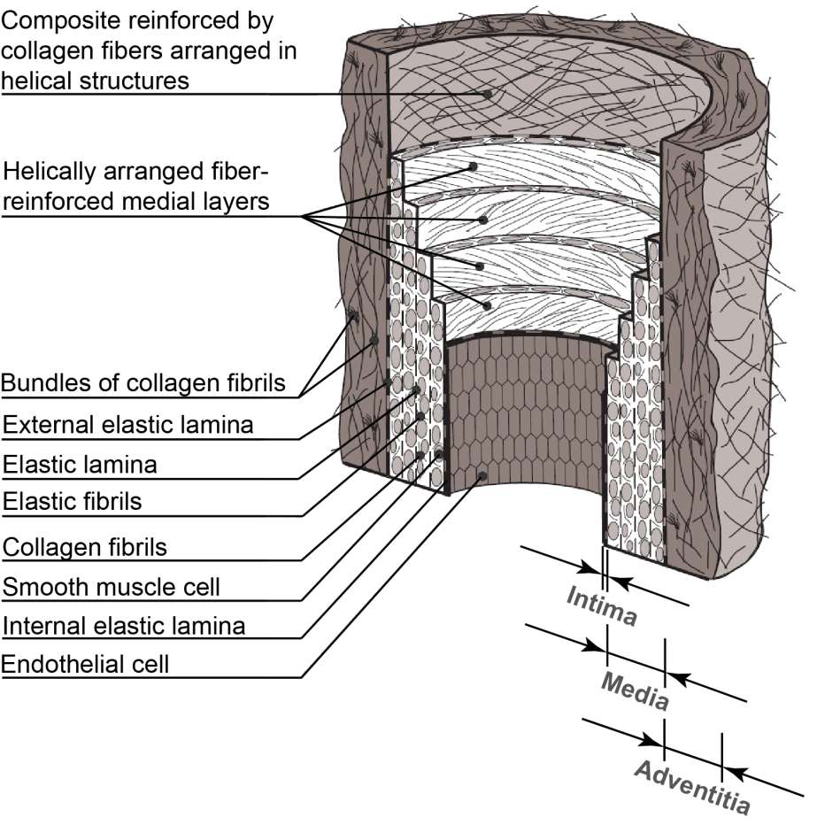

Figure 1. 1 Dissection of the multi-layer tissues that constitute the artery wall. The components of the artery consist of the endothelium, basement membrane, elastic layers, smooth muscle, and connective tissue in a configuration that provides elasticity to the vessel and low resistance to flow through it.

Atherosclerosis refers to a process where the arterial walls thicken and harden due to a gradual build-up of fatty deposits, such as white blood cells, lipids and cholesterol. It is a pathological process that takes place in the major arteries and is the underlying cause of heart attacks, stroke and peripheral artery disease. In an atherosclerotic artery, the lumen is narrowed and the arterial wall is stiffened by the build-up of fatty plaque beneath the endothelium (Figure 1. 2). During atherosclerosis, monocyte adherence to the endothelium is one of the earliest steps in lesion development. A monocyte entering the arterial wall at a junction between the endothelial cells consume the excess Low Density Lipoprotein (LDL) that is present in the arterial wall, and then transform into macrophages. The macrophages then consume more LDL and then oxidize to become foam cells. The accumulation of foam cells can damage the arterial wall increasing its permeability and the rate of plaque build-up (Plenz and Robenek, 1998). When the plaque ruptures and a thrombus blocks the path of blood flow, the tissue suffers from a lack of oxygen supply, which may result in myocardial ischemia and lead to myocardial infarction (heart attack) or angina pectoris (chest pain from an ischemia).

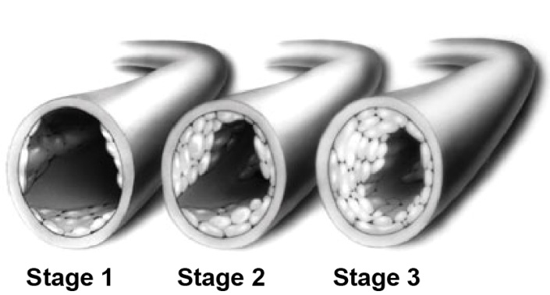

Figure 1. Narrowing of lumen based on build-up of plaque over time. The localization of plaque and its growth takes place over time and results in lumen narrowing. This further aggravates the growth of plaque. When plaque ruptures, the platelets of the blood tend to adhere to the cytokines at the arterial wall at the injury site to form a clot that blocks the flow completely. Eventually, a complete blockage results to obstruct the entire blood supply.

Haemodynamics is the study of the properties of blood and how it flows. Its physical principles can be described by the same fluid flow equations that derive from classical fluid dynamics. However closer inspection of the dynamic nature of blood reveals its complex nature. It is a liquid tissue that under fluid motion necessitates principles of modern fluid dynamics such as rheology and fluid structure interactions to describe its flow behaviour. Computational Haemodynamics (CHD) is the computer simulation of blood flow in the cardiovascular system. The motion of blood flow can be modelled by using Computational Fluid Dynamics (CFD) and its interaction with blood vessel structures can be studied by combination with the use of Finite Element Method (FEM). This is becoming an emerging research field that may lead to a renaissance of computer modelling techniques for many biomedical engineering applications. The biomedical engineering industry comprises the health, pharmaceutical, and medical research fields, whereby interest is increasing in the use of CHD modelling for cardiac flow analysis, effectiveness of stents, and discovery of new phenomena related to physiological flows.

Cardiac diseases remain a major cause of ill health and death in our society and thus advancements in current clinical therapies are of significant importance. Due to the aging population and epidemic situation of obesity, there will be an increasing demand for Computational Haemodynamic analysis techniques to facilitate the prognosis and diagnosis of cardiovascular diseases. The framework can be used to diagnose pre- and post- surgical treatments. In particular, fluid mechanical flow quantification can be adequately documented from simulated cardiovascular flow for diagnosis of the heart, cardiac flow analysis and medical imaging provides an alternative approach to characterize cardiac abnormalities.

## 1. Motivation and Objectives

The current study is motivated by an intension to further understand the biomechanics involved in the dynamics of human artery vessels, with a view to further explore computational methods as a research tool in enhancing diagnosis and treatment for diseased artery vessels such as atherosclerosis.

The past two decades have seen much interest in understanding the ignition and progress of atherosclerosis via experimental measurements (see for example (Tabrizchi and Pugsley, 2000, Ascher et al., 2002, Johnson et al., 2008)) and numerical simulations (see for example (Qiu and Tarbell, 2000, Olufsen et al., 2000, Tokuda et al., 2008)). Through the literature review presented in Chapter 2, the current numerical modelling studies are examined, and few interested research gaps are identified. Finally, research objectives are proposed as listed below:

* The numerical modelling accuracy should be validated prior to its implementation. Although numerical simulation has several advantages comparing against experiment measurements, such as less time consuming, more detailed information (e.g. wall shear stress), lower cost, and better applicability for complex realistic artery models, its prediction accuracy should be evaluated against other experiment measurements prior to using it as a research tool for data analysis.
* The boundary conditions for carotid artery bifurcation models should be carefully addressed, especially for the two outlets. Carotid arteries are two superficial large blood vessels lying under both sides of our neck. It comes from aorta arch and branches into two sub-branches: internal carotid artery and external carotid artery. This kind of artery plays a critical role in maintaining a normal and functional brain as they supply oxygenated blood to the large part of the brain. Due to its bifurcating nature, it is found to be vulnerable for developing atherosclerosis, which will affect the normal healthy blood transportation, and even lead to stroke. To gain better understanding of atherosclerotic carotid artery bifurcations, enormous research efforts have been spent on this research area. However, majority of them adopted over simplified outlets boundary conditions due to lack of physiological data. Therefore, the treatment of outlets boundary conditions needs to be further improved, especially for severely diseased carotid artery models.
* The post process of image-based carotid artery simulation results needs to be refined. The results presented in current research studies are more fluid dynamics based, majority of them are focused on analysing the intravascular blood flow dynamics due to the presence of atherosclerotic plaques. Unfortunately, this kind of results is lack of clinical significance since it is not compatible with clinical diagnosis criterions. Thus more research efforts need to be added on data processing of current numerical simulation, so as to convert them into clinical readable data for treating physicians.
* Apart from haemodynamic forces (such as wall shear stress), the effects of mechanical loading should also be considered when conduction numerical simulation. According to literature review, both mechanical and haemodynamic forces play significant roles in atherosclerosis progress. However, majority of the numerical studies are focused on fluid dynamics modelling, while assuming the arterial wall as rigid wall. Therefore, the compliant nature of the arterial vessel could not be considered, and the haemodynamic forces could be over predicted. To further improve the numerical simulation accuracy, simulations adopting fluid-structure interaction should be performed, from which the arterial vessel deformation and mechanical forces within the vessel wall induced by pulsatile blood flow can be accessed.

## 1. Research Overview

The application of medical image reconstruction for blood vessel modelling has developed rapidly in recent decades. With the development of modern imaging technology, especially magnetic resonance imaging (MRI) and computed tomography (CT), subject-specific physiological models can be acquired and reconstructed (Milner et al., 1998). With the use of CFD simulations, the ability to evaluate complex relationship between haemodynamics and the prediction for atherosclerosis may be possible (Marshall et al., 2004, Rikhtegar et al., 2012).

Combined with MRI and CT images, this thesis presents a systematic CHD research of human cardiovascular system. In which, atherosclerosis prevailed locations, such as carotid artery, left coronary, aorta arch, and abdominal artery are investigated and detailed in the following chapters. Prior to implementing numerical simulations, the numerical prediction accuracy is validated against experimental measurements using particle image velocimetry (PIV). After that, a downstream impedance model is developed to improve numerical simulation accuracy for image-based artery bifurcations. In addition, the numerical simulation results are correlated with a clinical indicator to make the numerical results to be more meaningful for treating physicians. Lastly, two-way fluid-structure interaction (FSI) modelling over left coronary artery models with different bifurcation angles is conducted. The relationship between the mechanical force (first principle stress), the hemodynamic force (wall shear stress), and the bifurcation angle is revealed.

In summary, this study presents a new downstream artery impedance model, and converts the numerical simulation results into clinical indicators, which can improve the current simulation accuracy and contribute more meaningful suggestions to assist a better clinical diagnosis. Furthermore, through performing FSI simulation over left coronary artery bifurcation models with variable bifurcation angles, the influence of bifurcation angle on the progress of atherosclerosis is analysed. Combining with haemodynamic and mechanical results, the left circumflex side bifurcation shoulder is found to be more vulnerable to develop atherosclerosis.

## 1. Thesis Outline

In the following, a brief overview of the individual thesis chapters is given:

**Chapter 2** reviewed current relevant literature from several key aspects, such as medical imaging, arterial geometry reconstruction, boundary conditions and numerical coupling. Based on this literature review, few research questions are identified, and appropriate research methods are proposed to make up the main contents of this thesis.

**Chapter 3** provides an overview of contemporary methods for image processing, edge detection, and surface and volume definitions. Specifically, computer algorithms are developed for the delineation of anatomical structures and other regions of interest, which is central in the model reconstruction and many other biomedical imaging applications.

**Chapter 4** introduces guidelines for mesh generation. Although, a number of the mesh-generation packages are designed with very user-friendly interfaces, and easy to utilize, the prerequisite to proficiently managing these software packages still relies on the reader’s aptitude to operate them. One has to decide on the arrangement of discrete points (nodes) throughout the computational domain, and the type of connections of each point, which leads to either great success or utter failure of the numerical solution. Therefore, best practices for developing quality meshes are provided.

**Chapter 5** introduces fundamental theory of computational fluid dynamics (CFD) and fluid-structure interaction (FSI), which is intensively utilized in the following chapters. Although closer inspection of the dynamic characteristics of blood flow and arterial vessel wall reveals their complex nature, physical principles can still be described by the same fluid flow equations and structural deformation equations derived from classical fluid dynamics and finite elements methods. Therefore, this chapter lays theoretical and practical fundamentals for individual studies afterwards.

**Chapter 6** validates the numerical simulation accuracy against PIV measurements, which use identical idealized carotid artery bifurcation models. Through the results comparison, it is found the proposed numerical modelling approach can provide haemodynamics prediction with sufficient accuracy. However, for the artery vessel with stenosis, discrepancies are observed. Overall, this chapter verifies the numerical modelling accuracy and lays foundation for further numerical studies.

**Chapter 7** develops a novel downstream artery impedance model to account for the downstream peripheral vascular impedance (DPVI) effect using patient-specific carotid artery bifurcation models. This model can be applied when the outlet flow conditions are not available. Compared with other relevant method, it is proved to have sufficient accuracy at a relatively lower computational cost.

**Chapter 8** incorporates more high-resolution three-dimensional angiography results with CFD modelling, in which clinical related indicators are introduced for atherosclerosis severity stratification. Ten carotid artery bifurcations are reconstructed, and intravascular flow patterns are examined using CFD analysis with a fine structured mesh and a non-Newtonian viscosity model. The stenosis-induced flow performance and the flow disturbance in pre-stenosis and post-stenotic regions are assessed. Each step in the workflow is monitored for reproducing reasonable results with a minimized time cost. This work can assist both doctors and patients to have a better understanding of carotid artery stenosis (CAS) disease and to provide better guidance for clinical treatment.

**Chapter 9** presents an FSI study of the correlation between coronary artery branch angulation, local mechanical and haemodynamic forces using anatomically accurate and idealized human coronary artery models. This chapter aims to elucidate the link between coronary artery angulation, coronary haemodynamics, such as oscillatory shear index (OSI), and local mechanical forces, such as tensile stress to enable a better understanding of the role of haemodynamics in atherosclerotic disease initiation and progression in the vicinity of bifurcations.

**Chapter 10** summarizes key research findings yield from this thesis, and proposes possible future improvements and applications for this research.

# CHAPTER 2

# Literature Review

## 2. Endothelial Biology

Atherosclerosis and related cardiovascular diseases (CVD) are the leading risk factors for deaths worldwide. According to statistics reported by the American Heart Association for adults of age above 20, the prevalence of stroke in 2005 was as high as 6.5 million; and each year, approximately 795,000 cardiac patients experience new or recurrent stroke (Lloyd-Jones, 2009). Of all strokes, 87% are ischemic, 10% are intra-cerebral haemorrhage, and 3% are subarachnoid haemorrhage. Most of the ischemic stroke occurs in the carotid territory in Western countries (Bamford et al., 1991, Anderson et al., 1994, Rothwell et al., 2000). Atherosclerosis is characterised by the development of arterial plaque and deposition of fatty and calcified tissue on the arterial wall. If untreated, this can lead to thrombus formation or complete vessel occlusion and stroke. Clinical treatments for carotid artery disease include carotid endarterectomy (the operation to remove the inner lining plaque) and carotid stenting (the operation to expand the narrowed lumen with stent).

It has become evident that the haemondynamic environment (e.g. wall shear stress (WSS), flow separation, or secondary flow) in the carotid artery and other major artery vessels is directly linked to pathology of atherosclerosis. For example, due to the presence of flow disturbance (i.e. flow separation) caused by artery bifurcating or curvature, carotid artery, aorta arch, abdominal artery are found to be atherosclerosis-prone sites in human cardiovascular system (Taylor et al., 1998a).

A key player here is the endothelial cells, which form a monolayer of cells attaching to the inner walls of the artery (Figure 1. 1), and hence act as the interface between the blood flow and the arterial wall. Endothelial cells are the main responder to all pathological changes and play a central role in the mechanisms underlying the development of vascular disorders (Michiels, 2003). The healthy endothelium is optimally aligned and is able to respond to physical and chemical stimuli by production of a wide range of factors that regulate vascular tone, cellular adhesion, thromboresistance, smooth muscle cell proliferation, and vessel wall inflammation (Traub and Berk, 1998, Chatzizisis et al., 2007).

Endothelial dysfunction represents a switch from a quiescent phenotype (resting cells) towards a pro-coagulant/pro-thrombotic phenotype (activated cells) (Pearson, 1999), which leads to a number of pathogenetic risk factors. In this cascade of cellular responses and gene expression, the vasodilator nitric oxide (NO) is believed to play a crucial role as it exhibits key athero-protective characteristics (Barbato and Tzeng, 2004). A strong relationship between reduced NO activity and endothelial dysfunction has been identified, which includes the up-regulation of vasoconstrictors, the promotion of vascular adhesion molecules, the stimulation of growth factors to cause proliferation of the underlying smooth muscle cessl, and increased permeability of the endothelium to low-density lipoproteins (LDL). As a consequence, the endothelium not only becomes dysfunctional, but endothelial cells also lose integrity, progress to senescence, and detach into the circulation (Woywodt et al., 2002).

Although the cause of endothelial dysfunction is still unclear, a number of cardiovascular risk factors such as hypercholesterolemia (i.e., increased blood cholesterol levels), obesity, smoking, alcohol consumption, diabetes and chronic infections as well as hypertension (i.e., high blood pressure) and genetic predisposition are believed to be closely involved. Additionally, endothelial dysfunction is strongly associated with the prevailing haemodynamic environment, which controls wall shear stress activated NO release (Gimbrone et al., 2000). Therefore, understanding the detailed haemodynamic environment may provide information about predisposed locations for endothelial dysfunction, which can be clinically used to identify potential areas prone to atherosclerosis (Davignon and Ganz, 2004, Chatzizisis et al., 2007).

## 2. The Role of Haemodynamic Forces in Atherosclerosis

Blood flow patterns can vary from relatively well-developed laminar flow in the unbranched portions of medium-sized muscular arteries, to complex disturbed laminar flow patterns (i.e. flow separation, recirculation, and flow reattachment) in regions with significant temporal and spatial shear stress gradients over relatively short distances (Karino, 1986, Giddens et al., 1993, Nagel et al., 1999). As mentioned before, the disturbed laminar flow patterns are mostly occurred near branch points, bifurcations, and major curves, which are typically associated with the earliest appearance and progression of atherosclerotic lesions. In contrast, the unbranched, tubular portions of arteries are relatively protected from atherosclerosis due to the uniform laminar flow environment.

As shown in Figure 2. 1, the pulsatile blood flow through the branched tubular array of the arterial vasculature generates three types of haemodynamic forces: (1) wall shear stress (WSS), a tangential frictional drag force due to blood viscosity; (2) transmural pressure, a perpendicular cyclic force due to blood pressure; (3) mechanical stretch, a cyclic tensile stress of pulsatile flow. Physiologically, vascular endothelial cells sense such forces and secrete various vasoactive substances to regulate vascular tone and maintain normal homeostasis. Among these haemodynamic forces, the influences of WSS on the pathogenesis of atherosclerosis have been extensively investigated and well understood (Caro et al., 1969, Ku et al., 1985, Asakura and Karino, 1990). Changes in WSS can regulate the secretion of several factors, including vasodilators such as NO and prostacyclin (Rubanyi et al., 1986, Bhagyalakshmi and Frangos, 1989), vasoconstrictors such as endothelin-1 (Kuchan and Frangos, 1993), and growth factors such as platelet-derived growth factor (Hsieh et al., 1991, Malek et al., 1993).

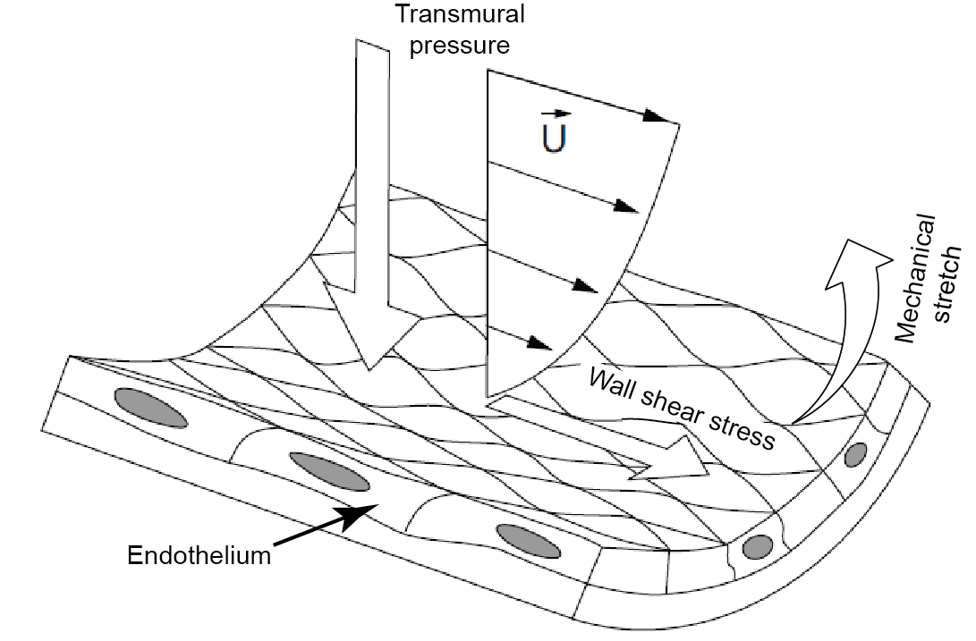

Figure 2. In vivo, vascular walls are exposed to three main haemodynamic forces: (1) wall shear stress (WSS), a tangential frictional drag force due to blood viscosity; (2) transmural pressure, a perpendicular cyclic force due to blood pressure; (3) mechanical stretch, a cyclic tensile stress of pulsatile flow.

On the other hand, although some recent reports have clarified the effects of mechanical stretch on vascular endothelial cells (Sumpio and Banes, 1988, Sumpio and Widmann, 1990, Iba and Sumpio, 1991, Awolesi et al., 1995, Oluwole et al., 1997, Liu and Agarwal, 2010), its role in the pathogenesis of atherosclerosis still remains unclear. Clinical observations have shown that in the arterial tree, mechanical stretch is significantly higher at bifurcations and curvatures than in straight portions (Thubrikar and Robicsek, 1995). Furthermore, high blood pressure, which increases vascular wall stretch (Bergel, 1961, Patel et al., 1965), is a well-recognized risk factor in atherosclerosis (Alexander, 1995). These considerations suggest that mechanical stretch may also play important roles in the pathogenesis of atherosclerosis.

In summary, the pathogenesis of atherosclerosis is a complex multifactorial process of vascular wall injury and atherosclerotic plaque formation due to local haemodynamic environment and systemic factors (Figure 2. 2) (Cunningham and Gotlieb, 2005, Chatzizisis et al., 2007). Wall shear stress (WSS) plays an important role in the pathogenesis of the atherosclerotic plaque, especially where laminar blood flow is disturbed with low or oscillatory WSS. In addition, many risk factors (e.g. hypertension, smoking, hypercholesterolemia, and diabetes mellitus) have a direct impact on endothelial cell function and impair flow-mediated vasodilatation in a progressive and additive way (Landmesser et al., 2004). The combination of altered arterial haemodynamics around atherosclerosis-prone sites (e.g. curvatures, bifurcations), where secondary flows occur, and systemic risk factors promote atherosclerotic lesion initiation, progression of atherosclerotic plaques.

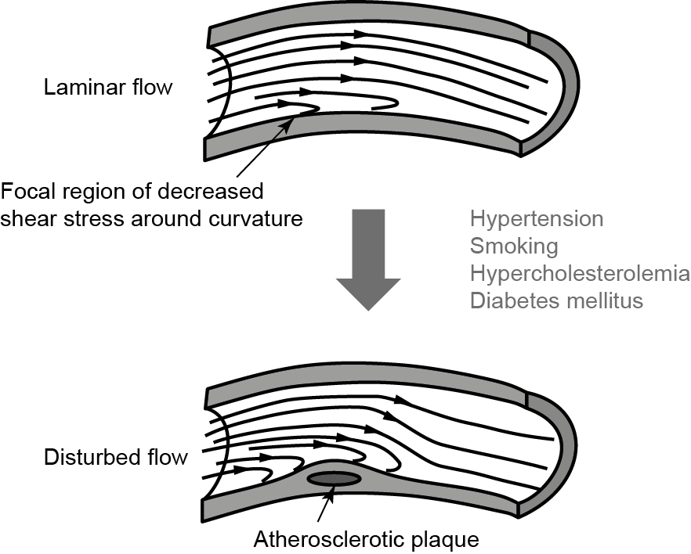

Figure 2. A schematic diagram of the early progression of atherosclerosis. The decreased shear stress affects cellular morphology and cell functions, several of which are atherogenic. In addition, in the presence of some risk factors as listed, there is an increased likelihood of atherosclerotic plaque formation at these sites (Cunningham and Gotlieb, 2005).

## 2. Flow Measurements of Blood Flow

The history of blood flow measurement started from the mid of 19th century when the ends of a known volume air tight U-tube was connected to a blood vessel to measure the rate of arterial blood flow according to the Poiselle formula (Dokunin, 1958). After decades of evaluation, a variety of techniques are routinely employed for the measurement of beat-to-beat cardiac output nowadays. Currently, the most widely applied techniques for in vivo blood flow measurement include Doppler (Bitterman et al., 1996, Barfod et al., 1997), magnetic resonance imaging flowmetry (Iida, 1995, Urdzik et al., 2013), and ultrasonic transit-time flow sensors (Elhawary and Pang, 1995, He and Tabrizchi, 1997). Obviously, measurement of blood flow in any vessel requires that the flow probe or sensor is accurate and linear over the flow range in the vessel of interest. Moreover, additional desirable features include, design, size and weight.

While in vivo techniques as mentioned above have the potential to provide the most realistic flow field data, they can only offer results with limited spatial and temporal resolution (Chen et al., 1997, Decking et al., 2004), which limits the representation of the true physiological boundary conditions such as vessel geometry, blood and tissue properties.

An alternative to in vivo measurements is Laser Doppler Velocimetry (LDV) or Particle Image Velocimetry (PIV) experiments using laboratory models representing the interested arterial geometries. These models are either reconstructed from patient specific arteries or summarized based on population averaged data built by optically transparent materials. Therefore, the experiments can be of various degrees of complexity, including steady (Clingan and Friedman, 2000, Day and McDaniel, 2005) and pulsatile flow conditions (Ku et al., 1985, Lim et al., 2001), idealised (Bharadvaj et al., 1982, Ku et al., 1985) and patient specific geometries (Liepsch et al., 1998, Buchmann et al., 2011).

Although considerable amount of in vitro experimental studies have been conducted, majority of them are focused on flow velocity measurements, while one of the most important haemodynamic parameters, wall shear stress (WSS), is not accessible due to the relatively low spatial resolution of the visualised flow field. Through some research efforts have been made to produce the wall shear stress distribution (Nguyen and Wells, 2006), the current experimental assessment of key haemodynamic parameters such as spatial and temporal wall shear stress is still difficult and prone to experimental uncertainties.

## 2. Numerical Modelling of Blood Flow

As an emerging research tool, computational fluid dynamics (CFD) approach is progressively adopted by biofluid dynamics community as the preferred technique for numerical modelling of large artery haemodynamics. CFD simulations can offer numerous haemodynamic parameters such as WSS and its related indices which remain difficult to be accessed via in vivo and in vitro measurements.

Due to the strong correlation between low WSS and lesion development (Zarins et al., 1983, Ku et al., 1985), wall shear stress remains one of the most intensively studied areas in CFD modelling. Perktod and Resch (Perktold and Resch, 1990) investigated the effects of artery geometric factors, such as the shape of the carotid sinus and the branch angle, in carotid bifurcation atherogensis under pulsatile flow conditions. They concluded that the most physiologically relevant flow variable is WSS and its temporal variation, which is in agreement with previous in vitro results. Following this work, numerous numerical studies were conducted in a variety of arterial models, predominantly artery bends and bifurcations. These include WSS studies (Myers et al., 2001, Lee et al., 2001), and also related indices such as oscillatory shear index (OSI) (He and Ku, 1996), wall shear stress gradients (WSSG) (Lei et al., 1995, Lee et al., 2009), and particle residence time (Suh et al., 2011, Ene-Iordache and Remuzzi, 2012).

Although plenty of numerical studies have been conducted attempting to formulate the underlying characteristics that lead to the onset of atherosclerosis, some limitations still remain.

First, majority image-based carotid artery simulations, the carotid artery domain of interest is always truncated and taken out of the context of the entire circulatory system. As such, the application of the inlet and outlet boundary conditions will affect the numerical prediction accuracy dramatically. Therefore, the imposition of individual inflow and outflow flow rates based on ultrasound or MRI measurements may be preferred (Maurits et al., 2007, Vignon-Clementel et al., 2010, Groen et al., 2010). However, for some applications such as the outcome prediction of proposed interventions, the outlet flow and pressure waveforms are not known, and the need for more accurate boundary conditions turns out to be acute.

Second, most of them have concentrated on analysing the blood flow pattern within the stenotic district through various modelling assumptions, such as steady flow (Gijsen et al., 1999), pulsatile flow (Chaniotis et al., 2010, Schirmer and Malek, 2012), rigid vessel (Tambasco and Steinman, 2003), compliant vessel (Lee et al., 2004), Newtonian flow (Tu et al., 2011), Non-Newtonian flow (Fan et al., 2009). However, the hemodynamic burden (effect on blood flow transportation) caused by the existence of the plaque was not investigated, which is of great clinical importance as it is treated as a key indicator to choose proper clinical treatment (Michaels and Chatterjee, 2002).

Last, since atherosclerosis is a complex disease associated with multiple factors, early researches only analysing from haemodynamics points of view are obviously not enough (Soulls et al., 2006, Gijsen et al., 2007), even taking vessel compliant effect into consideration (Torii et al., 2009, Huo et al., 2009). Although Tang et al. (Tang et al., 2009) conducted a complex modelling of stenotic vessel segment, the effect of artery bifurcations was neglected. Therefore, the numerical simulations about effects of circumferential stretch for anatomically accurate human arteries are still lacking.

# CHAPTER 3

# Geometric Model Reconstruction

## 3. Introduction

Computational reconstruction of the human cardiovascular structures can be divided into four stages: image acquisition, data conversion, segmentation and surface reconstruction. The development of a model first begins with medical imaging of a human subject which can be obtained from various sources, yet all provide essentially similar information. This includes a 3D matrix (or series of 2D matrices) of volume elements (voxels), in which tissues and structures are distinguished from one another by differences in brightness or greyscale. Two dimensional slices contain data of pixels; while a voxel is the three dimensional analogy of a pixel where the third dimension is the spatial distance between each slice.

Visualizing and reconstructing morphological structures from scanned images is an area of active research. This chapter provides an overview of contemporary methods for image processing, edge detection, and surface and volume definitions, for both clinical and research images of cardiovascular structures. Specifically, computer algorithms are developed for the delineation of anatomical structures and other regions of interest. This includes image segmentation which is central in the model reconstruction and many other biomedical imaging applications of anatomical structure, and pathologies (e.g. stenosis, and related cardiovascular disease identification, treatment planning, and computer integrated surgery).

## 3. Non-invasive Medical Imaging

To identify the geometry of the cardiovascular system, various medical imaging modalities can be used. In this section we provide an introduction to Magnetic Resonance Imaging (MRI), and Computed Tomography (CT) imaging modalities.

MRI scans use magnetic fields, and radio waves to obtain cross-sectional images of a section of the body. During a scan an electric current passes through coils of wires to generate a magnetic field. Hydrogen protons of water molecules inside the body that normally spin in random directions are then aligned with the magnetic field. With the hydrogen protons aligned, a short burst of tuned radio waves is sent through which momentarily changes the quantum state of the protons (e.g. flips the spin of the proton). When the radio wave stops, the proton returns to its original orientation and in doing so echo’s its own radio signal that a scanner detects and deciphers into images. This means that different tissue structures will produce different pulse sequences, leading to contrast changes for a number of tissue parameters. In addition, anatomical and physiological variation between subjects requires different pulse sequences to achieve the correct contrast.

CT scans use multiple x-rays taken at thin cross-sections in the region of interest along the person’s body forming slices (like slicing a loaf of bread). During a scan x-ray beams consisting of photons are absorbed or redirected (i.e. scattered) by material in the body which reduces the strength of the x-ray beam. Electronic detectors collect the x-ray information from each cross-section and send them to a computer that combines them into a single image. CT scans produce images with resolutions equal to or better than MRI. However soft tissue contrast in CT is not as good as in MRI, but is superior for imaging bone and bone tumours. Since CT scanners use x-rays which are a form of ionising radiation, its cumulative use has associated risks that are unavoidable and therefore CT scans are only performed where the benefit of the examination outweighs any potential risks. Both MRI and CT are non-invasive techniques however a contrast dye is sometimes injected into the body via one of the veins during the scan, referred to as an MR- or CT- angiograph. The contrast dye highlights the circulatory pathway and allows detection of interested arteries on the x-ray images. This type of scanning is referred to as angiography.

The scanned images are a series of cross-sections of pixels containing greyscale values with respect to different organs or tissues. These greyscale values represent a mapping of the linear x-ray attenuation coefficient in CT or a measure of the radio-density in MRI. In medical imaging a Hounsfield scale with units of HU is used, while in image processing the greyscale is numbered between 0 to 255 (0 stands for black and 255 stands for white). A representative greyscale image is shown in Figure 3. 1.

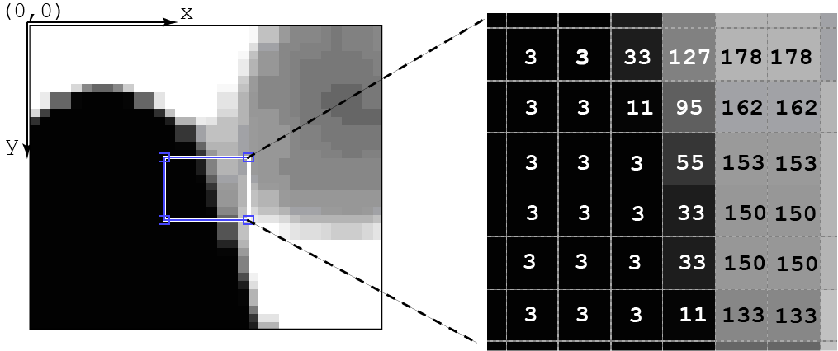

Figure 3. A greyscale image represents digitally by row (*x*) and column (*y*), and the greyscale function *f*(*x,y*) applied over each pixel.

## 3. Image Segmentation

The purpose of image segmentation is to partition images to different regions based on given criteria for future process. In detail, it is the process of assigning a label to every pixel based on a criterion in an image so as to connect pixels with the same label to form a contiguous region. While neighbouring pixels which do not belong to the anatomical structure will exhibit a pixel value outside of the criterion. Segmentation can be manually performed by selecting individual pixels on the cross-sectional slices or automated. In manual segmentation the user selects the region of interest in every cross-sectional image in a set of scanned images. Therefore this procedure is time-consuming and also introduces inter-observer and intra-observer variability. On the other hand, fully automated or semi-automated segmentation for monochrome images are generally based on discontinuities or similarities within the image based on greyscale values (referred to as intensity). For example, discontinuities at edges in an image can be identified based on abrupt changes in the intensity (greyscale level). Similarity in the intensity can be used to extract a region which exhibits similar properties according to a set of predefined criteria.

Methods for performing segmentation have been explored for many years producing a large variety of algorithms dependent on the speciﬁc application, imaging modality, and other factors. For example segmentation of carotid arteries involves handling of outliers, feature point detection, and additional user interaction. However segmentation remains a challenging problem to overcome the increasing number of anatomical structures of interest, large variations in the properties within the images, and imaging artefacts such as noise, partial volume effects, and motion-blur. Therefore there is no single algorithm that can produce sufficient results for all types of medical images (Balafar et al., 2010).

## 3. Segmentation Approaches

A region within an image can be defined by its pixel properties (e.g. greyscale intensity), boundary (edge) or its interior. Therefore segmentation approaches can be broadly categorised into the following:

* Pixel based (Thresholding): each pixel is labelled based on its grayscale values that represent intensity from the scans.
* Edge based: detects edge pixels to form a boundary containing the region of interest.
* Region based: considers pixel greyscale levels from neighbouring pixels by including similar neighboring pixels (region growing).

Pixel based methods are the simplest and easiest approach to implement, however they lack contextual information and fail in scans with high inhomogeneity through a single region. Edge based methods are the next simplest approach and are efficient on scans of anatomical structures that have clearly defined boundaries such as the artery. A common problem however is that noise or occlusions can cause false or missed edge detection. Region based methods are the most complete but complex methods since regions of interest includes more pixel categorization than edges. Furthermore region growing techniques are useful in noisy images where edges are difficult to detect.

## 3. Surface and Volume Reconstruction

A generic work flow is shown as a flowchart in Figure 3. 2. After segmentation, the output file can be directly read into a CFD meshing software or additional topological data can be included into the model. An advantage of including the topological data is that the file becomes compatible with CFD software. During the addition of topological data, the geometry can be mathematically described with a Non-Uniform Rational B-Spline (NURBS) for simple integration into a CFD-mesh software. This involves patching or overlaying a water-tight surface which holds point, line, and face data that are interconnected and relational. This is important since some CAD models will not be water-tight. The decision to directly output or apply a water-tight surface is dependent on the software, since a lot of CAD processing is self-contained and can be performed within the software itself.

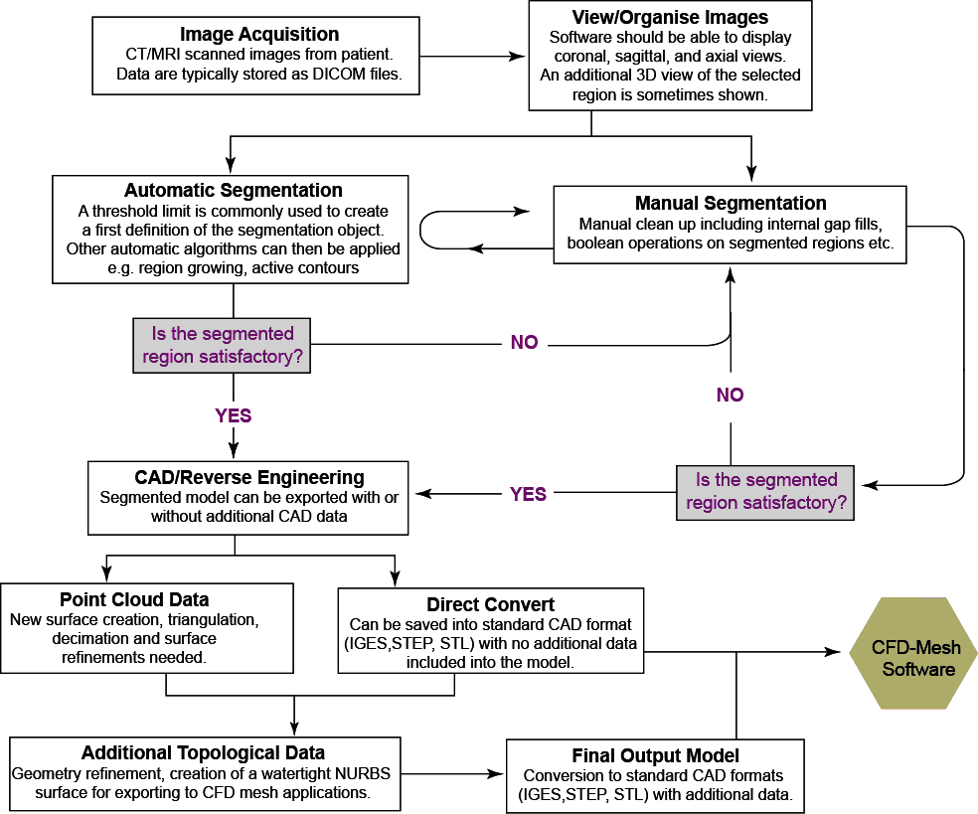

Figure 3. Flow chart showing the segmentation process to extract and export a region of interest into a 3D computer model (commonly referred to as a Computer-Aided-Drawing (CAD) model).

## 3. Summary

Reconstruction of the cardiovascular anatomy begins with obtaining the relevant data from medical imaging. Regardless technique, the scanned images typically form 2D contiguous slices that are separated by a known interval distance. The reconstruction of this data from 2D to 3D requires extraction of the region of interest in what is known as the segmentation process. A number of algorithms have been developed by researchers and biomedical scientists, and they can be accessed through either open-source/free software or commercial software. After segmentation, the extracted region typically needs to be ‘cleaned’ for any noise or artificial regions that are not needed. Sometimes the model may need further processing in CAD software. An important step before moving to a CFD mesh model is to ensure that the segmented model has a water-tight surface. This chapter aimed to review the up-to-date reconstruction theory and techniques that cross over into different disciplines including biomedical imaging, manufacturing/reverse engineering, and CAD/drafting fields. Using a patient-specific carotid artery as an example, the basic model reconstruction procedure used in this study is illustrated in Figure 3. 3.

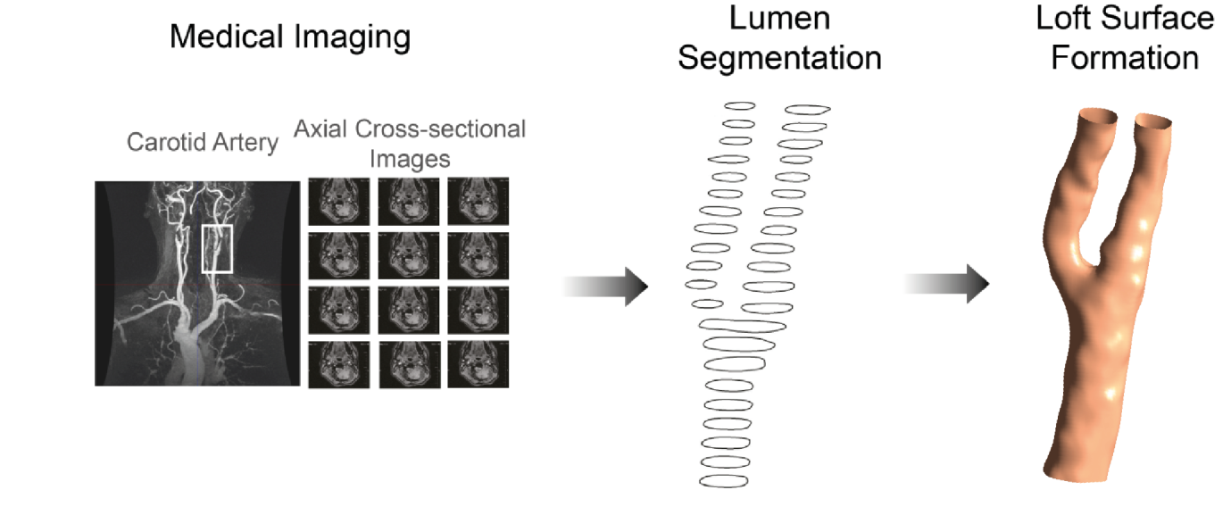

Figure 3. Reconstruction procedure of an patient-specific carotid artery sample.

# CHAPTER 4

# Mesh Generation

## 4. Introduction

A mesh can be viewed as a number of small elements or grid cells that overlays entire domain geometry. In general the set of fluid and structural equations are applied onto each cell, or finite element. Through solving these discrete equations, the changes or interpolations between cells are calculated to yield corresponding field variables such as velocity, pressure, temperature, and deformation.

Mesh generation is also referred to as grid generation, and is a separate discipline by itself, in a very active area of research and development. This chapter does not intend to elaborate on all the various methods of grid generation. Although, a number of the mesh-generation packages are designed with very user-friendly interfaces, and easy to utilize, the prerequisite to proficiently managing these software packages still relies on the reader’s aptitude to operate them. One has to decide on the arrangement of discrete points (nodes) throughout the computational domain, and the type of connections of each point, which leads to either great success or utter failure of the numerical solution. In this chapter, guidelines and best practices are given for developing quality meshes.

## 4. Mesh Design Strategy

A meshing strategy is to create an initial coarse mesh topology. This allows a quick solution which can be evaluated and the model then later refined. A suitable coarse mesh allows a number of “test-runs” to be carried out in quick turnaround time to assess the convergence or divergence behaviour of the numerical calculations, and physical models. When the numerical setup is correct and the solution is converging, mesh refinement is then undertaken to achieve a more accurate solution. If the solution is diverging, then the mesh or model setup needs to be debugged and investigated. Some possible sources of errors can be attributed to physical modelling and human errors, and not necessarily the numerical setup itself.

Since, there is no restriction on the use of particular cell type in an unstructured grid arrangement, a hybrid mesh that combines different element types has the ability to match appropriate cells with boundary surfaces and allocating cells of various element types in parts of the complex flow regions. For circular geometries such as arteries, grid quality is enhanced through the placement of quadrilateral or hexahedral elements in resolving the viscous boundary layers near the walls whilst triangular or tetrahedral elements are generated for the rest of the flow domain. Finally, special grid design features such as O-grid or C-grid need careful consideration of block interfaces as this significantly improves the overall quality of a block-structured mesh.

In all cases, after preliminary testing the mesh should be re-checked in critical regions of high flow gradients and large changes to ensure the results are agreeing with validation data such as experiments or known flow behaviour.

## 4. Mesh Quality

Mesh quality depends on the cell shape based on its aspect ratio, skewness, warp angle, and smoothness. A quadrilateral cell having a mesh spacing of Δ*x* and Δ*y* and an angle of *θ*  between the grid lines of a cell is shown in Figure 4. 1. The cell aspect ratio is defined as *AR = Δy / Δx*. Large aspect ratios should always be avoided in important flow regions (e.g. jets, flow separation, attachment and recirculation) as they degrade the solution accuracy and result in poor iterative convergence (or divergence) depending on the computational flow solver during the numerical computations.

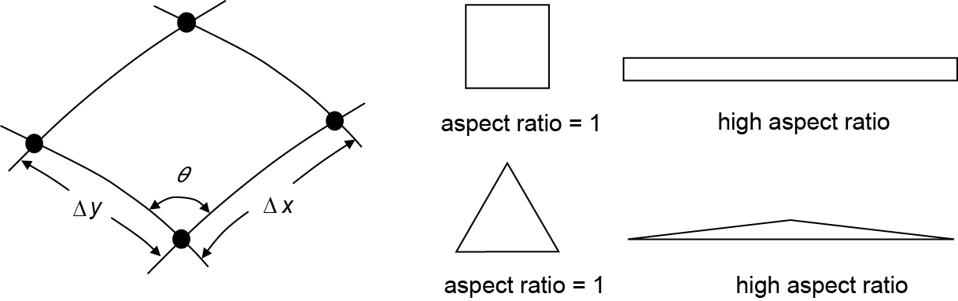

Figure 4. Definition of mesh spacing, Δ*x* and Δ*y* and an angle of *θ* between the grid lines of a quadrilateral cell, and examples of high aspect ratio elements.

The *AR* should be maintained within the range of 0.2 < *AR* < 5 within the interior region, if possible. However for near wall boundaries, the condition for *AR* can be further relaxed. If the fluid flow is in the *x* direction, then the first mesh requirement is to resolve the velocity gradient in the *y*-direction because of the thin boundary layer. To avoid poor *AR*, the Δ*x* mesh spacing should also be small enough to produce an *AR* within the suitable range. Such consideration can assist in possibly alleviating convergence difficulties and enhancing the solution accuracy especially where appropriately resolving the wall boundary layers is necessary.

Mesh distortion or skewness is measured by determining the angle *θ* between the mesh lines (Figure 4. 2). For triangles and tetrahedrals, the skewness can be quantified by using the ideal equilateral triangle as a reference.

 (Eq. 4. 1)

For quadrilateral cells, minimal distortion, mesh lines should be at an angle *θ* of approximately 90º (orthogonal). If the angle is *θ* < 45º or *θ* > 135º, the mesh becomes skewed and can lead to deterioration in the computational results or numerical instabilities.

|  |  |
| --- | --- |
| skewness-Circle |  |
| (a) skewed triangular cell | (b) skewed quadrilateral cell |

Figure 4. An example of a highly skewed triangular cell, and a quadrilateral cell.

For an unstructured mesh warp angles measuring between the surfaces’ normal to the triangular parts of the faces should be no greater than 75º, indicated by the angle *β* in Figure 4. 3. Cells with large deviations from the co-planar faces can lead to serious convergence problems and deterioration in the computational results. This often occurs when trying to cluster tetrahedrals in wall boundaries to resolve the thin fluid boundary layers. The use of tetrahedral elements should be avoided in wall boundary layers and instead prismatic or hexahedral cells are preferred. In any case, warp angle problems can be overcome by grid smoothing to improve the element warp angles.

*β*

Triangle in-centres

Figure 4. A triangular cell having an angle of *β* between the surfaces normal to the triangular parts of the faces connected to two adjacent triangles.

In addition, mesh elements should also exhibit gradual or smooth change in sizes from one to another. Adjacent cells should be less than 20% in size difference as any large sudden increase or decrease in adjacent cells causes difficult convergence of the solution.

## 4. Mesh Types

The nature of blood flow is inherently internal flows inside circular geometries. Figure 4. 4 compares the outcome of different meshing strategies. It is found that the mapping scheme fails with highly skewed elements in local corners of the circle. The triangular and paved scheme can fit the circular shape but could not provide refinement in the near wall region requires (i.e. prism layers). Triangular with prism layers is a hybrid unstructured mesh, and it is one of the most widely used mesh strategy as it can well fit the circular shape and provide near wall refinement at the same time. Lastly, the multi-block structured mesh can be achieved through introducing a square or an octagonal shape internal block, and both of them allow prismatic layers in the near wall region. In this study, the triangular with prism layers and multi-block structured mesh are applied.

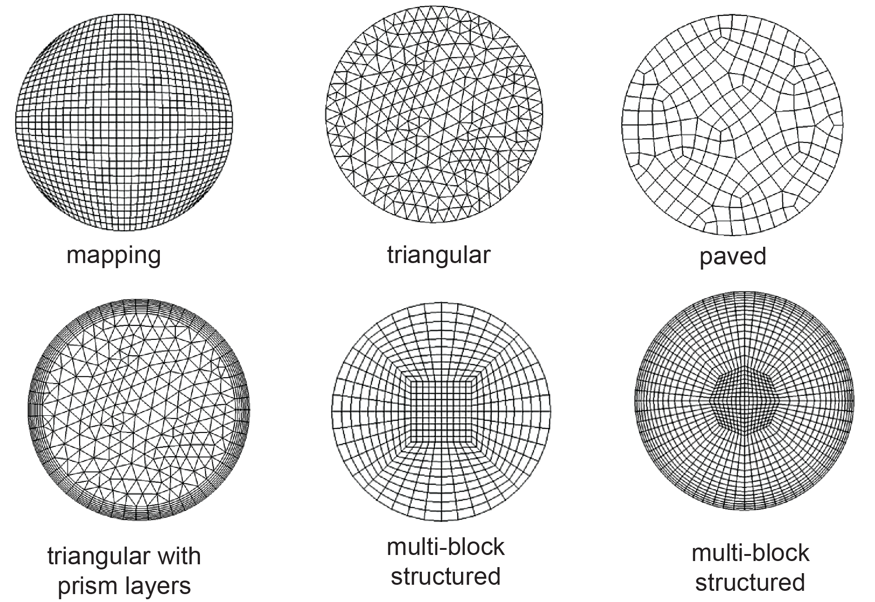

Figure 4. Meshing outcomes using different mesh strategies on a cross-sectional slice of an artery vessel.

## 4. Blocking Strategies

Setting up the blocks to produce a structured mesh where possible can be difficult at the beginning; however with experience then this visualization can be attained. Figure 4. 5 provides two examples in setting up the required blocks starting from a single block. The first example is a bend in the blood vessel is a common feature found in the vasculature vessel network. Any curved bend and in particular a 90o-bend found in the aortic arch can be treated as a single O-grid block topology, where the block is split into two sub-regions to allow for the bend. The second example is a bifurcating geometry where the initial block is split into six smaller blocks. The two outer blocks are then discarded to leave four smaller blocks that form a T-shape. This block is then re-shaped and split further for more control in the final mesh.

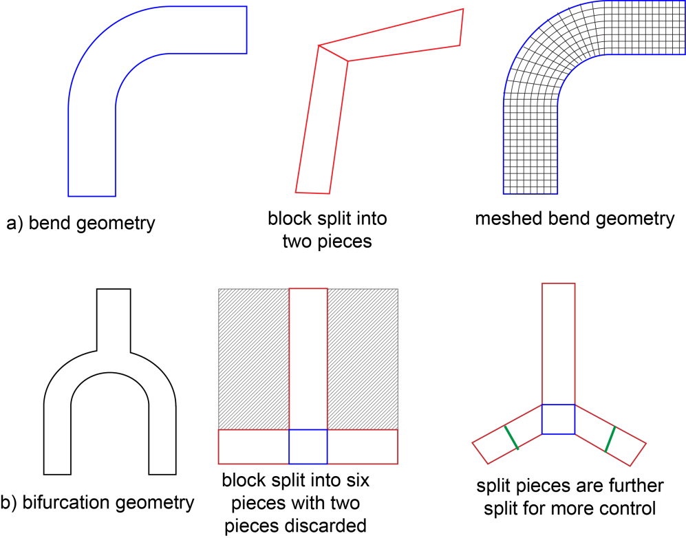

Figure 4. Blocking strategies examples: a) bend geometry, b) bifurcating geometry.

## 4. Meshing Examples

In order to provide an insight into the practical strategies and techniques for CHD mesh generation, few practical examples are presented in this section as demonstrations for relevant mesh design guidelines.

### 4.6. Stenosed artery step-by-step

In this section we present a specific example of a representative straight artery vessel with a moderate stenosis and provide detailed step by step guide (Figure 4. 6).

1. First, the fluid domain is enclosed by a single initial block.
2. This block is split into six sub-blocks (shown by the red markings in Figure 4. 6) that includes four sub-blocks at the stenosis site where the cross-sectional area experiences abrupt changes.
3. Each edge from the six sub-blocks is projected to the corresponding fluid domain surfaces and curves at the inlet and outlet. To optimize mesh quality, the block vertices are evenly spaced to minimize the average deviation of the edges from the surface curvature.
4. To further fit the fluid domain, all blocks are split along the x-direction and y-direction, thus creating further blocking topology for the fluid domain.
5. Similar with step three, all new block edges are associated to their nearest geometry entities.
6. The existing hexa-grid blocking topology is converted to an O-Grid topology, where a prism layer is created at the near wall region.
7. Based on the dimension of the fluid domain, reasonable node distributions are defined at each block edge to produce the final mesh.

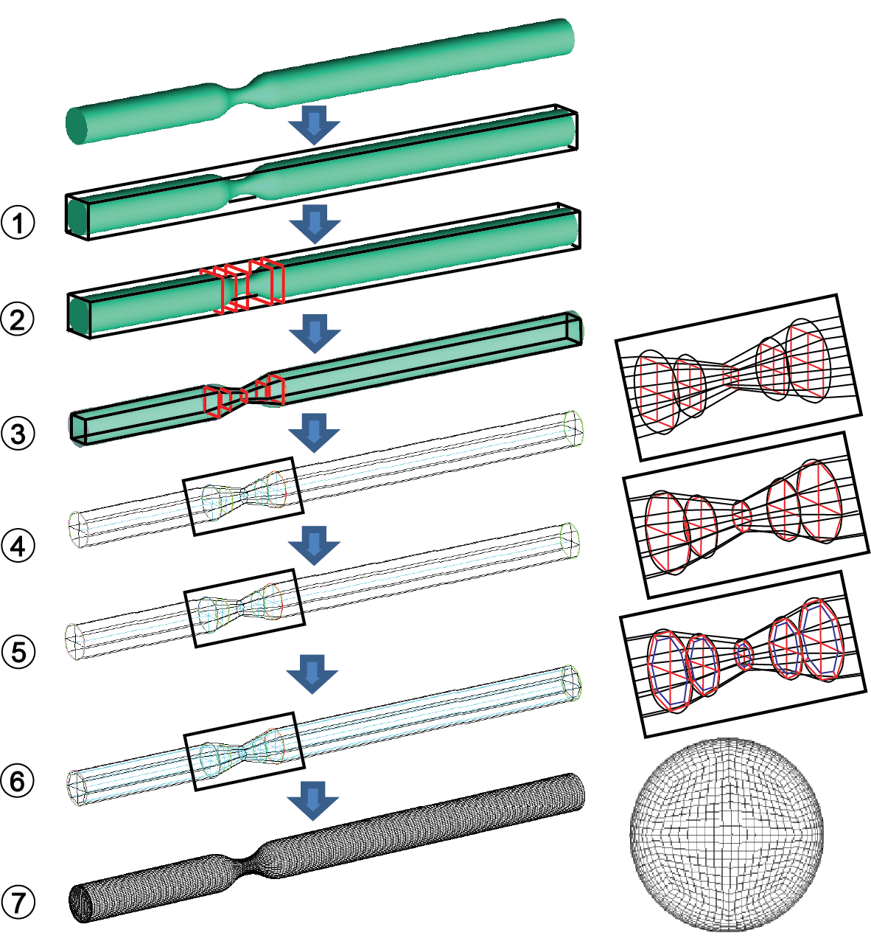

Figure 4. Multi-Block structured mesh flow chart for a stenosed artery.

### 4.6. Left coronary artery bifurcation step-by-step

Similar with the stenosed artery case study, a representative left coronary artery bifurcation is meshed, and detailed step instructions are provided in Figure 4. 7.

1. First, a single initial block is created to enclose the whole fluid domain.
2. The initial block is divided into six sub-blocks
3. Two blocks are deleted to form a T-shape.
4. The remaining blocks are associated to the nearest geometry entities, and a preliminary block topology is built to meet the bifurcating branches.
5. To better capture the branch curvature, all blocks are split into more sub-blocks along main branch and sub-branches.
6. The new blocks are associated to the nearest geometry entities, once again to attain the same curvature as the fluid domain.
7. All blocks are split along the vessel radius-direction to further fit the fluid domain, and all block edges are projected to the corresponding geometry entities again.
8. The existing hexa-grid blocking topology is converted to an O-Grid topology, where a prism layer is created at the near wall region.
9. Based on the dimension of the fluid domain, reasonable node distributions are defined at each block edge to produce the final mesh.
10. The final mesh results are produced and a close view of inlet mesh is shown.

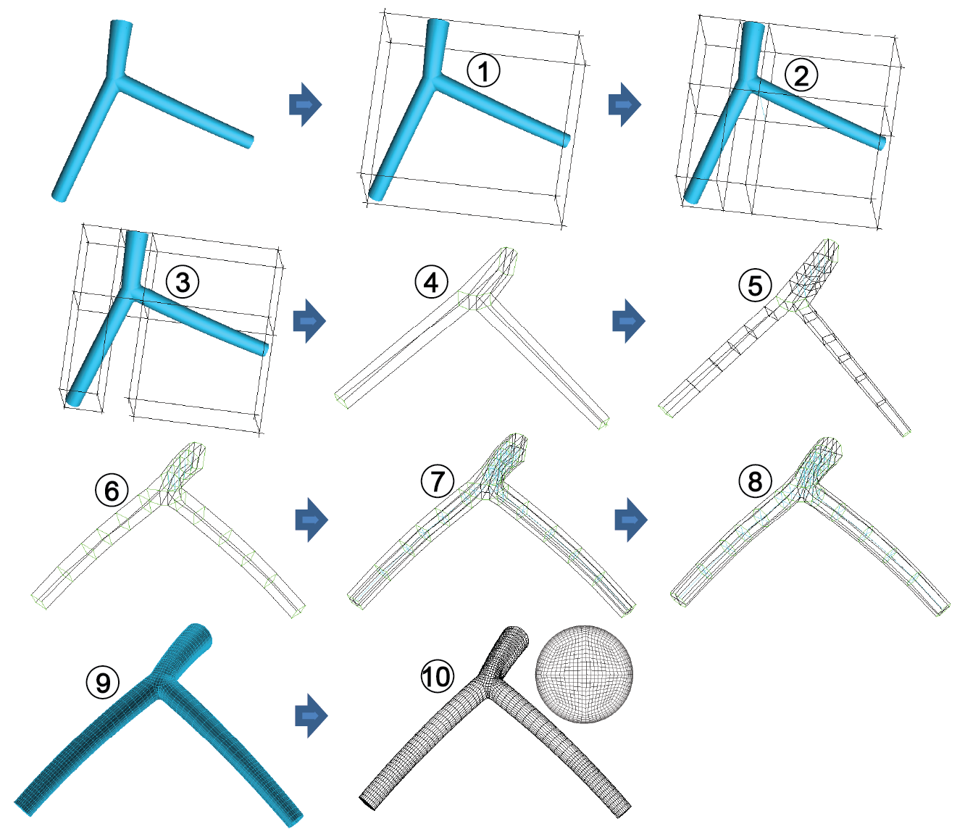

Figure 4. Multi-Block structured mesh flow chart for a left coronary artery bifurcation.

Apart from idealized models, two selected locations of image-based aortic artery, aortic arch and Aortic Abdominal Aneurysm (AAA), were also meshed using the same strategy. Figure 4. 8 shows the outcome of applying the same steps as mentioned above.

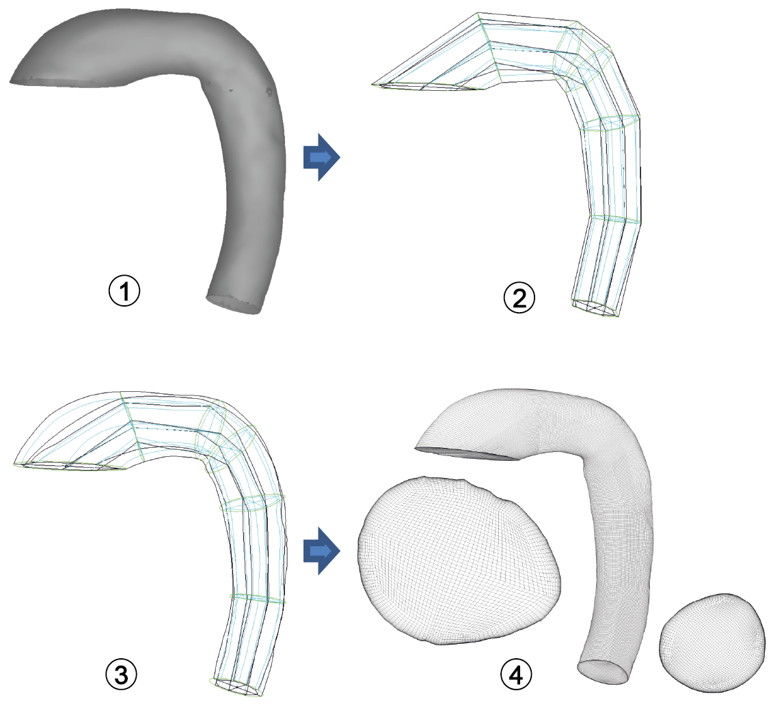

(a)

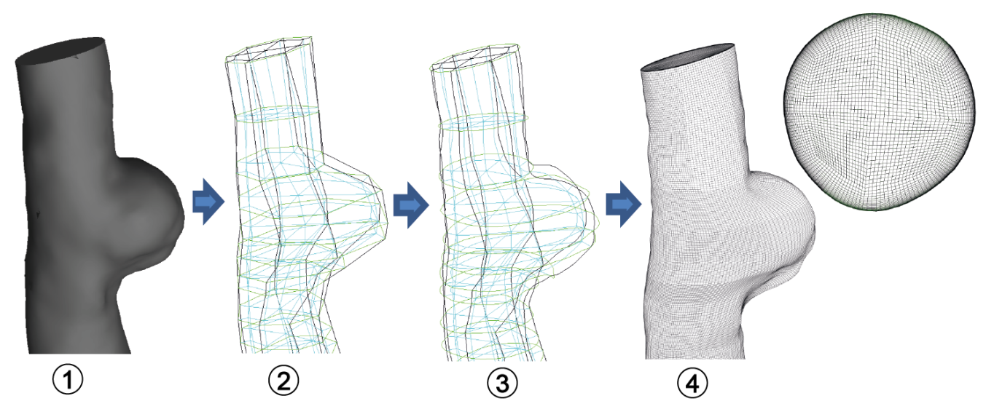

(b)

Figure 4. Schematic mesh procedures for an image-based aortic artery: (a) aortic arch, (b) aortic abdominal aneurysm.

# CHAPTER 5

# Fundamentals of CFD and FSI

## 5. Computational Fluid Dynamics

The fluid dynamics equations are mathematical statements of the conservation laws in physics. The equations describe the transport of mass, momentum, and energy through a physical domain. These equations are:

* The conservation of mass;
* The conservation of momentum (Newton’s second law, the rate of change of momentum equals the sum of forces acting on the fluid);
* The conservation of energy (first law of thermodynamics, the rate of change of energy equals the sum of rate of heat addition to and the rate of work done on the fluid).

### 5.1. Mass conservation

The mass conservation indicates the amount of mass entering a control volume surface is equal to the mass leaving the control volume surface, this can be summarised as

$\sum{{\dot{m}}_{in}-\sum{{\dot{m}}_{out}=0}}$ $→$ $\sum{\left(ρu_{in}A_{in}\right)-\sum{\left(ρu_{out}A_{out}\right)=0}}$ (Eq. 5. 1)

Throughout the circulatory network, many parts of the arteries bifurcate into subsequent smaller branches. The major bifurcations include the carotid artery, coronary artery, and abdominal aorta bifurcation (Figure 5. 1).

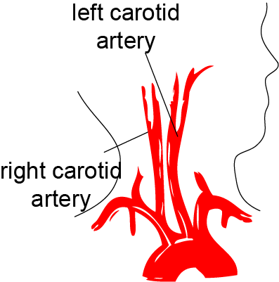 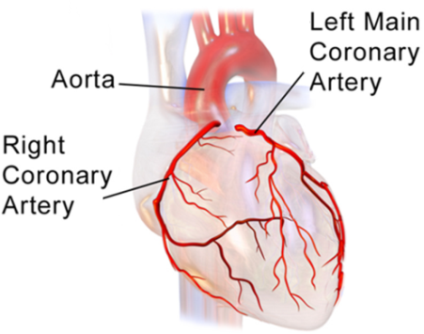 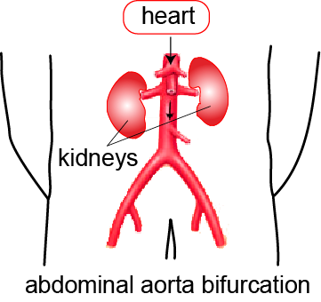

(a) (b) (c)

Figure 5. Main artery bifurcations in the body which include: (a) carotid arteries, (b) coronary arteries, and (c) abdominal aorta artery.

In these geometries the main flow is divided into two separate streams, and therefore its mass flow rate is divided, and in the case of the main coronary artery, further bifurcation occurs frequently. The subdivision of the flow rate is dependent on the resistance to flow and this is determined by the subsequent branch diameters and its alignment with the main branch. Nevertheless the mass flow must be conserved throughout the entire branch network. Figure 5. 2 demonstrates the mass conservation through an idealised bifurcation network. If we consider the mass flow rate at the inlet as ${\dot{m}}_{1}$, then the sum of all the mass flow rates through the outlets must equal to ${\dot{m}}_{1}$.

$\dot{m_{1}}=\dot{m_{2}}+\dot{m_{3}}=\dot{m_{4}}+\dot{m_{5}}+\dot{m_{6}}+\dot{m_{7}}+\dot{m_{8}}+\dot{m_{9}}+\dot{m_{10}}+\dot{m_{11}}$ (Eq. 5. 2)

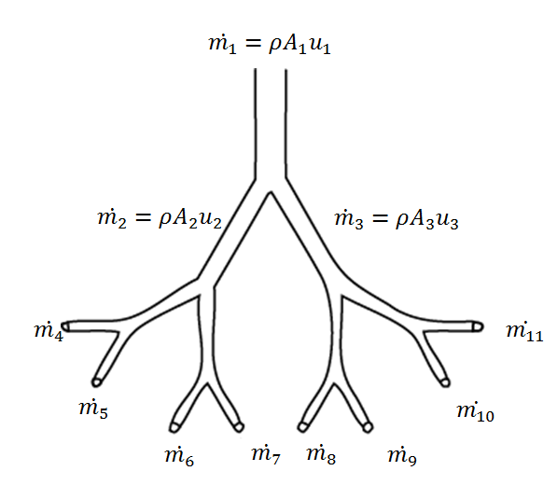

Figure 5. 2 Schematic of an idealised bifurcation network having one main inlet and subsequent bifurcations to produce eight outlet branches.

### 5.1. Momentum conservation

The conservation of momentum is derived from *Newton’s second law of motion*, , where  is the sum of all forces acting on a control volume of which there are two types of forces, namely *body forces* and *surface forces*. For an incompressible flow,

$ρ\frac{DU}{Dt}=F_{body}+F_{surface}$ (Eq. 5. 3)

where the acceleration is defined as $DU/Dt$.

*Body forces* act over the entire volume which includes gravity, centrifugal, Coriolis and electromagnetic forces which act at a distance to the control volume. These effects are usually incorporated by introducing them into the momentum equations as an additional term to the contribution of the surface forces where applicable. Surface forcesare those forces that act on the surface of the fluid element causing it to deform (Figure 5. 3). This includes the normal stress *σxx,* which are a combination of pressure *p* exerted by the surrounding fluidand normal viscous stress components *τxx* that bothact perpendicular to fluid element, and tangential stresses *τyx* and *τzx* that act on the surfaces of the fluid element.

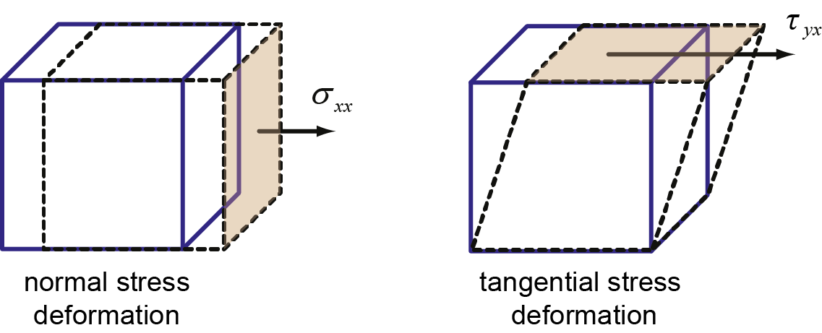

Figure 5. Deformed fluid element due to the action of the surface forces, in the form of normal and tangential stresses.

Therefore, the momentum conservation equation can be rewritten as

$\underset{inertia}{\underbrace{ρ\frac{DU}{Dt}}}=\underset{pressure}{\underbrace{-\frac{∂P}{∂x}}}+\underset{diffusion}{\underbrace{∇∙σ_{ij}}}+\underset{gravity}{\underbrace{ρg_{i}}}$ (Eq. 5. 4)

The term $DU/Dt$ is a material derivative and is defined as the local and advection inertial force through its acceleration as

$\frac{DU}{Dt}=\underset{local}{\underbrace{\frac{∂u}{∂t}}}+\underset{advection}{\underbrace{∇∙u_{i}u_{i}}}$ (Eq. 5. 5)

### 5.1. Turbulence modelling

Turbulence is associated with the existence of random fluctuations in the fluid. As shown in Figure 5. 4, the blood flow is assumed to be conducted by a schematic blood vessel. At any moment in time its motion is random and unpredictable. If we measured its velocity at Point X over time, then the velocity variation would exhibit random fluctuations.

 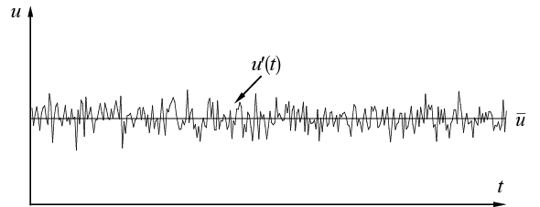

(a) (b)

Figure 5. 4 (a) Schematic of instantaneous flow fluctuations in a blood vessel. (b) Velocity measurement taken at Point X over time displaying a averaged value with random deviations from the averaged value at any moment in time.

The onset of turbulence depends on the ratio of the inertia to viscous force, which is indicated by the Reynolds number. At low Reynolds number, inertia forces are smaller than the viscous forces. The naturally occurring disturbances are dissipated away and the flow remains laminar. At high Reynolds number, the inertia forces are sufficiently large to amplify the disturbances, and a transition to turbulence occurs. The velocity and all other flow properties vary in a random and chaotic manner.

Turbulence models are the inclusion of additional equations or modifications to the governing equations (continuity, momentum, and energy) to account for the turbulent fluctuations in the flow field by finding a solution for the Reynolds stresses. The continuity and momentum equations are known as the Navier-Stokes equations (named after famous mathematicians) and its averaged form is called the Reynolds Averaged Navier-Stokes (RANS). This produces a set of time averaged equations with the turbulent features encapsulated by a new term called the Reynolds stress. They have been derived and improved over time by many researchers, based on experimental measurements, boundary layer theory, wall bounded flows and simple free shear flows. There are a number of turbulence models that range in complexity which is summarised in Table 5. 1.

In diseased artery region, the flow is significantly influenced by the vessel geometry and is far from being laminar in character. In order to capture various types of transition mechanisms and to evaluate the numerical accuracy against comparable experiment, the ‘transitional SST model’ developed by Menter et al. is used (Menter et al., 2006). This model is based on two additional transport equations to solve the turbulence kinetic energy *k* and the specific dissipation *ω*: the first is an intermittency equation (*γ*-equation), used to trigger the transition process; and the second is the transition onset momentum thickness Reynolds number equation (Reθt-equation), which is forced to follow experimentally-determined correlations. The model uses a new empirical correlation to cover standard bypass transition as well as flows in low free-stream turbulence environments.

Table 5. Summary of common RANS turbulence models

|  |  |  |  |
| --- | --- | --- | --- |
| **Turbulence model** | **Notes** | **Advantages** | **Disadvantages** |
| *mixing length* | No additional equations, but relies on a mixing length theory to find the Reynolds stress. | Fast calculation times. Good predictions for simple flows where experimental correlations for the mixing length exist. | Cannot describe flow separation or recirculation where the turbulent length scale varies. |
| *Spalart-Allmaras* | One additional equation for the turbulent viscosity. | Good for attached wall-bounded flows, and flows with mild separation and recirculation. | Bad for large separation, free shear flows, and decaying turbulence. |
| *k-ε models* | Two additional equations one for *k* and *ε* each. Most widely used model along with the *k-ω.* Assumes fluid flow is fully turbulent. The model leads to equal normal stresses, and isotropic turbulence. | Stable calculations and reasonable predictions for many flows. Most general turbulence of all RANS models. | Poor predictions for swirling and rotating flows, strong separation, severe pressure gradient. Lack of sensitivity to adverse pressure gradients |
| *k-ω models* | Two additional equations one for *k* and *ω* each. Its numerical behaviour is similar to the *k*-*ε* and suffers from similar disadvantages such as the isotropic turbulence assumption. Allows for a more accurate turbulent profile near the wall but requires a fine mesh to resolve the thin turbulent boundary layer. Is generally superior to *k*-*ε* for wall-bounded, free shear. and low Reynolds number flows, but separation is typically predicted to be excessive and early | | |
| *Reynolds Stress Models* | Seven additional equations, one each for the six independent Reynolds stresses, and one turbulent dissipation. Unlike other RANS model, the isotropic turbulence assumption is avoided | Accurately predicts more complex flows, accounting for streamline curvature, swirl, rotation, high strain rates, and separation | More equations contain more unknown terms that need to be modeled. Requires more computational time due to additional equations. |

## 5. Fluid-Structure Interaction

The fluid structure interaction (FSI) approach can fabricate an accurate and mature haemodynamic modelling of diseased vessel structure. This enables a reliable and robust FSI platform for simulating detailed 3D fluid-vessel or fluid-vessel-plaque in anatomically realistic deformable vessels. The fluid structure interaction must satisfy three important conditions:

* The structural solver describes nonlinear, anisotropic and inhomogeneous cardiovascular tissue characteristics;
* The CFD code resolves large deformations on the flow domains and updates the mesh accordingly;
* The coupling algorithm couples the fluid and structural solver effectively to achieve convergence. For the fluid modelling, a finite volume method can be used to discretise the Navier–Stokes equations, and for the structural modelling, the nonlinear finite element method can be implemented.

The combination of Computational Fluid Dynamics (CFD) with Finite Element Method (FEM) method is used to investigate the dynamic interaction of blood flow with the vessel wall solid structure due to the a pressure wave propagation. It can enable the nonlinear and anisotropic material properties to be introduced into the model by user-defined functions and even incorporate large deformation nonlinear flexible structures into it. In today’s commercial CFD software, FSI can be effectively applied with the multi-physics components required to solve the problem.

### 5.2. Elasticity

A material is elastic if it deforms under an applied force, and returns to its original position when the force is removed. As a result of the force, the body deforms and the amount of deformation, *d* as a ratio of its initial shape, e.g. length, *Lo* is defined as the strain, *ε*. The amount of force applied per unit area, *A* is the stress loading, *δ*. During elastic deformation the relationship between stress and strain is the material’s Young’s modulus, *E* (Figure 5. 5). Young’s modulus, *E* describes how stiff a material is; a higher *E* produces a steeper slope, which means that a greater force loading is needed to deform the material.

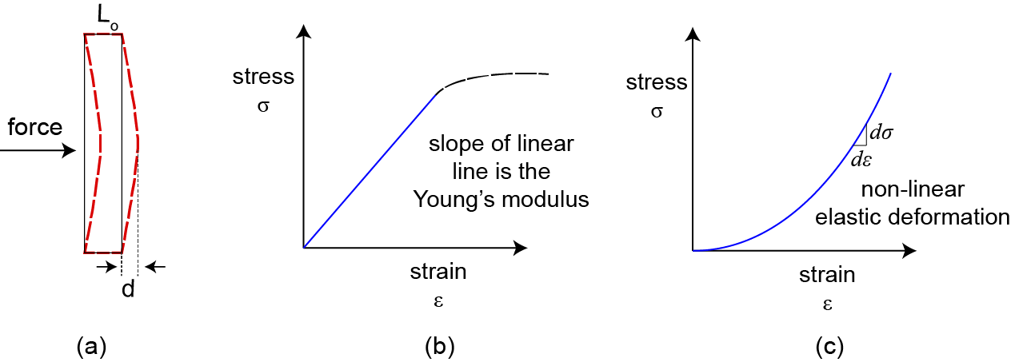

Figure 5. A body such as a wall structure subjected to a force load. (a) The initial length is *L*o and the deflection caused by the force load is *d*. For elastic materials (b) the stress-strain relationship is governed by Hooke’s Law producing a linear line that is the Young’s modulus. (c) For non-linear elastic deformation the Young’s modulus is found by taking the incremental gradient.

Arteries exhibit non-linear elastic behaviour, where the material does not follow Hooke’s Law (Figure 5. 5). The relationship is non-linear showing that as the stress in an artery increases, the material becomes stiffer and resists the strain. In such cases Young’s modulus is defined as the slope of the curve at a given stress-strain point, which is termed the incremental Young’s modulus, defined as

$E_{inc}=\frac{dσ}{dε}$ (Eq. 5. 6)

During material deformation, axial strain occurs in the direction of the force load. In addition there is deformation in the other two directions, laterally and perpendicular to the force direction (Figure 5. 6).

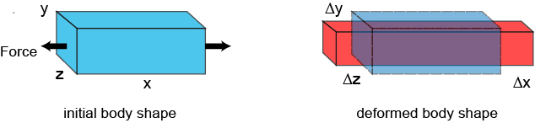

Figure 5. Deformation in all three directions of an elastic material subjected to a force in tension along the *x*-axis. The initial body shape expands in the *x-*direction but contracts in the *y-* and *z-*directions.

Deformation in all three directions caused by an axial force load is referred to as the Poisson effect and for isotropic materials, the Poisson’s ratio, ν is

$ν=\frac{lateral strain}{axial strain}=\frac{-ε_{y}}{ε_{x}}=\frac{-ε_{z}}{ε_{x}}$ (Eq. 5. 7)

which measures the change in shape in the lateral direction in relation to the change in shape in the axial direction.

### 5.2. Elastic properties of arteries

As shown in Figure 1. 1, artery walls are made up of four types of tissues, i) endothelial cells, ii) connective elastic and collagenous fibres, iii) smooth muscle, and iv) irregular connective elastic and collagenous fibres. These are found within three layers: the tunica intima (inner), the tunica media (middle), and the tunica adventitia (outer). The amount and composition of the different tissues in the artery varies based on the artery size and this determines its elasticity. More elastin in the arteries allows them to expand and contract more easily. Accordingly the arteries are either predominantly muscular or elastic.

The deformed artery holds this energy through expansion during systole and releases this energy through recoiling back to its original shape during diastole. As a result, the blood flow is propelled forward. In addition, the ability to absorb the peak systolic pressure dampens sudden loads on the artery wall. Compared with relatively large-sized arteries, arterioles contain less elastin and more smooth muscle which make the walls more rigid and stiff. Therefore, arterial compliance plays important roles in predicting the mechanical loading within the arterial wall and also considerably affects the blood flow itself.

Although arterial wall is known to be a composite tissue including collagen fibres, one of the most widely applied model is the nine parameter Mooney–Rivlin (M-R) hyperelastic model (Koshiba et al., 2007), which simplifies heterogeneous and anisotropic structure properties of the arterial wall. The strain energy function in the M–R model is given by:

$W=c_{1}\left(I_{1}-3\right)+c_{2}\left(I_{2}-3\right)+c_{3}{\left(I_{1}-3\right)}^{2}+c_{4}\left(I_{1}-3\right)\left(I_{2}-3\right)+c_{5}{\left(I_{2}-3\right)}^{2}+c_{6}{\left(I_{1}-3\right)}^{2}+c_{7}{\left(I_{1}-3\right)}^{2}\left(I_{2}-3\right)+c_{8}\left(I_{1}-3\right){\left(I_{2}-3\right)}^{2}+c_{9}{\left(I_{2}-3\right)}^{2}+D_{1}[exp⁡(D_{2}\left(\left(I_{1}-3\right)\right)-1)]$ (Eq. 5. 8)

$I_{1}=C_{\text{kk}}, I_{2}=1/2[I_{1}^{2}-{\text{C}}_{\text{ij}}{\text{C}}_{\text{ij}}]$ (Eq. 5. 9)

where *I*1 and *I*2 are the first and second strain invariants of the Cauchy-Green deformation tensor **C**ij, **C**ij = 2*ε*ij + *δ*ij, *δ*ij is the Kronecker delta; *c*1 to *c*9 and *D*1, *D*2 are material constants.

### 5.2. Coupling

The interaction between the fluid and structural fields is achieved by enforcing kinematic and dynamic continuity conditions at the common interface between these domains. The kinematic continuity condition follows from the requirement that no mass flows across the interface. For a general viscous fluid, a no-slip boundary condition for both normal and tangential components of displacements and velocities are imposed at the interface (Gerstenberger and Wall, 2008):

$d^{f}=d^{s}$, $u={\dot{d}}^{s}$ (Eq. 5. 10)

where $d^{f}$ and $d^{s}$ represent the fluid and structural displacement vectors at the interface, **u** and ${\dot{d}}^{s}$ are the fluid and structural velocity vectors. The dynamic continuity condition is based on force equilibrium across the interface according to principle of action and reaction. Since the interface area is equal, this reduces to equality of traction between both fluid and structural fields as:

$σ^{f}∙n=σ∙n$ (Eq. 5. 11)

where n represents the outward unit normal vector of the interface, $σ$ represents the stress in three coordinates, the Cauchy stress tensor for structural field; and $σ^{f}$ is the stress tensor for the fluid field, made up of the pressure and shear stress terms.

Solution strategies for FSI Coupling are mainly divided into “Monolithic” and “Partitioned” methods. The differences between them are the method for solving the governing equations and the way handling the interface conditions. The monolithic method completely couples the solid and fluid domains into one system of equations and solves them directly, while the partitioned approach separates the fluid and solid domains and then solves their governing equations iteratively using two different solvers until the solutions converge.

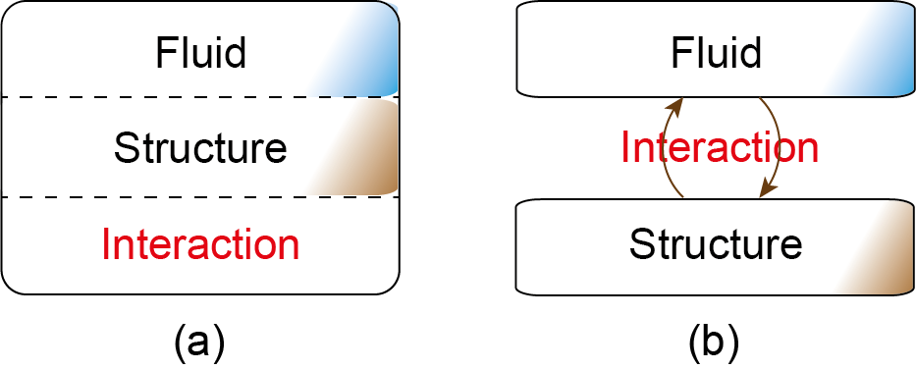

Figure 5. Solution strategies for FSI simulations: (a) Monolithic methods (b) Partitioned methods.

There are benefits and deficiencies to both the monolithic and the partitioned approaches. The obvious benefit to the monolithic approach is that, if solved, it always produces a fully-coupled solution in a single iteration per time step. On other hand, the biggest issue to this approach is the relatively higher computational cost. Michler (Michler et al., 2004) showed that in a simple one dimensional FSI problem, the computational cost of the monolithic procedure is three to four times the one of the partitioned procedure; however, the monolithic approach reached accuracies much greater than the partitioned approach when weakly coupled with respect to calculated structural displacements. One of the benefits to the partitioned approach is its relative simplicity in implementation and solution. The interface conditions for the partitioned case can all be applied directly, while in the monolithic case they must be added to the system of equations as extra Jacobian terms. Also, each set of governing equations for the partitioned case can be solved independently, requiring fewer unknowns per solve than for the monolithic case. Due to its relative ease of implementation and lower computational cost, partitioned schemes have dominated the majority of FSI research and been implemented in this research.

To match both kinematic and dynamic conditions simultaneously in both fluid and solid equation solvers, a successive iteration method is applied. In this partitioned approach, segregated solvers for each fluid and structural field are employed and the interacting quantities at the interface from each field are exchanged sequentially. A flow chart demonstrating this process is given in Figure 5. 8.

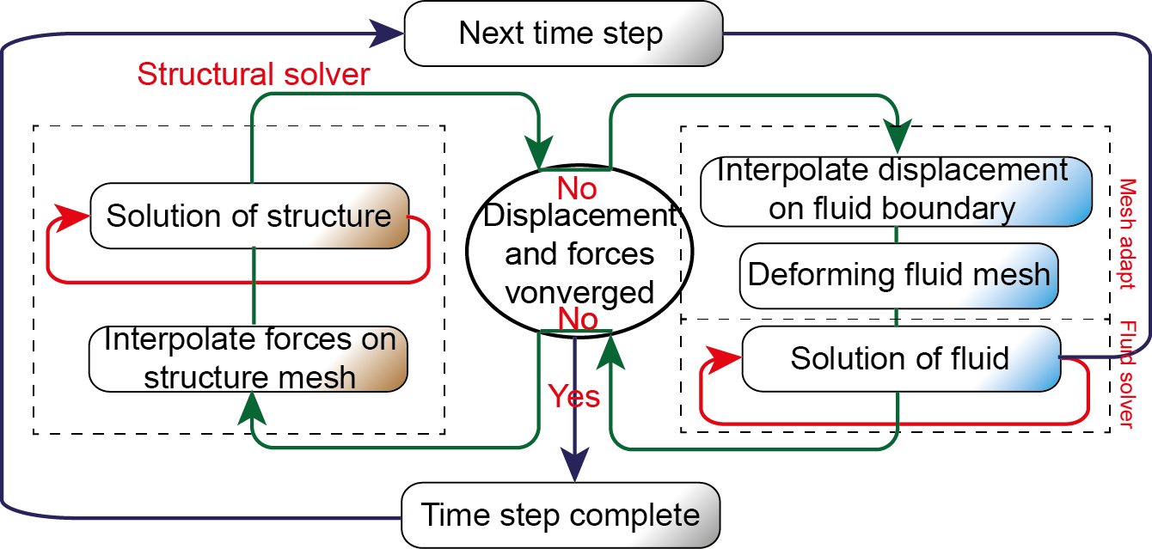

Figure 5. 8 Fluid-structure coupling flowchart.

Within each component of iterations, the solutions must reach converged results before moving to the next set of iterations. The steps are detailed as:

1. **Fluid Solver:** The fluid variables, ($u, v,w, P$) are solved based on initial or current geometrical configuration, i.e. based on the current displacement at the interface, $d_{k-1}^{n}$ at time $t^{n}$ and coupling iteration $k-1$. The fluid pressure and shear forces at the interface are resolved to in all three components, *x*, *y*, and *z*.
2. **Structural Solver:** The forces and boundary constraints produced from the fluid equations are applied to the structure at the interface for the structural equations. The structural deformation is determined, giving the current interface displacements $d_{k}^{n}$.
3. **Mesh Adapt:** The interface displacement is interpolated across the fluid interface mesh nodes which are used to alter the mesh deformation on the fluid domain.
4. The fluid equations are solved again for the unknown fluid variables based on the new geometrical configuration caused by $d_{k}^{n}$.
5. **FSI Coupling**: The process is repeated until the difference in nodal deflection and forces exchanged in steps 3 and 1, from current and previous coupling iterations, are within a specified tolerance – suggesting that at a given timestep, the kinematic and dynamic continuity are satisfied at the interface.

The transfer of the fluid flow variables (e.g. velocity, pressure, force, temperature) from the fluid solver to the structural solver, applied at the fluid-structure interface as loads without the return influence from structure to fluid is referred to as a one-way FSI coupling. One-way transfer is appropriate when displacements and temperatures differentials calculated in the structural application are small enough to have an insignificant impact on the fluid analysis. In two-way FSI coupling, the deformation of the fluid-structure interface is also transferred to the fluid solver to deform the fluid mesh. Therefore, the two-way FSI coupling solution is more accurate, especially for cases with larger deflections where the fluid field is strongly influenced by the structural deformation. In this research, two-way FSI coupling is applied.

Using partitioned methods, the FSI coupling solutions are separated into two physical fields. One field that has to be solved is fluid dynamics, the other is structure dynamics. At the boundary between fluids and solids, the fluid-structure interface, information for the solution is shared between the fluid solver and structure solver. The information exchanged is dependent on the coupling method. For one-way coupling calculations, only the fluid pressure acting at the structure is transferred to the structure solver. For two-way-coupling calculations, the displacement of the structure is also transferred to the fluid solver.

A structure solver will most probably use ﬁnite elements on unstructured grids as discretization scheme, while a ﬂuid solver might use a ﬁnite volume approach on Cartesian grids. Therefore, interpolation methods play keys roles in mapping data of one mesh to the other. In addition, a ﬂuid with low viscosity might be highly turbulent and require very small time steps to stay stable, while the structure could advance with much larger steps. A kind of sub-cycling can improve this situation by allowing the ﬂuid solver to accumulate several small time steps on its own before transfer fluid flow variables to the structural solver.

Since the solvers are separated, they both use their own discretization method, leading to nonmatching grids on both sides of the coupling interface between fluid and structure. In order to transfer loads across a dissimilar mesh interface, the nodes of one mesh must be mapped to the local coordinates of an element in the other mesh. In a FSI coupling problem, fluid nodes must be mapped to the solid elements to transfer displacements. Likewise, solid nodes must be mapped to the fluid elements to transfer stresses.

Lastly, FSI coupling is characterised by the amount of repeated iterations between the fluid and solid domains. Computationally, this refers to how many iterations are used to resolve the fluid and solid domains to reach convergence. A weak coupling is one that uses a minimum iteration while a strong coupling uses a maximum. Physically this means that a weakly coupled FSI is suitable for cases with minimal deformation between the fluid domain and structure domain, while a stronger coupling is desired for cases with more deformation.

### 5.2. Stability and convergence

Stability at the fluid–solid interface can be a big concern with FSI simulations that use separate fluid and structural solvers, particularly for fluid-vessel interaction simulation when the structure is very flexible and often exhibit instabilities at the FSI interface. For example, in two-way coupling calculation, the deformation of FSI interface deforms the fluid mesh. To calculate this deformation, the displacement diffusion algorithm is used. The connections between the nodes are modelled as springs with different stiffness. This stiffness can change from node to node, and it is set very high for nodes near boundaries. In the normal direction from the FSI interface, the first ten nodes have displacements in the range of the boundary displacement.

In some cases, applying the full magnitude of data on the target side of FSI interface will initiate oscillatory convergence or even divergence within and between the coupled co-simulation solvers. Therefore, the target side data may be ramped from the final value observed in the previous coupling step to the full magnitude during the initial coupling interactions within the current step through applying proper under-relaxation factors.

The co-simulation solvers sequencing also affects the FSI solution stability. In general, the driver of the physical problem should be processed first. That means, for a FSI simulation, since the fluid flow causes the structure to deform, the fluid analysis should be first in the processing sequence. To check the convergence of the FSI solution, the structure solver, the fluid solver and the data exchanged across the FSI interface have to be all converged to the prescribed residual limits. For a full transient simulation, convergence should take place for every time step for the results to be accurate.

# CHAPTER 6

# Validation against PIV Measurements

## 6. Introduction

Stenotic carotid bifurcations are subjected to disturbed flow conditions, particularly in the post-stenotic regions. For example, flow detachment, recirculation, oscillating wall shear stress and turbulence, which contribute to thrombus formation (Stein and Sabbah, 1974, Holme et al., 1997). Therefore, the discovery and assessment of flow disturbance in post-stenotic regions is important in understanding and diagnosing of carotid artery atherosclerosis.

Various in-vitro experimental studies have been performed to reveal flow patterns in stenotic arteries under physiologically realistic Reynolds (Re) and Womersley numbers. Kefayati et al. (Kefayati and Poepping, 2013) conducted a series of PIV measurements on idealized normal, 50% and 70% stenotic carotid models by means of proper orthogonal decomposition under pulsatile flow conditions. Complex flow and a flatter slope of energy decay were found in a 70% stenotic model. Poepping et al. (Poepping et al., 2010) performed pulsed Doppler ultrasound (DUS) measurements to investigate the effect of stenosis symmetry on blood flow disturbance over four idealized carotid bifurcation models with variable stenosis severity. Comparing with concentric stenosis, the eccentric stenosis with the same stenosis severity exhibited stronger flow disturbance in the post-stenotic region.

Meanwhile, as an alternative approach, CFD simulations using sophisticated numerical methods, can resolve the intravascular flow patterns of healthy and stenotic artery models for in-depth quantitative studies. Although considerable research efforts have been spent in many research directions, such as fluid-structure interaction (Kim et al., 2008, Lee et al., 2012), plaque instability (Tang et al., 2005, Teng et al., 2010), and intervention outcome assessment (Markl et al., 2010), the numerical simulation accuracy is difficult to verify due to the inherent high complexity.

To validate the numerical model accuracy and provide a further detailed understanding of hemondynamics in carotid artery bifurcations, CFD simulations using identical carotid artery models with referred PIV experimental measurements (Buchmann, 2010) were performed. The flow patterns in the vicinity of carotid artery bifurcation were analysed. The results yielded from this chapter can contribute to the calibration of turbulent models, characterisation of flow patterns within artery bifurcations.

## 6. Methods

### 6.2. Phantom geometry

The averaged tuning-fork shaped human carotid artery bifurcation originally proposed by Ding et al. (Ding et al., 2001) is used in this chapter. The model is described as a parametric stereolithography model (STL) and scaled up to approximately 3.2 times a real model. Based on this model, a stenotic model is constructed with a smooth reduction in the carotid sinus diameter. Stary et al. (Stary et al., 1995) reported that the cross-sectional shape created by arterial plaques is essentially circular and thus the stenosis profiles are assumed relatively smooth. In this chapter, the anatomical variation in vessel diameter is described with a cosine function to create a concentric stenosis with a 63% reduction in cross-sectional area. Both healthy and stenotic models are depicted in Figure 6. 1, with key geometry features and five predefined locations labelled. All relevant dimensions are summarised in Table 6. 1.

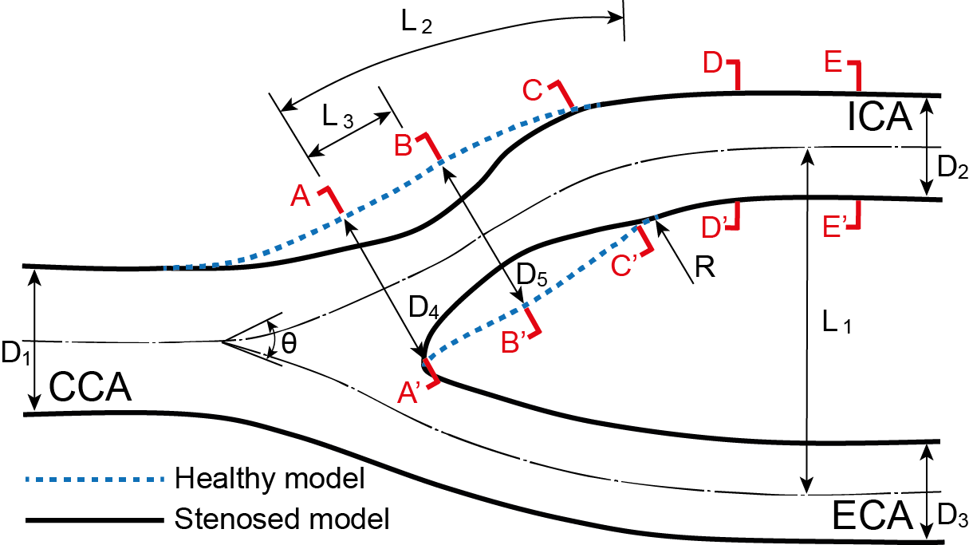

Figure 6. Schematic representation of the carotid artery models: dashed line represents the healthy model, and the solid line represents the 63% ICA stenosed model.

Table 6. Dimensions of the idealized carotid artery bifurcation models.

|  |  |  |  |  |  |  |  |  |  |
| --- | --- | --- | --- | --- | --- | --- | --- | --- | --- |
| Indicated Locations | D1 | D4 | D5 | D2 | D3 | L3 | L2 | L1 | R |
| Dimensionless Values | 1.0 | 1.04 | 1.11 | 0.72 | 0.69 | 0.9 | 3.0 | 2.4 | 4.1 |
| Healthy | 20 | 20.8 | 22.2 | 14.4 | 13.8 | 18.0 | 60 | 48 | 82 |
| Diseased | 20 | 16.8 | 8.8 | 14.4 | 13.8 | 18.0 | 60 | 48 | 82 |

Dimensions in (mm), *θ* = 50o for all models

### 6.2. Flow circuit setup

According to Buchmann’s work (Buchmann, 2010), physical prototypes of the bifurcation models were manufactured by him using three-dimensional computer controlled printing. A schematic representation of the experimental setup is given in Figure 6. 2. Steady flow was supplied by a constant header tank and conducted to the test section via a 1.5 m pipe ensuring fully developed flow at the entrance of the CCA. An electromagnetic flow sensor (Flowmaster FXE4000, ABB) was placed upstream of the test section and two rotameters were located in the two daughter branches to adjust the individual flow rates in the ICA and ECA. The working liquid was an aqueous glycerine solution (39% water and 61% glycerine by weight) to match the refractive index of the silicone flow phantom (*n* = 1.141). It has a dynamic viscosity *μ* = 11.7 × 10-3 Pa ∙ s and density *ρ* = 1150 kg m-3 at 20 ºC. To ensure stable operating conditions, a temperature feedback controlled system is installed to maintain the temperature variation of the working fluid within ± 0.5 ºC.

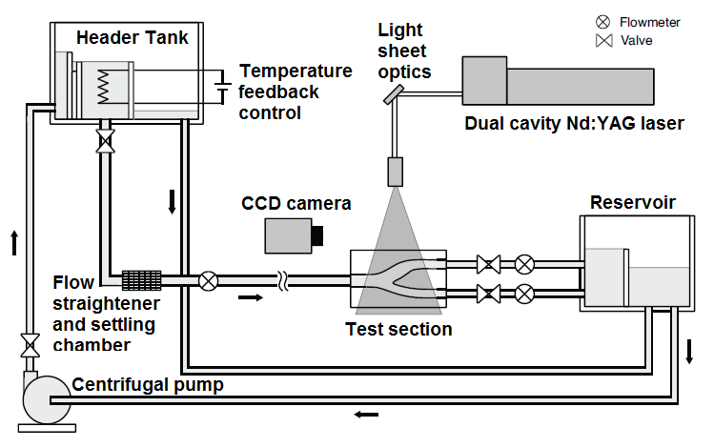

Figure 6. 2 Schematic representation of the experimental facility.

### 6.2. PIV data acquisition

Planar PIV was used to measure blood flow velocities in the plane of bifurcation and several cross-sectional planes along the carotid sinus. The PIV system consisted of a pulsed 120mJ Nd:YAG laser (New Wave Solo XT), a digital CCD camera (Kodak Megaplus 1.0) and optics to form a light sheet of approximately 1 mm thickness. The camera was positioned perpendicular to the sidewall of the model allowing a normal viewing of the illuminated flow passages. To measure the secondary flow structure, the camera was positioned under an angle such that the test cross-section could be viewed through the left wedged corner as shown in Figure 6. 2. The working fluid was seeded with 10 µm hollow glass spheres (*ρ* = 1100 kg m-3) and sequential images of the illuminated particles were recorded on 1008 × 1018 pix2 frames at a rate of 14 Hz. Further experimental information can be referred from Buchmann’s work (Buchmann, 2010).

### 6.2. Numerical model setup

Identical artery bifurcation models were imported into ANSYS-ICEM (ANSYS, NH, USA) and meshed with structured hexahedral mesh using multi-block O-grid method. For better resolution of near wall flow quantities, near wall grid refinement with 10 points were imposed on each model. A detailed mesh result is shown in Figure 6. 3.

The flow field was solved iteratively via the continuity (Eq. 6.1) and momentum (Eq. 6.2) equations:

 (Eq. 6. 1)

 (Eq. 6. 2)

where **u** is the velocity vector, *p* denotes blood pressure, and the fluid density *ρ*, and viscosity *μ* were kept identical with the working fluid as mentioned above. The commercial finite-volume CFD package ANSYS-CFX (ANSYS, NH, USA) was used, where the governing equations were solved iteratively using the SIMPLE algorithm for the pressure-velocity coupling and a second-order upwind scheme for the convective terms.

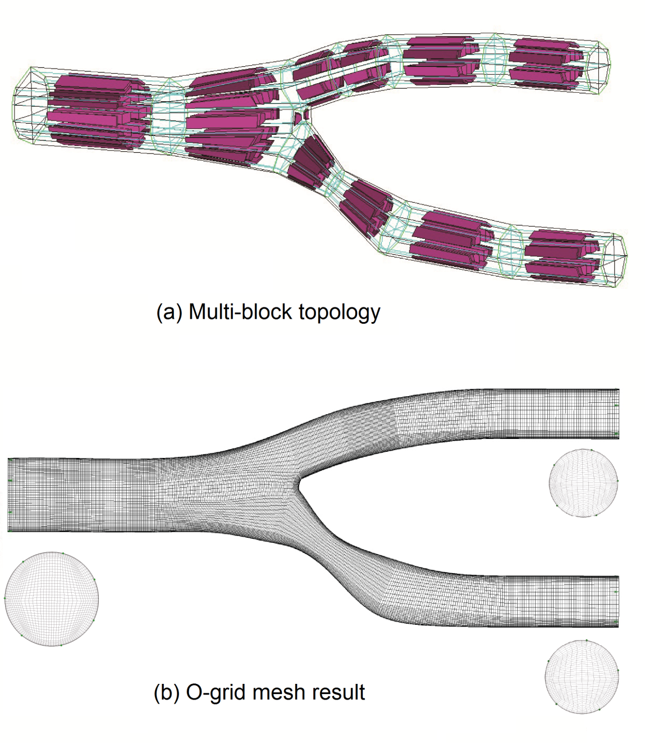

Figure 6. 3 Structured mesh result of the 63% ICA stenosed ST-AHCB model.

The wall of the artery bifurcation model was assumed to be rigid and stationary, with no-slip boundary conditions. A fully-developed Poiseuille flow profile was applied at the inlet. Re = 400, and 800, representing of mean and peak systolic flow conditions, were performed for numerical simulations and measurements. This is to provide an understanding of how different inlet conditions affect the formation of flow recirculation, secondary flows and WSS distribution. Although the division of flow in the two daughter branches varies during one cardiac cycle, in this chapter, in order to maintain identical operation conditions compared with the referred PIV measurement, the time averaged flow division in the carotid artery is assumed to be constant *γ* = 0.7.

### 6.2. Turbulence modelling

In general, the blood flow in large arteries can be treated as laminar if all vessels are typically normal and healthy in geometry without any significant constrictions. However, where atherosclerosis is present in arteries, these regions of severe constrictions will experience a vastly different biomechanical environment that exhibits the presence of transitional and turbulent flow in comparison with healthy vessels (Kefayati and Poepping, 2013).

During past decades, many in-vitro measurements (Deshpande and Giddens, 1980, Lieber and Giddens, 1990) and numerical studies using turbulence models (Younis and Berger, 2004, Birchall et al., 2006) were performed on stenotic arterial vessels, which have provided visualization of the flow characteristics in proximal and post-stenotic regions. The flow is significantly influenced by the vessel geometry and is far from being laminar in character. In order to capture various types of transition mechanisms and to evaluate the numerical accuracy against comparable experiment, the ‘transitional SST model’ developed by Menter et al. (Menter et al., 2006) is used. This model is based on two additional transport equations to solve the turbulence kinetic energy *k* and the specific dissipation *ω*: the first is an intermittency equation (*γ*-equation), used to trigger the transition process; and the second is the transition onset momentum thickness Reynolds number equation (Reθt-equation), which is forced to follow experimentally-determined correlations. The model uses a new empirical correlation to cover standard bypass transition as well as flows in low free-stream turbulence environments.

## 6. Results and Discussion

Figure 6. 4 presents the comparison between numerically predicted and PIV measurements of the stream-wise flow patterns at the center-plane of a healthy and stenotic idealized carotid artery models. All the velocities were normalized with the maximum value at the centerline of the CCA inlet.

For the healthy model, due to its healthy vessel shape, the blood flow remains laminar, thus laminar flow modelling is used. However, for the ST-AHCB model, as it is highly stenosed at the ICA sinus, the transitional-SST model is used to predict the transitional flow patterns occurring proximal and downstream of the stenotic region.

In general, for both Reynolds numbers, good agreements are achieved for the healthy model. The velocity profiles are skewed towards the inner wall from plane A-A’ to plane C-C’ within the carotid sinus region. Blood flow conducted by the common carotid artery (CCA) is divided at the bifurcation apex, which causes the flow to concentrate within the inner wall region. In the outer wall region, flow separation and recirculation occur due to the adverse pressure gradient. The low velocity region occupies approximately 50% of the vessel lumen. Then, the velocity profile becomes more evenly distributed with blunt velocity profiles as the downstream vessel turns to be relatively straight (plane D-D’, and E-E’).

Compared with the healthy model, the stenotic model exhibits very different flow patterns. Due to the 63% ICA stenosis, a flow jet is formed at the carotid sinus region and the flow velocity magnitude is doubled at the stenosis throat (plane B-B’). Unlike the blunt velocity profiles downstream of ICA branch discovered in the healthy model, the jet impinges towards the outer ICA wall in the post-stenotic region, while flow separation and recirculation occupy the inner ICA wall region continuously. Due to the presence of more disturbed flow, obvious variations between the numerical simulation and experimental data are found for the stenotic model. For both Reynolds number, great disagreement occurs at the stenosis throat (plane B-B’), where the velocity is considerably over-predicted by the numerical simulation with a maximal discrepancy of approximately 27.8% when Re = 800.

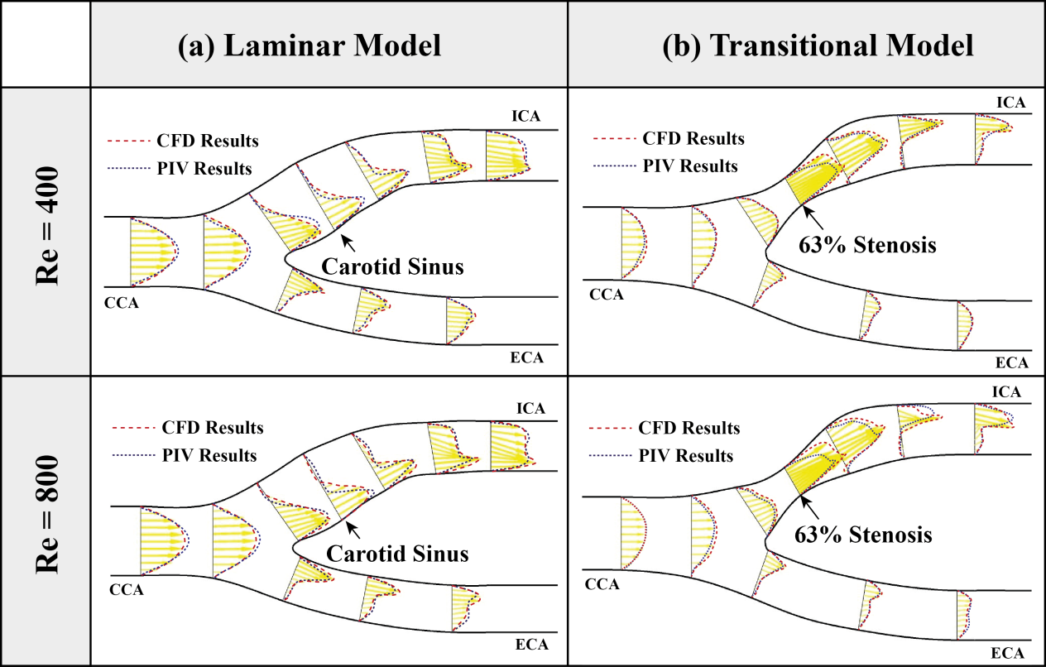

Figure 6. Comparison between numerical and referred PIV experimental results at different Reynolds numbers: (a) healthy artery bifurcation using laminar model (b) stenotic artery bifurcation using transitional model.

In conclusion, the predicted stream-wise flow patterns are in satisfactory agreement with the measured data. Compared with the PIV data, flow separation and recirculation regions due to the abrupt cross-sectional area expansion at the ICA sinus region of the healthy model were successfully predicted by the numerical simulation based on a laminar model (Figure 6. 4a, b). For the diseased model (Figure 6. 4c, d), the velocities predicted at the stenotic site were over-predicted for both Reynolds number conditions, but for the other regions of this model, good agreement with the experimental data was found. Nonetheless, this order of error is comparable to published works, which has reported maximum relative errors between numerical and experimental results of 40% (Bertolotti et al., 2001) and 55% (Zhang et al., 2008), respectively. The better prediction performance in this paper may be due to the steady flow condition and the use of a transitional turbulence model. The diseased model was also simulated using a laminar model which produced slightly worse comparisons with the experimental data. Therefore, the basic numerical configurations used in this paper are capable of providing more accurate information of the intravascular flow field for both healthy and stenotic carotid bifurcation models.

# CHAPTER 7

# A CFD Model for Representing Downstream Peripheral Vascular Impedance

The study of cardiovascular models were presented in this chapter based on medical image reconstruction and computational fluid dynamics. Our aim is to provide a reality platform for the purpose of flow analysis and virtual intervention outcome predication for vascular diseases. By connecting two porous mediums with transient permeability at the downstream of the carotid bifurcation branches, a downstream peripheral impedance model was developed, and the effect of the downstream vascular bed impedance can be taken into consideration. After verifying its accuracy with a healthy carotid bifurcation, this model was implemented in a diseased carotid bifurcation haemodynamics. Based on time-averaged wall shear stress, oscillatory shear index, and the relative residence time, fractions of abnormal luminal surface were highlighted, and the atherosclerosis was assessed from a hemodynamic point of view. The effect of the atherosclerosis on the transient flow division between the two branches due to the existence of plaque was also analysed. This work demonstrated that the proposed downstream peripheral vascular impedance model can be used for computational modelling when the outlets boundary conditions are not available, and successfully presented the potential of using medical imaging and numerical simulation to provide existing clinical prerequisites for diagnosis and therapeutic treatment.

## 7. Introduction

As the superficial carotid bifurcation is an ideal target for non-invasive imaging via ultrasound (US), magnetic resonance imaging (MRI) or computed tomographic (CT) imaging, intensive research interest has been performed during the past decades, and numerous of image-based haemodynamics studies of carotid bifurcation have been conducted from experimental and numerical modelling aspects. Groen et al. demonstrated that the plaque ulceration is related to the existence of high wall shear stress (WSS) at the upstream region of the plaque (Groen et al., 2007). On the contrary, a serial MRI-based study based on 21 carotid artery plaques proved that the regions where exposed to low WSS and low wall stresses are most prone to develop atherosclerotic plaques (Tang et al., 2008). Some researchers also put efforts to investigate local risk factors such as time-averaged wall shear stress (TAWSS) and oscillatory shear index (OSI) in atherosclerosis (Lee et al., 2008). The sensitivity of these physiologically relevant parameters to the arterial inlet and outlet boundary conditions were also investigated by image-based haemodynamics studies (Moyle et al., 2006, Morbiducci et al., 2010) respectively. Although large quantitative uncertainties may exist among these works, qualitative blood flow patterns are remarkably robust as highlighted by Lee et al. (Lee et al., 2008).

For image-based haemodynamics studies, the carotid artery domain of interest is always truncated and taken out of the context of the entire circulatory system. As such, the application of the inlet and outlet boundary conditions will affect the numerical accuracy of the local risk factors such as TAWSS and OSI dramatically. Therefore, the imposition of individual inflow and outflow flow rates based on US or MRI measurements may be preferred (Maurits et al., 2007, Vignon-Clementel et al., 2010, Groen et al., 2010). However, for some applications, the outlet flow and pressure waveforms are not known. For example, when we try to predict the outcomes of interventions, the outlet boundary conditions are inaccessible, and the need for more accurate boundary conditions turns out to be acute.

The simplest method to define the outflow conditions of the carotid bifurcation is by implementing a fixed flow division ratio between the internal carotid artery (ICA) and the external carotid artery (ECA), which was applied in some researches (Zhao et al., 1999, Steinman et al., 2000, Tan et al., 2008), while the transient flow division effect is neglected. Other researchers also put efforts into multi-scale modelling development by coupling the three dimensional numerical domain with a reduced order model to achieve a more realistic inlet and outlet flow environment (Lagana et al., 2002, Lagana et al., 2005, Migliavacca et al., 2006, Vignon-Clementel et al., 2006, Balossino et al., 2009, Morbiducci et al., 2010), but this approach requires more computational resources, and is less robust as compared to the sole three dimensional numerical simulation.

As the carotid artery tree is essentially a series of branching vessels where the daughter vessel diameters are significantly smaller than the parent. When the vessel diameter becomes smaller, the flow resistance turns to be much larger until the arterioles embed themselves at the cellular level and enmesh with the venous system. From a numerical modelling viewpoint, it is clearly not strategically feasible to model the flow through continual branching down to the arterioles due to excessive three dimensional artery reconstruction works and high computational expense. Since the peripheral vascular bed can be viewed as being a random distribution of interstitial pores on a macro scale, the statistical distribution of arterial diameters across the peripheral system can be associated with the porosity of the porous bed and the ease with which blood flows for a constant pressure difference from the systemic to the venous system can be associated with the permeability of the porous bed.

The main purpose of this chapter is to develop a computational haemodynamics model that incorporates the downstream peripheral impedance effect with three-dimensional carotid bifurcation analysis. This model can be applied when the outlet flow conditions are not available. The proposed modelling accuracy was verified by numerical simulation based on a healthy carotid bifurcation case study. Then, the haemodynamics differences between the proposed and the fixed flow division ratio models were addressed based on an atherosclerotic carotid bifurcation. Finally, the influence of atherosclerosis on the intravascular blood flow can be accessed and evaluated based on the extracted local risk indicators. This research can be used for accessing the physiological flow nature of the diseased carotid bifurcation, and providing interventional procedures outcome prediction, such as the preliminary evaluation of artery stenting or bypass, which can be helpful for the surgical success.

## 7. Methods

### 7.2. Three-dimensional artery reconstruction

High resolution magnetic resonance imaging (MRI) of carotid bifurcations was performed on patients using a 1.5 T General Electric scanner. All human experiments were approved by the Monash Medical Center and an Institutional Review Board. For each carotid artery, a total of 112 contiguous slices were generated with a voxel size of 0.63 mm × 0.73 mm × 0.63 mm. After the MRI scanning, the inner wall contours of the carotid artery were extracted by an automated detection algorithm using a two-dimensional watershed transform form markers that were applied to each slice (Grau et al., 2004, Yan et al., 2006). An issue with this process is the leakage of pixels, which occurs because the wall of the vessel that separates the surrounding tissues is relatively thin. At some locations, the noise in the image causes the segmentation algorithm to grow through the wall. As a result, potentially large regions may be falsely identified as vessels. In such a circumstance, a certain level of manual operation may be required to rectify the issue. Then, the lumen contours were imported into a computer-aided design program named ANSYS ICEM CFD, and “lofted” together to construct into a continuous surface representation of the lumen and the data was stored in a stereolithography (STL) file format.

In this chapter, two arteries were reconstructed, a healthy and an atherosclerotic carotid bifurcations (Figure 7. 1). In order to eliminate the local fluid dynamic effects due to the variation of the afferent and efferent vessels, extra extension with uniform diameter were added on the reconstructed arteries.

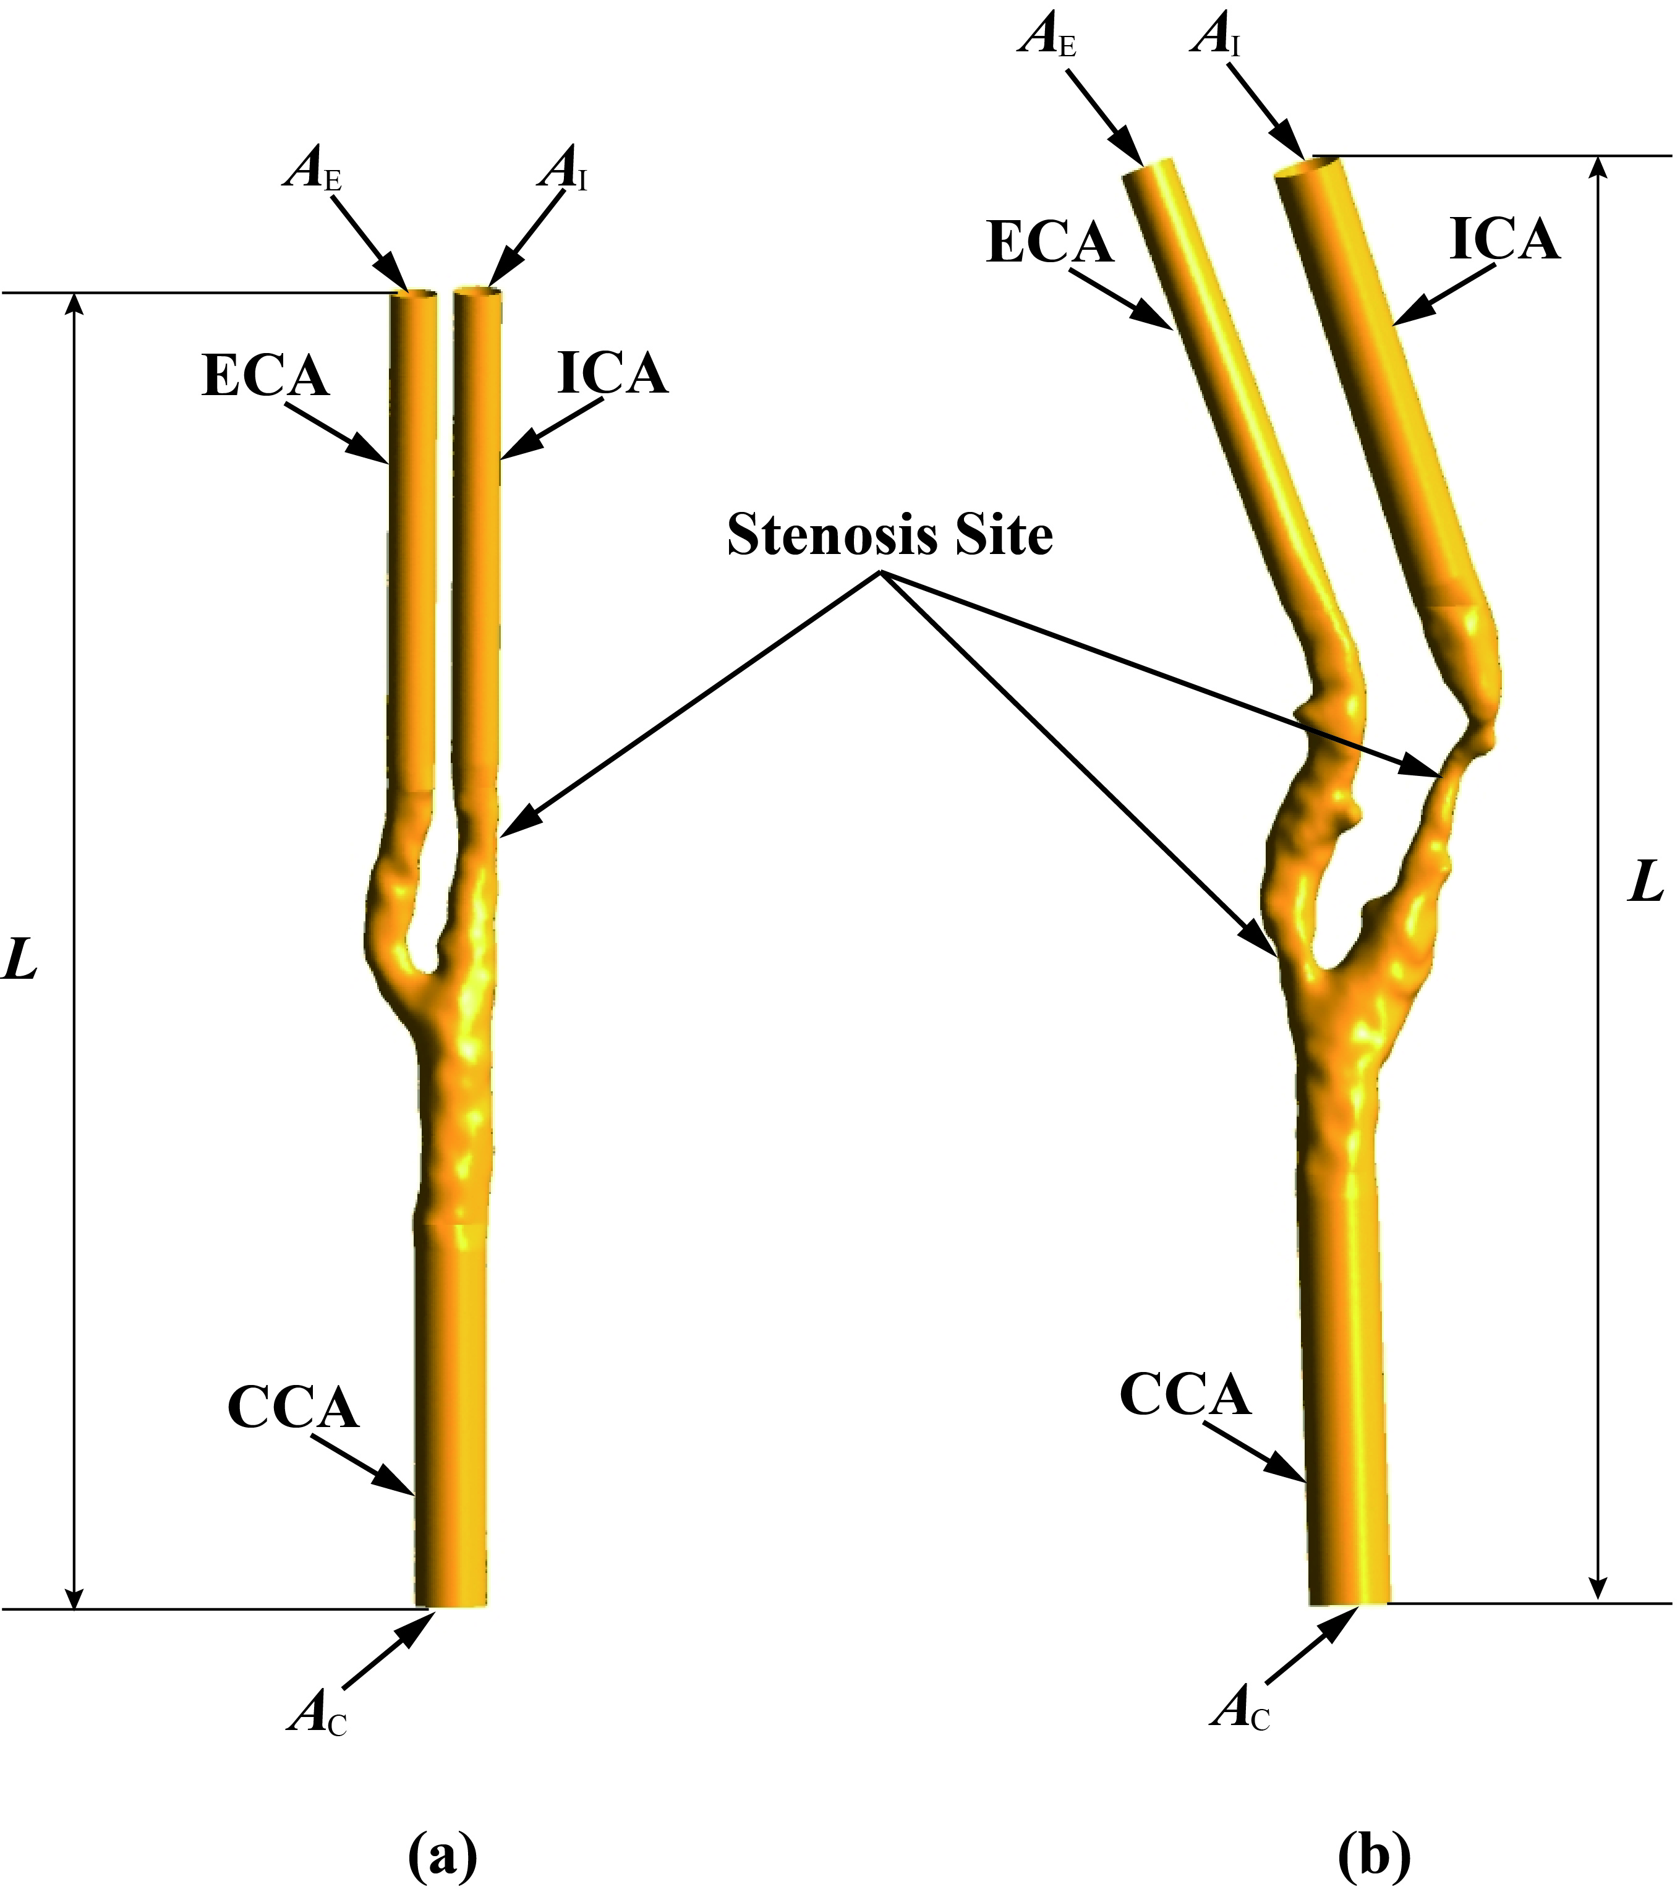

Figure 7. Three-dimensional reconstruction of carotid bifurcations: (a) the healthy model, (b) the atherosclerotic model.

Some basic geometrical parameters of the two carotid bifurcations are shown in Table 7. 1. It should be noted that the stenotic severity is calculated based on the luminal area reduction at the throat of the artery where plaque exists in comparison with its distal cross-sectional area (Tan et al., 2008).

Table 7. 1 Geometrical parameters of the investigated carotid bifurcations.

|  |  |  |
| --- | --- | --- |
|  | Healthy Carotid Bifurcation | Atherosclerotic Carotid Bifurcation |
| Total length ***L*** (mm) | 110 | 122 |
| Diameter of the CCA inlet ***A***C (mm) | 6 | 6.6 |
| Diameter of the ECA outlet ***A***E (mm) | 4 | 4.6 |
| Diameter of the ICA outlet ***A***I (mm) | 4 | 5.6 |
| ECA stenosis severity | 0% | 73% |
| ICA stenosis severity | 23% | 88% |

### 7.2. Non-Newtonian model

As was well known, the shear thinning and viscoelasticity of blood (Chien et al., 1970) are closely relevant to its microscopic structures, such as aggregation, deformation and alignment of the red blood cells, where the red blood cells mainly determine the rheological behaviour of blood. However, Gijsen et al. (Gijsen et al., 1999) also demonstrated that the shear thinning behaviour dominates the non-Newtonian property of the blood flow and viscoelasticity can be ignored for the prediction of velocity.

In this chapter, the shear thinning behaviour is modelled by the Carreau-Yasuda model (Bird et al., 1987), and the relationship between blood viscosity η and shear rate γ is written as shown by the following equation:

 (Eq. 7. 1)

where *η*∞ is the viscosity for an infinite shear rate, and *η*0 is the plasma viscosity at zero shear rate. *λ*, *n*, and *a* are fitting parameters, which are borrowed from the experimental data based on a well-tested blood-mimicking fluid (Gijsen et al., 1999). These parameters have the following values:

*η*∞ = 2.2×10-3 Pa s, *η*0 = 22×10-3 Pa s, *λ* = 0.11 s, *n* = 0.392, *a* = 0.644, and *ρ* = 1410 kg m-3.

### 7.2. Downstream peripheral impedance model

In this chapter, two porous beds with different permeability configuration were connected with the ICA and ECA branches each. Darcy's Law (Whitaker, 1986) is used to establish the correlation between the pressure difference across the porous bed Δ*P* , the volume flow rate *Q*, and the permeability *k* by the following equation:

 (Eq. 7. 2)

where *L*P is the length of the porous medium, *A* is the cross-sectional area to the blood flow, and *η* is the blood flow viscosity. In order to maintain numerical stability, *L*P was chosen to be 10 times the diameter of the efferent vessel. The value of the pressure difference Δ*P* can be referred from Pries et al.’s work (Pries et al., 1995), which indicates the pressure drop between the large arteries and capillaries is around 60 mmHg. The geometric details of the proposed porous medium are provided in Table 7. 2.

Table 7. 2 Geometrical parameters of the introduced porous mediums.

|  |  |  |  |  |
| --- | --- | --- | --- | --- |
|  | | Diameter (mm) | Cross-sectional area (mm2) | Length (mm) |
| Healthy Carotid Bifurcation | ECA Porous Medium | 4 | 12.6 | 40 |
| ICA porous Medium | 4 | 12.6 | 40 |
| Atherosclerotic Carotid Bifurcation | ECA Porous Medium | 4.6 | 16.6 | 46 |
| ICA porous Medium | 5.6 | 24.6 | 56 |

In order to implement the numerical simulation based on a physiological reasonably condition, the volume flow waveforms obtained from phase-contrast MRI velocity measurements at the outlet of both ICA and ECA, as well as the pulse pressure waveform at the inlet of the common carotid artery (CCA), were applied in this study (Cebral et al., 2002) (Figure 7. 2). Here, one cardiac cycle duration time T was set as 1 s.

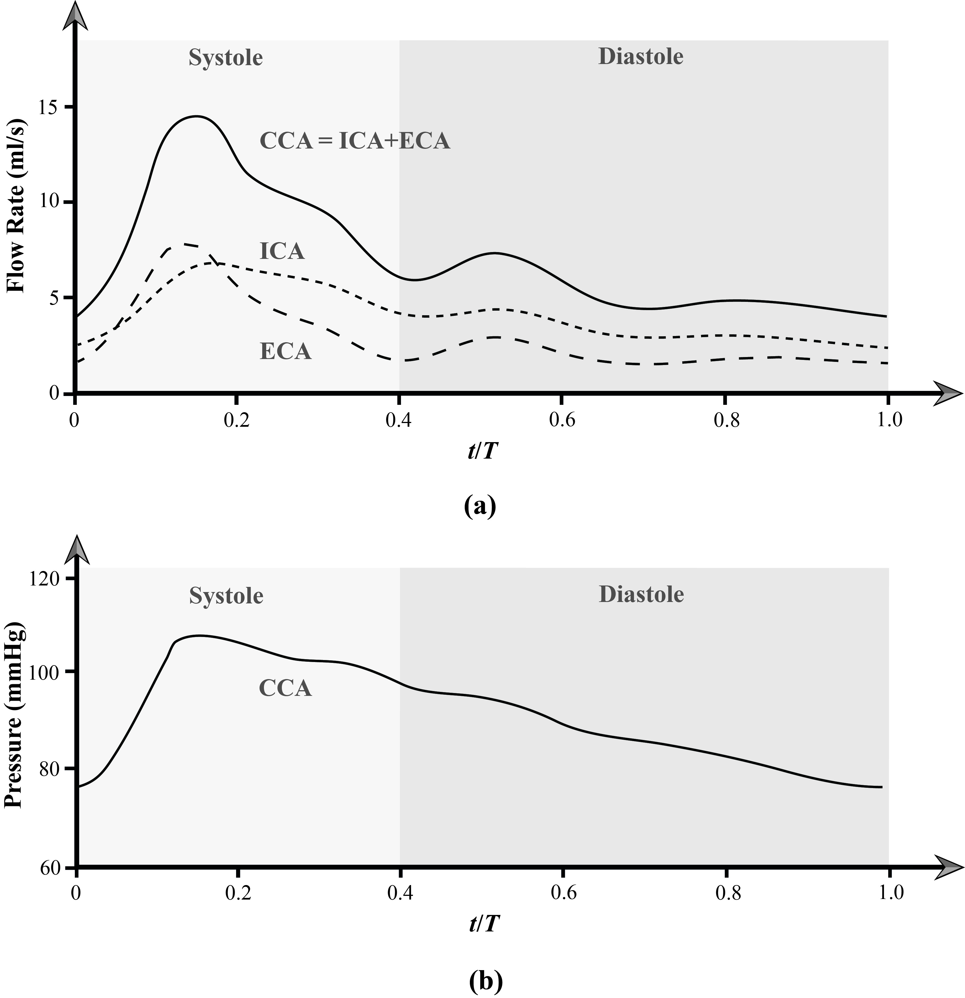

Figure 7. Pulsatile waveforms of healthy carotid bifurcation: (a) volume flow rate profiles at the outlet of both ICA and ECA, (b) pressure waveform at the inlet of CCA.

Based on Eq. 7.2, the permeability variation of the porous medium (*kA*/*ηL*p) can reflect the downstream vascular impedance *R* = -Δ*P*/*Q*. Therefore, the calculated ICA and ECA downstream porous domain permeability configuration can be used for other carotid bifurcation models to approximate the vascular bed impedance, and a standard peripheral flow environment can be established for computational haemodynamics of carotid bifurcations. A detail domains arrangement of the DPVI modelling for the computational haemodynamics of carotid bifurcations is illustrated in Figure 7. 3.

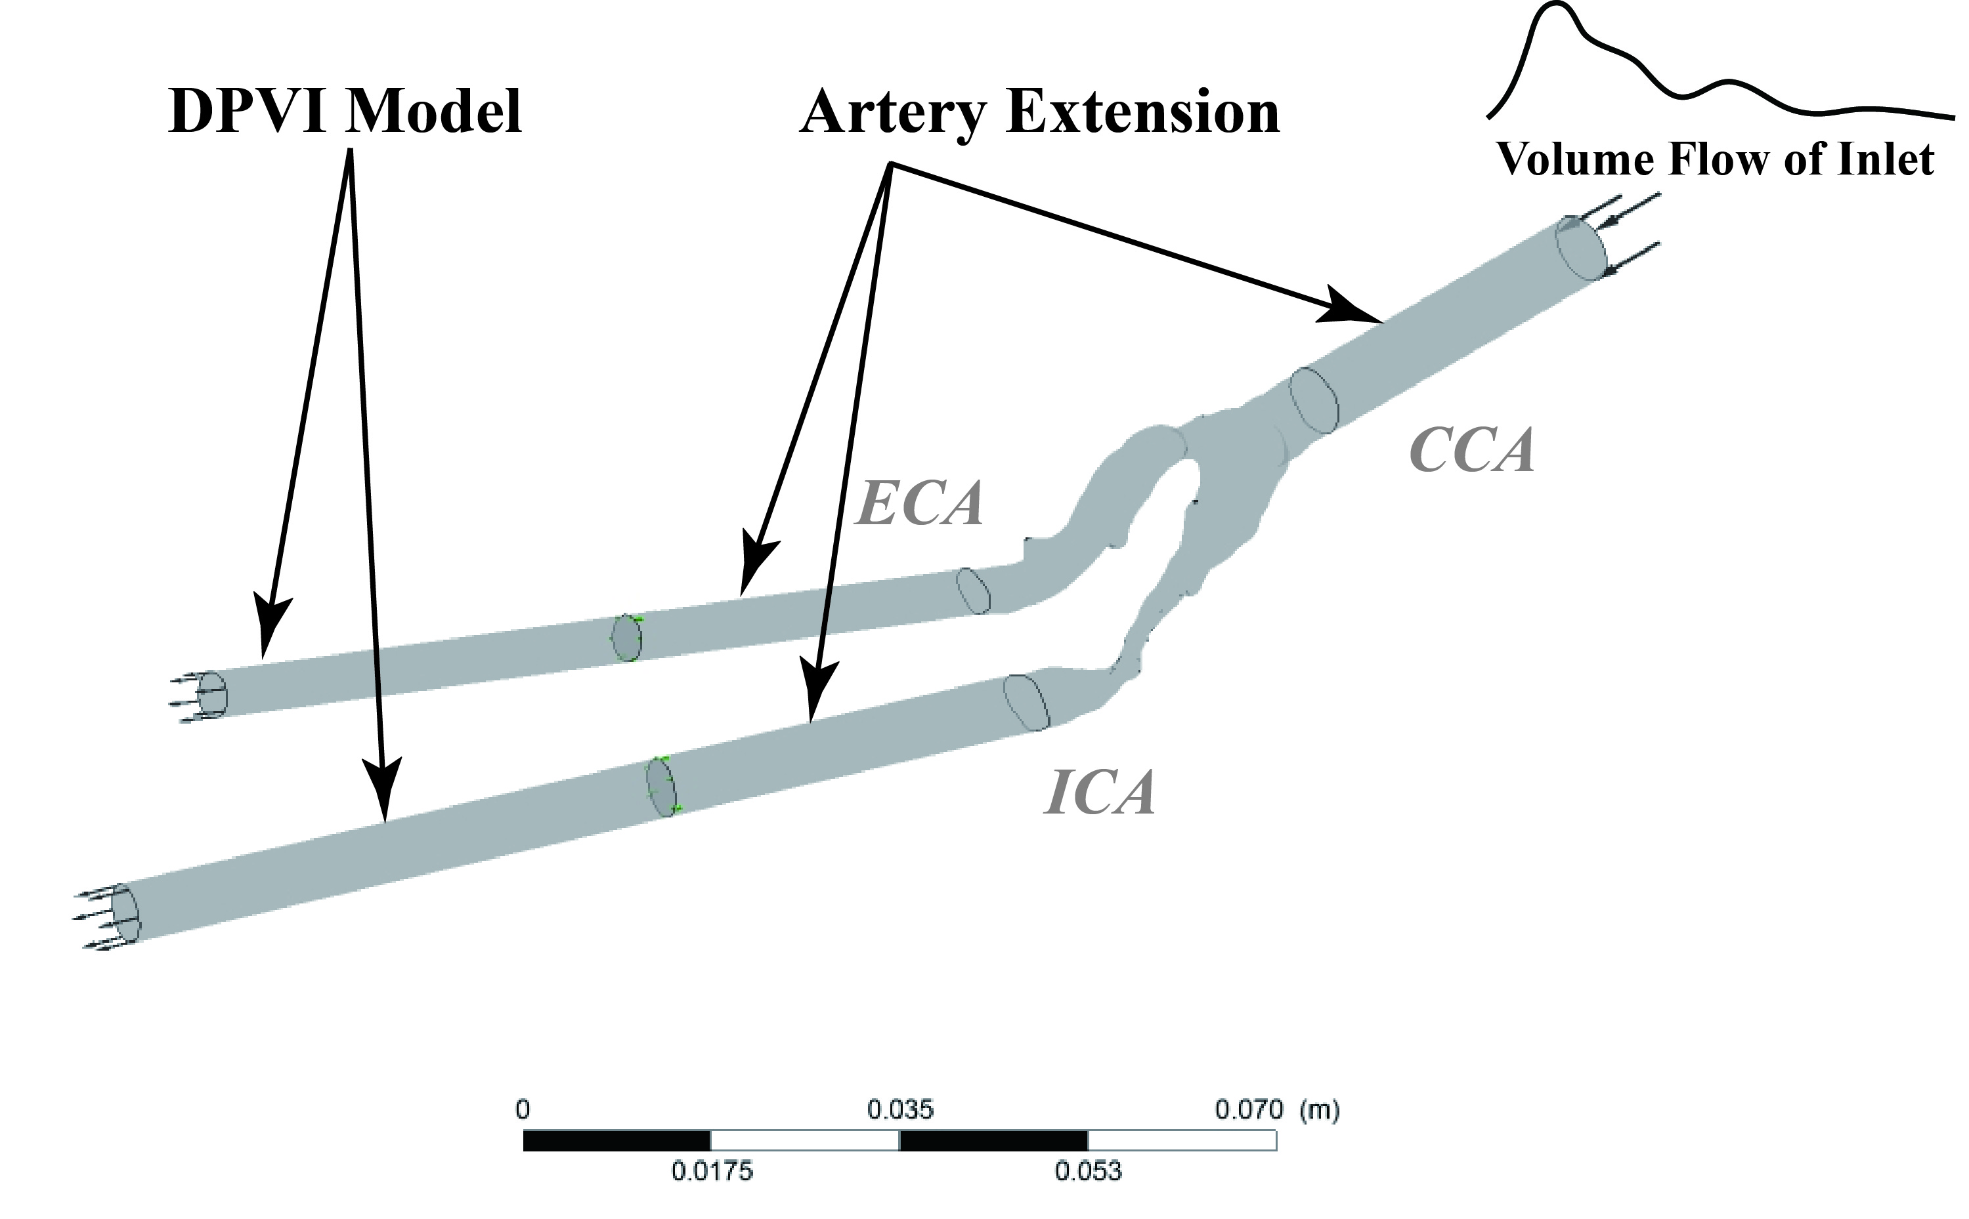

Figure 7. 3 Domains configuration for the computational haemodynamics of carotid bifurcation model.

### 7.2. Numerical model setup

After finishing the porous medium design, the porous domain connected carotid bifurcation geometries were meshed into tetrahedral elements and imported into the widely adopted CFD package—ANSYS CFX (ANSYS, NH, USA). In general, flow governing equations which are based on mass, momentum and energy conservation, are spatially discretized using a finite volume method and solved numerically via iterative procedures. In this study, 3D unsteady incompressible Navier-Stokes equations were solved by a second order implicit backward Euler method, and the solution was by the SIMPLE algorithm.

When choosing the turbulence models, the standard *k*–*ε* turbulence model was not suitable for the present study, since it was developed for fully developed turbulent flow regions at high Reynolds numbers. Therefore, the Wilcox low-Re *k*–*ω* turbulence model was chosen for all the simulations since that this model can be used directly to predict low-Re effects on the turbulence field at near-wall regions. In addition, it has also been demonstrated with advanced accuracy in describing the transitional flow effect from laminar to turbulent flow (Wilcox, 1994).

Vessel walls were assumed to be rigid for all models (Hoi et al., 2010), the convergence criterion for the relative residual of all dependent variables was set to 1×10−4 to ensure the convergence of each time step. For the calculation, two full cardiac cycles were required to damp the initial transient errors. Therefore, the last cycle of the three full cardiac cycle calculations was used for data analysis (Ghalichi and Deng, 2003). Studies of grid independence based on scales of 0.8 mm, 0.6 mm, 0.4 mm, and 0.2 mm and time-step size dependence based on time-steps of 0.01s, 0.008 s, 0.005 s, and 0.002 s were performed based on the healthy carotid bifurcation model using the prescribed inlet and outlets boundary conditions. The investigation results are shown in Table 7. 3. Accounting for the computational expenses, the most efficient grid scale *L*G and time-step size *t* settings are *L*G = 0.4 mm, *t* = 0.005 s.

Table 7. 3 Mesh scale independence study.

|  |  |  |  |
| --- | --- | --- | --- |
| Grid refinement | 0.8 mm | 0.4 mm | 0.2 mm |
| Peak TAWSS at the apex of the bifurcation (Pa) | 11.45 | 13.81 | 14.46 |
| CPU Time Cost (hr) | 5 | 18 | 96 |

### 7.2. Results visualization

Three commonly adopted flow indicators to evaluate the total shear stress exerted on the wall throughout a cardiac cycle are the TAWSS, the OSI, and the relative residence time (RRT), which can be obtained from the following equations:

 (Eq. 7. 3)

 (Eq. 7. 4)

 (Eq. 7. 5)

where *T* is a cardiac cycle period and *τ*w is the instantaneous wall shear stress. Low TAWSS values (lower than 0.4 Pa) (Malek et al., 1999), high OSI (higher than 0.5) (He and Ku, 1996, Taylor et al., 1998b) and high RRT (higher than 10 m2/N) (Lee et al., 2009, Morbiducci et al., 2010) are known to promote an atherogenic endothelial phenotype, while abnormally high TAWSS (higher than 40 Pa) values can cause direct endothelial injury and increase the risk of getting thrombosis (Malek et al., 1999).

## 7. Results and Discussion

### 7.3. Model verification

The computational haemodynamics results of the healthy carotid bifurcation with the proposed DPVI model were processed (Figure 7. 4) and validated with results that were calculated from the prescribed boundary conditions (Figure 7. 5). Both these two figures present almost the same simulation results, which can roughly confirm the accuracy of the DPVI model.

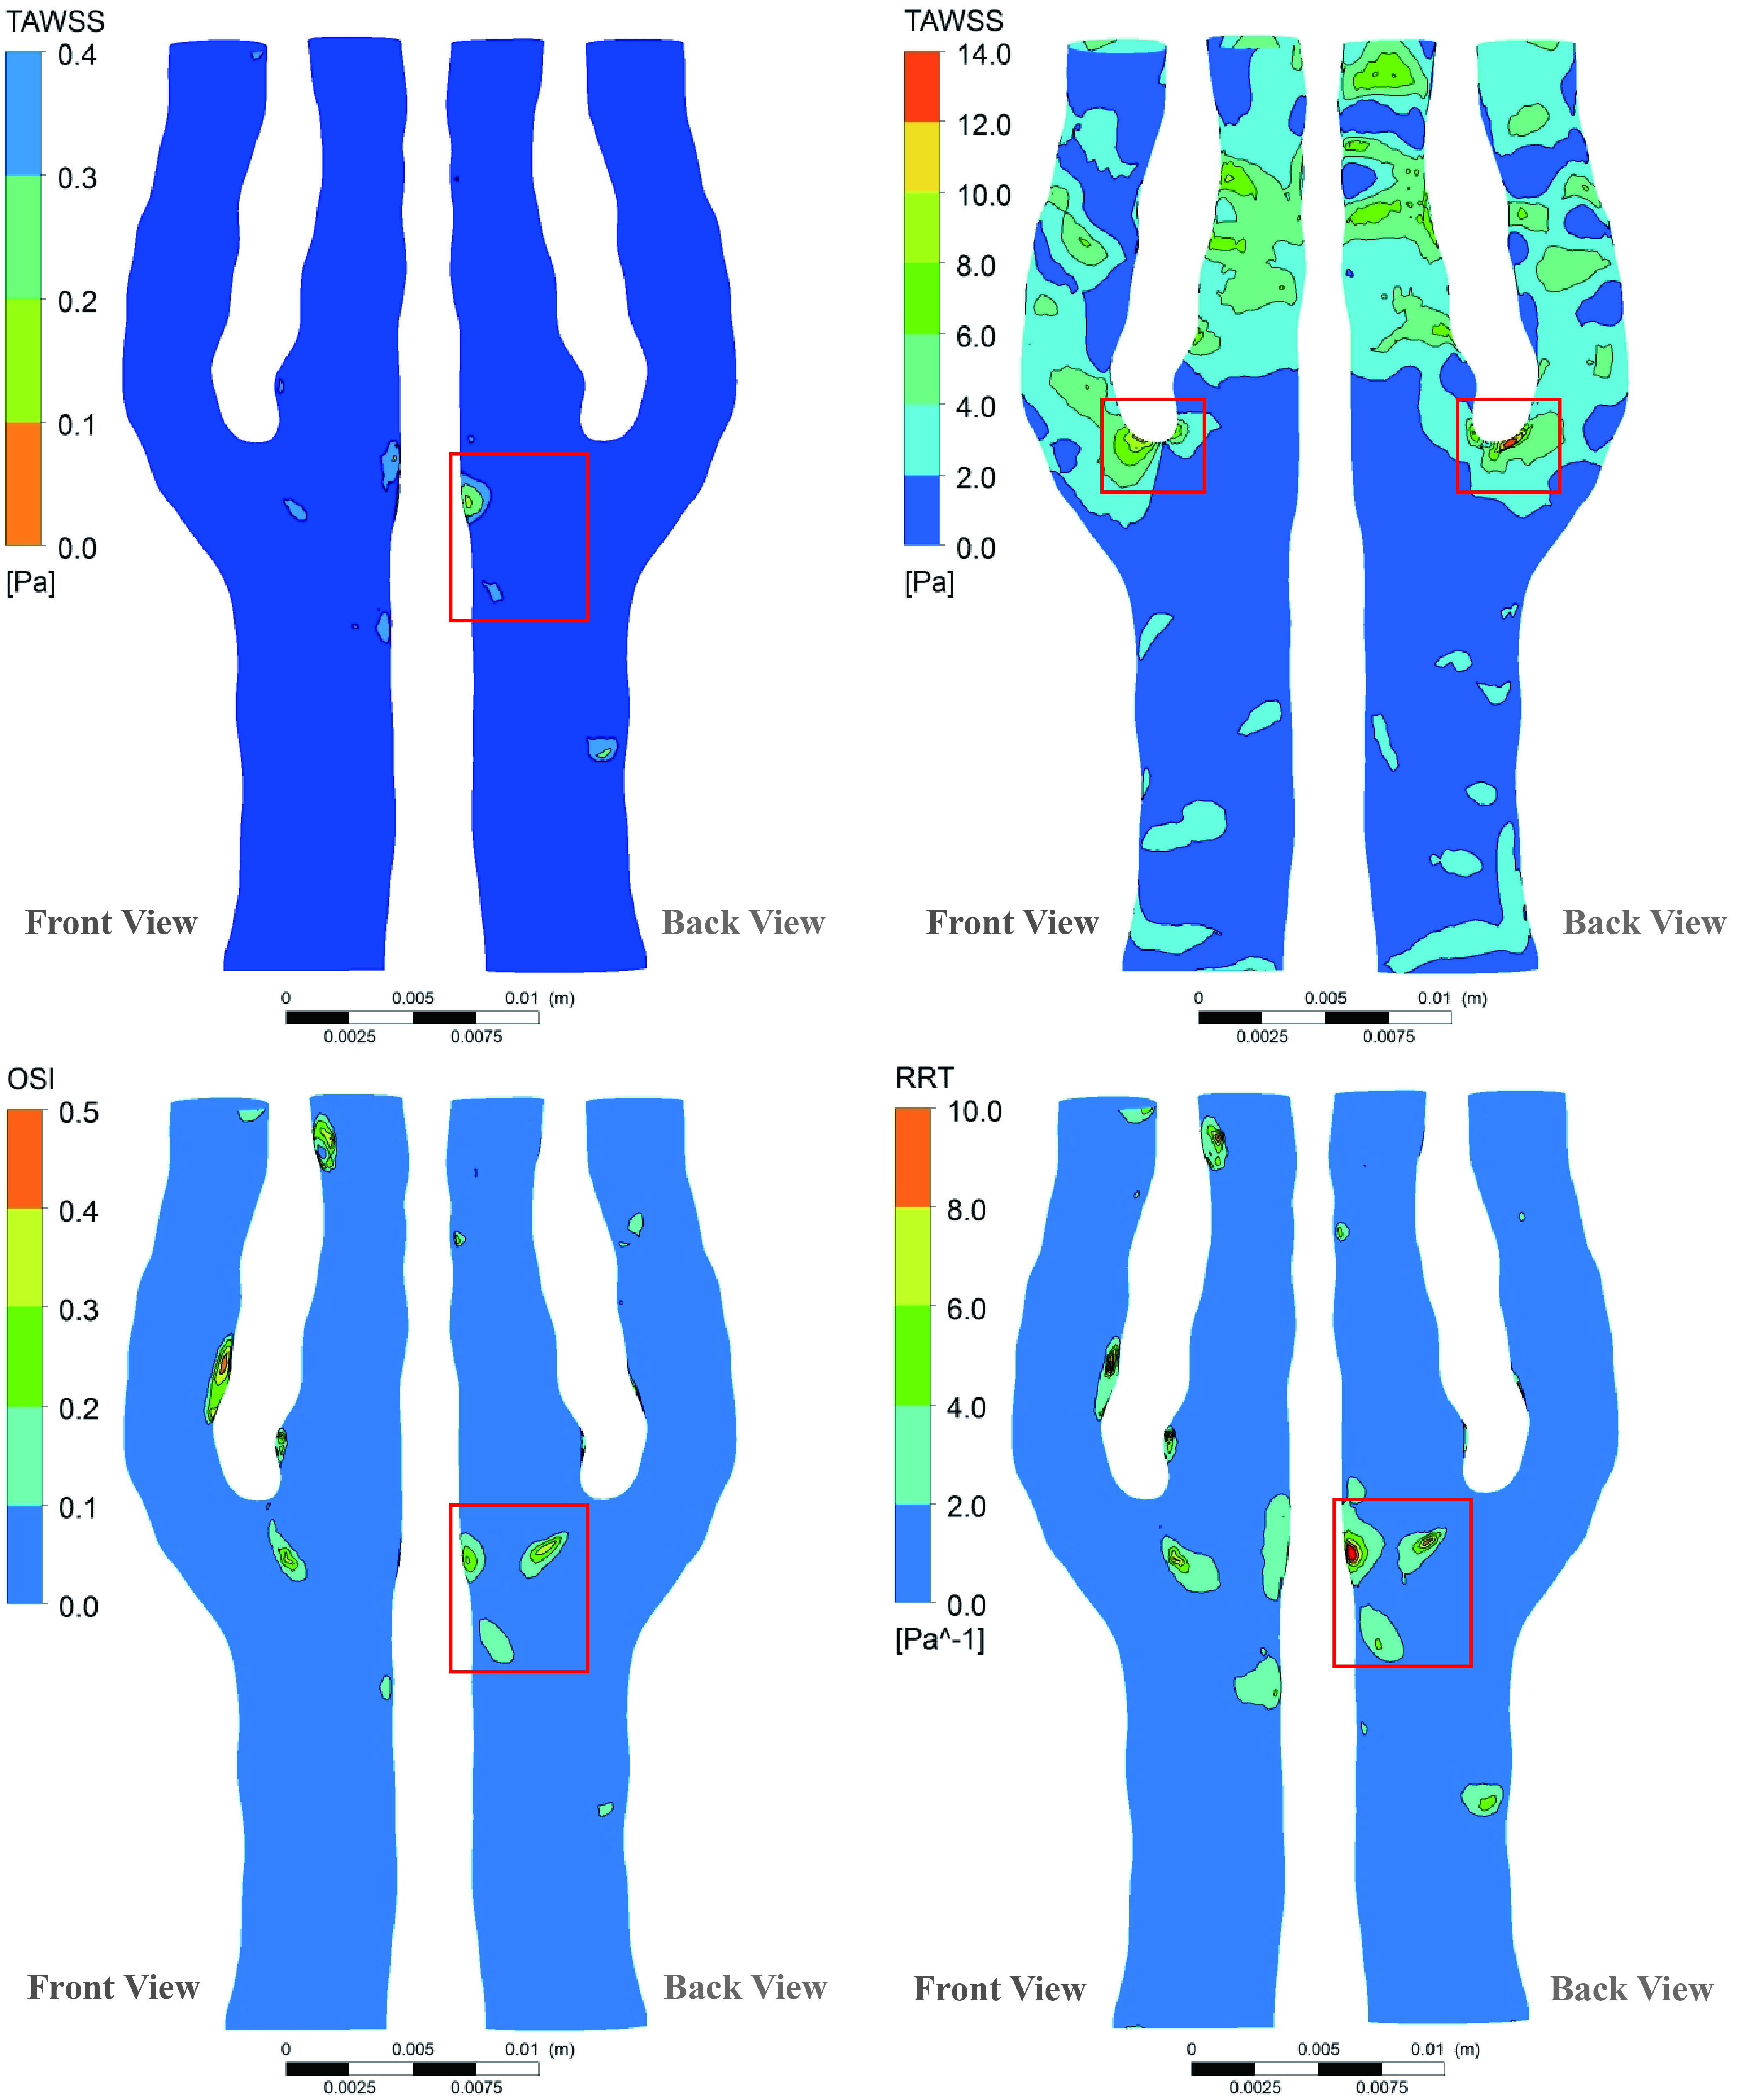

Figure 7. 4 Numerical results of the healthy carotid bifurcation haemodynamics with downstream peripheral impedance model.

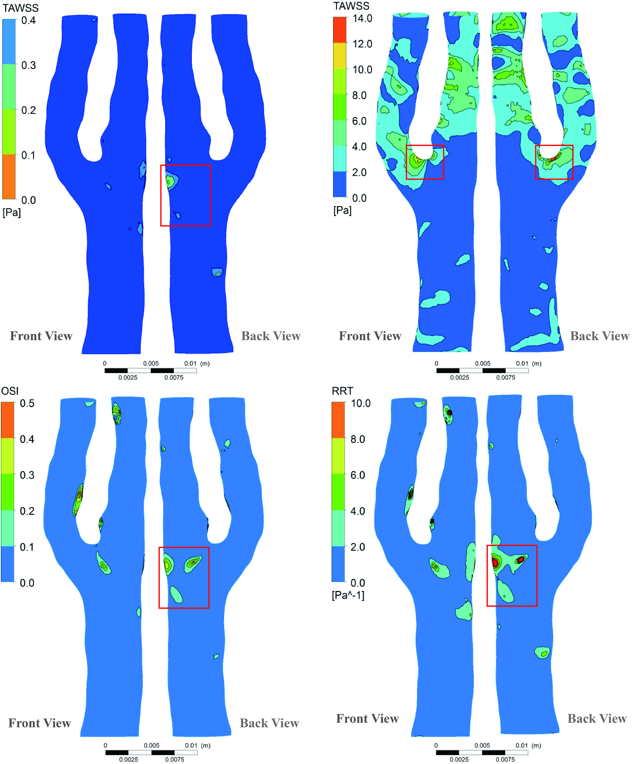

Figure 7. Numerical results of the healthy carotid bifurcation haemodynamics with prescribed boundary conditions.

Furthermore, a TAWSS comparison (Figure 7. 6) was also conducted to address the existing value difference. It shows that the peak value of TAWSS magnitude absolute difference (0.5 Pa) is located at the apex of the bifurcation, which only accounts for 3.6% of the maximum TAWSS value (14 Pa) at the same location. This order of percentage difference validates the model accuracy. Therefore, the DPVI model can well represent the prescribed outlets conditions and can be used for computational haemodynamics modelling.

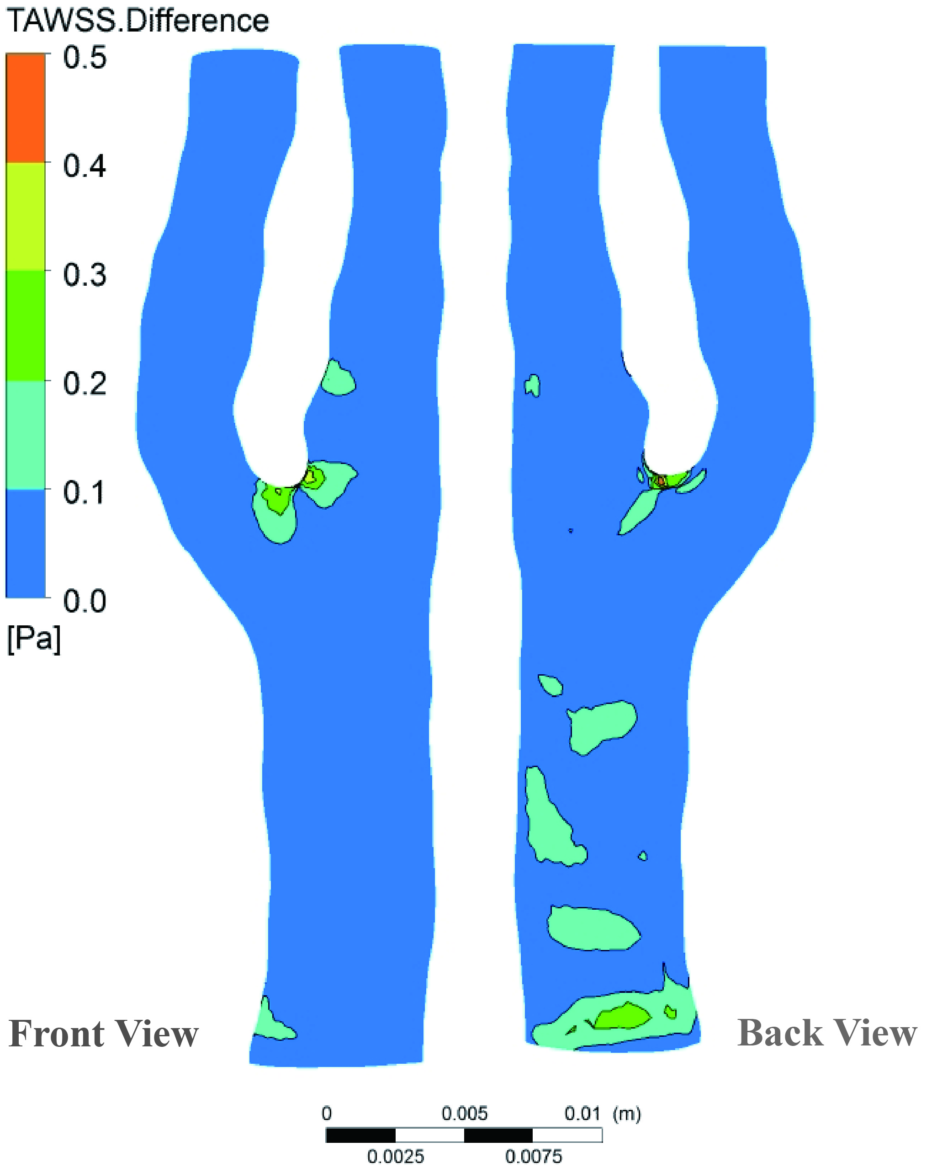

Figure 7. Absolute TAWSS difference of the healthy carotid bifurcation simulations with prescribed boundary conditions and downstream peripheral impedance model.

According to the thresholds of the local flow indicators, the outer-wall of the ICA origin at the bifurcation territory of the healthy carotid bifurcation, as indicated by red boxes both in Figure 7. 4 and Figure 7. 5, is experiencing low TAWSS, high OSI and long RRT at the same time. Therefore, it is a vulnerable site for developing atherosclerosis in long term. The apex of the divider-wall of the bifurcation experiences the maximum TAWSS (14 Pa) as compared to the remaining portion of the healthy carotid bifurcation. Because this peak TAWSS value is much lower than the threshold of 40 Pa, this site is still risk-free of getting direct endothelial injury from the blood flow.

### 7.3. Analysis of the effect of downstream peripheral impedance

In order to investigate the effect of the DPVI on the intravascular flow pattern for the diseased carotid bifurcation, two numerical simulations were performed. One case was imposed with healthy transient inlet and outlet flow profiles, while the other one was based on the validated DPVI model under the same inlet volume flow rate. The simulation results differences between the diseased carotid bifurcation with the DPVI model and that with the healthy transient flow conditions was analysed. The effect of the time-varying DPVI on the transient outflow division was also examined by comparing with the healthy flow division profile.

Figure 7. 7 illustrates the distribution of the three WSS-based metrics under a constant outlets flow split ratio (50%:50%). Apparent flow disturbances are captured by the low TAWSS, high oscillatory shear, and long resident time region at the carotid bulb and the outer-wall of the ICA origin as marked by two red boxes. Besides, high TAWSS region with the peak value of 58.5 Pa (larger than the threshold of 40 Pa) is also found at the throat of the ICA stenosis territory, which indicates that the plaque cap is suffering a continues high shear and being vulnerable to be taken off, which increases the risk of getting stroke.

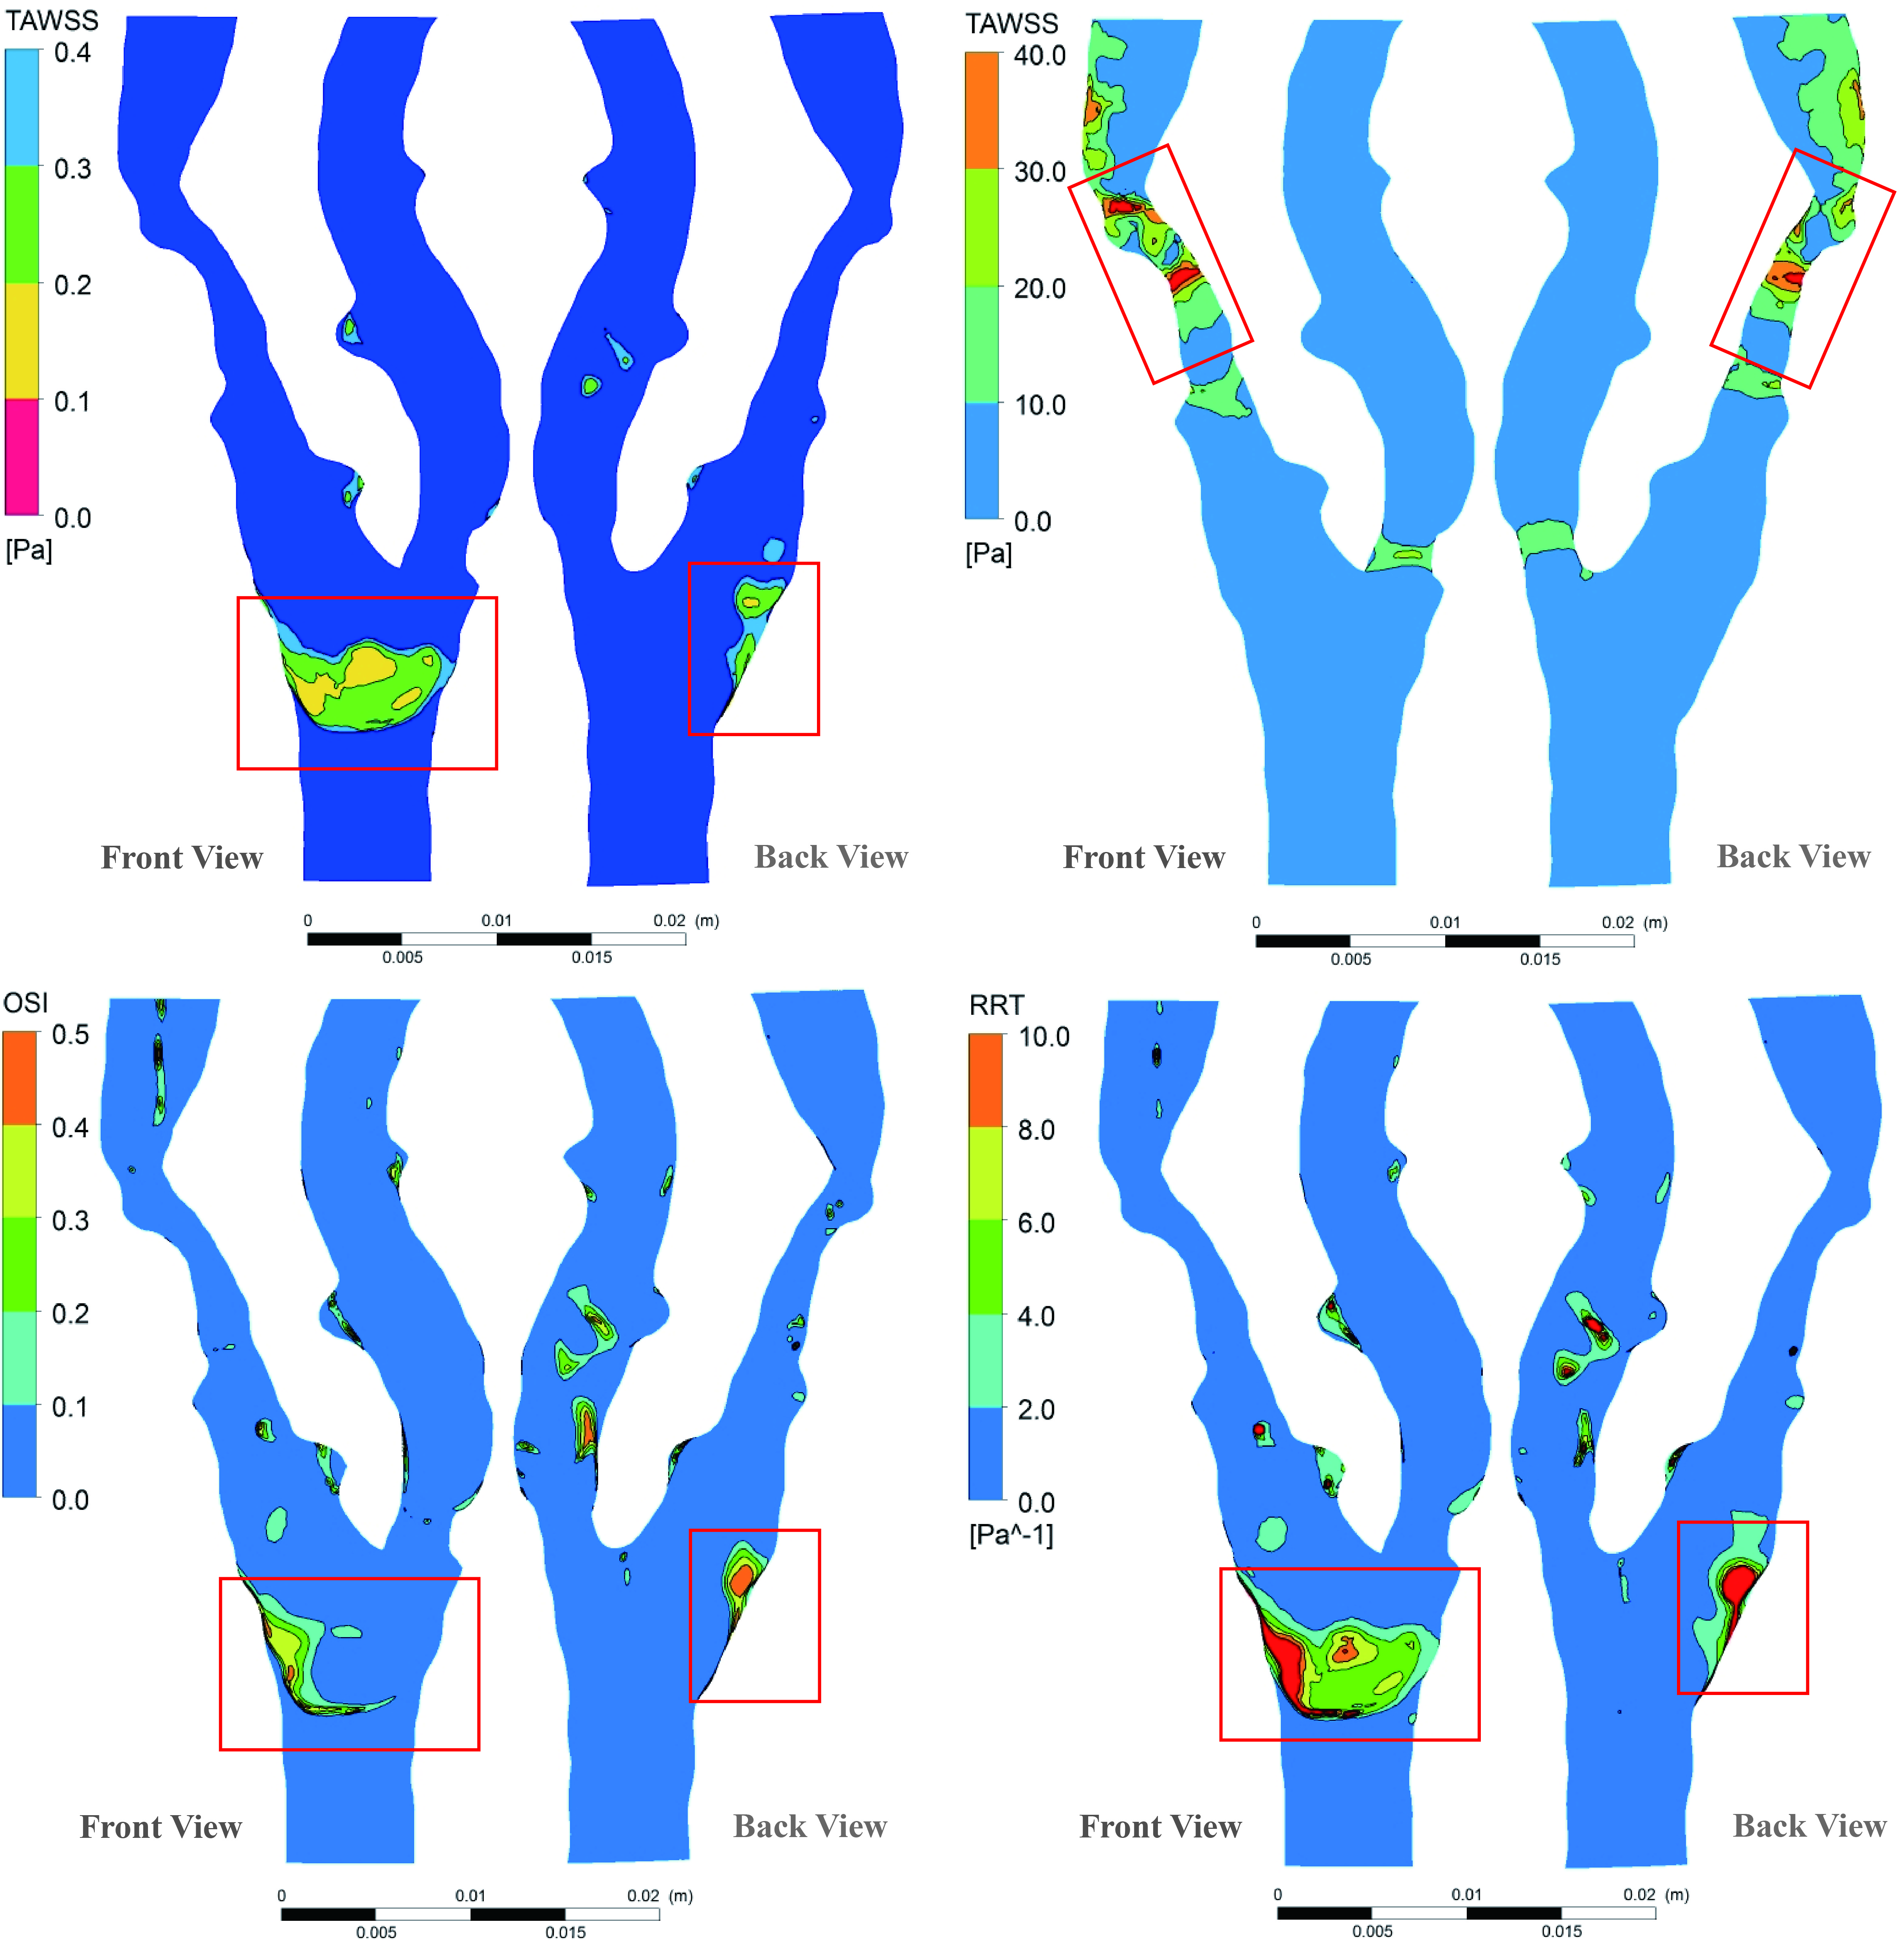

Figure 7. 7 Numerical results of the atherosclerotic carotid bifurcation hemodynamics with constant flow division.

Figure 7. 8 provides the same type of information based on the proposed DPVI model. The prediction of atherosclerosis susceptible locations is almost the same as the one that illustrated by Figure 7. 7 except for the ICA origin, where even the TAWSS value is lower than 0.4 Pa, and the relative resident time is larger than 10 m2/N, the oscillatory shear index is not high enough (<0.4). Therefore, the outer-wall of the ICA origin here is still non-susceptible.

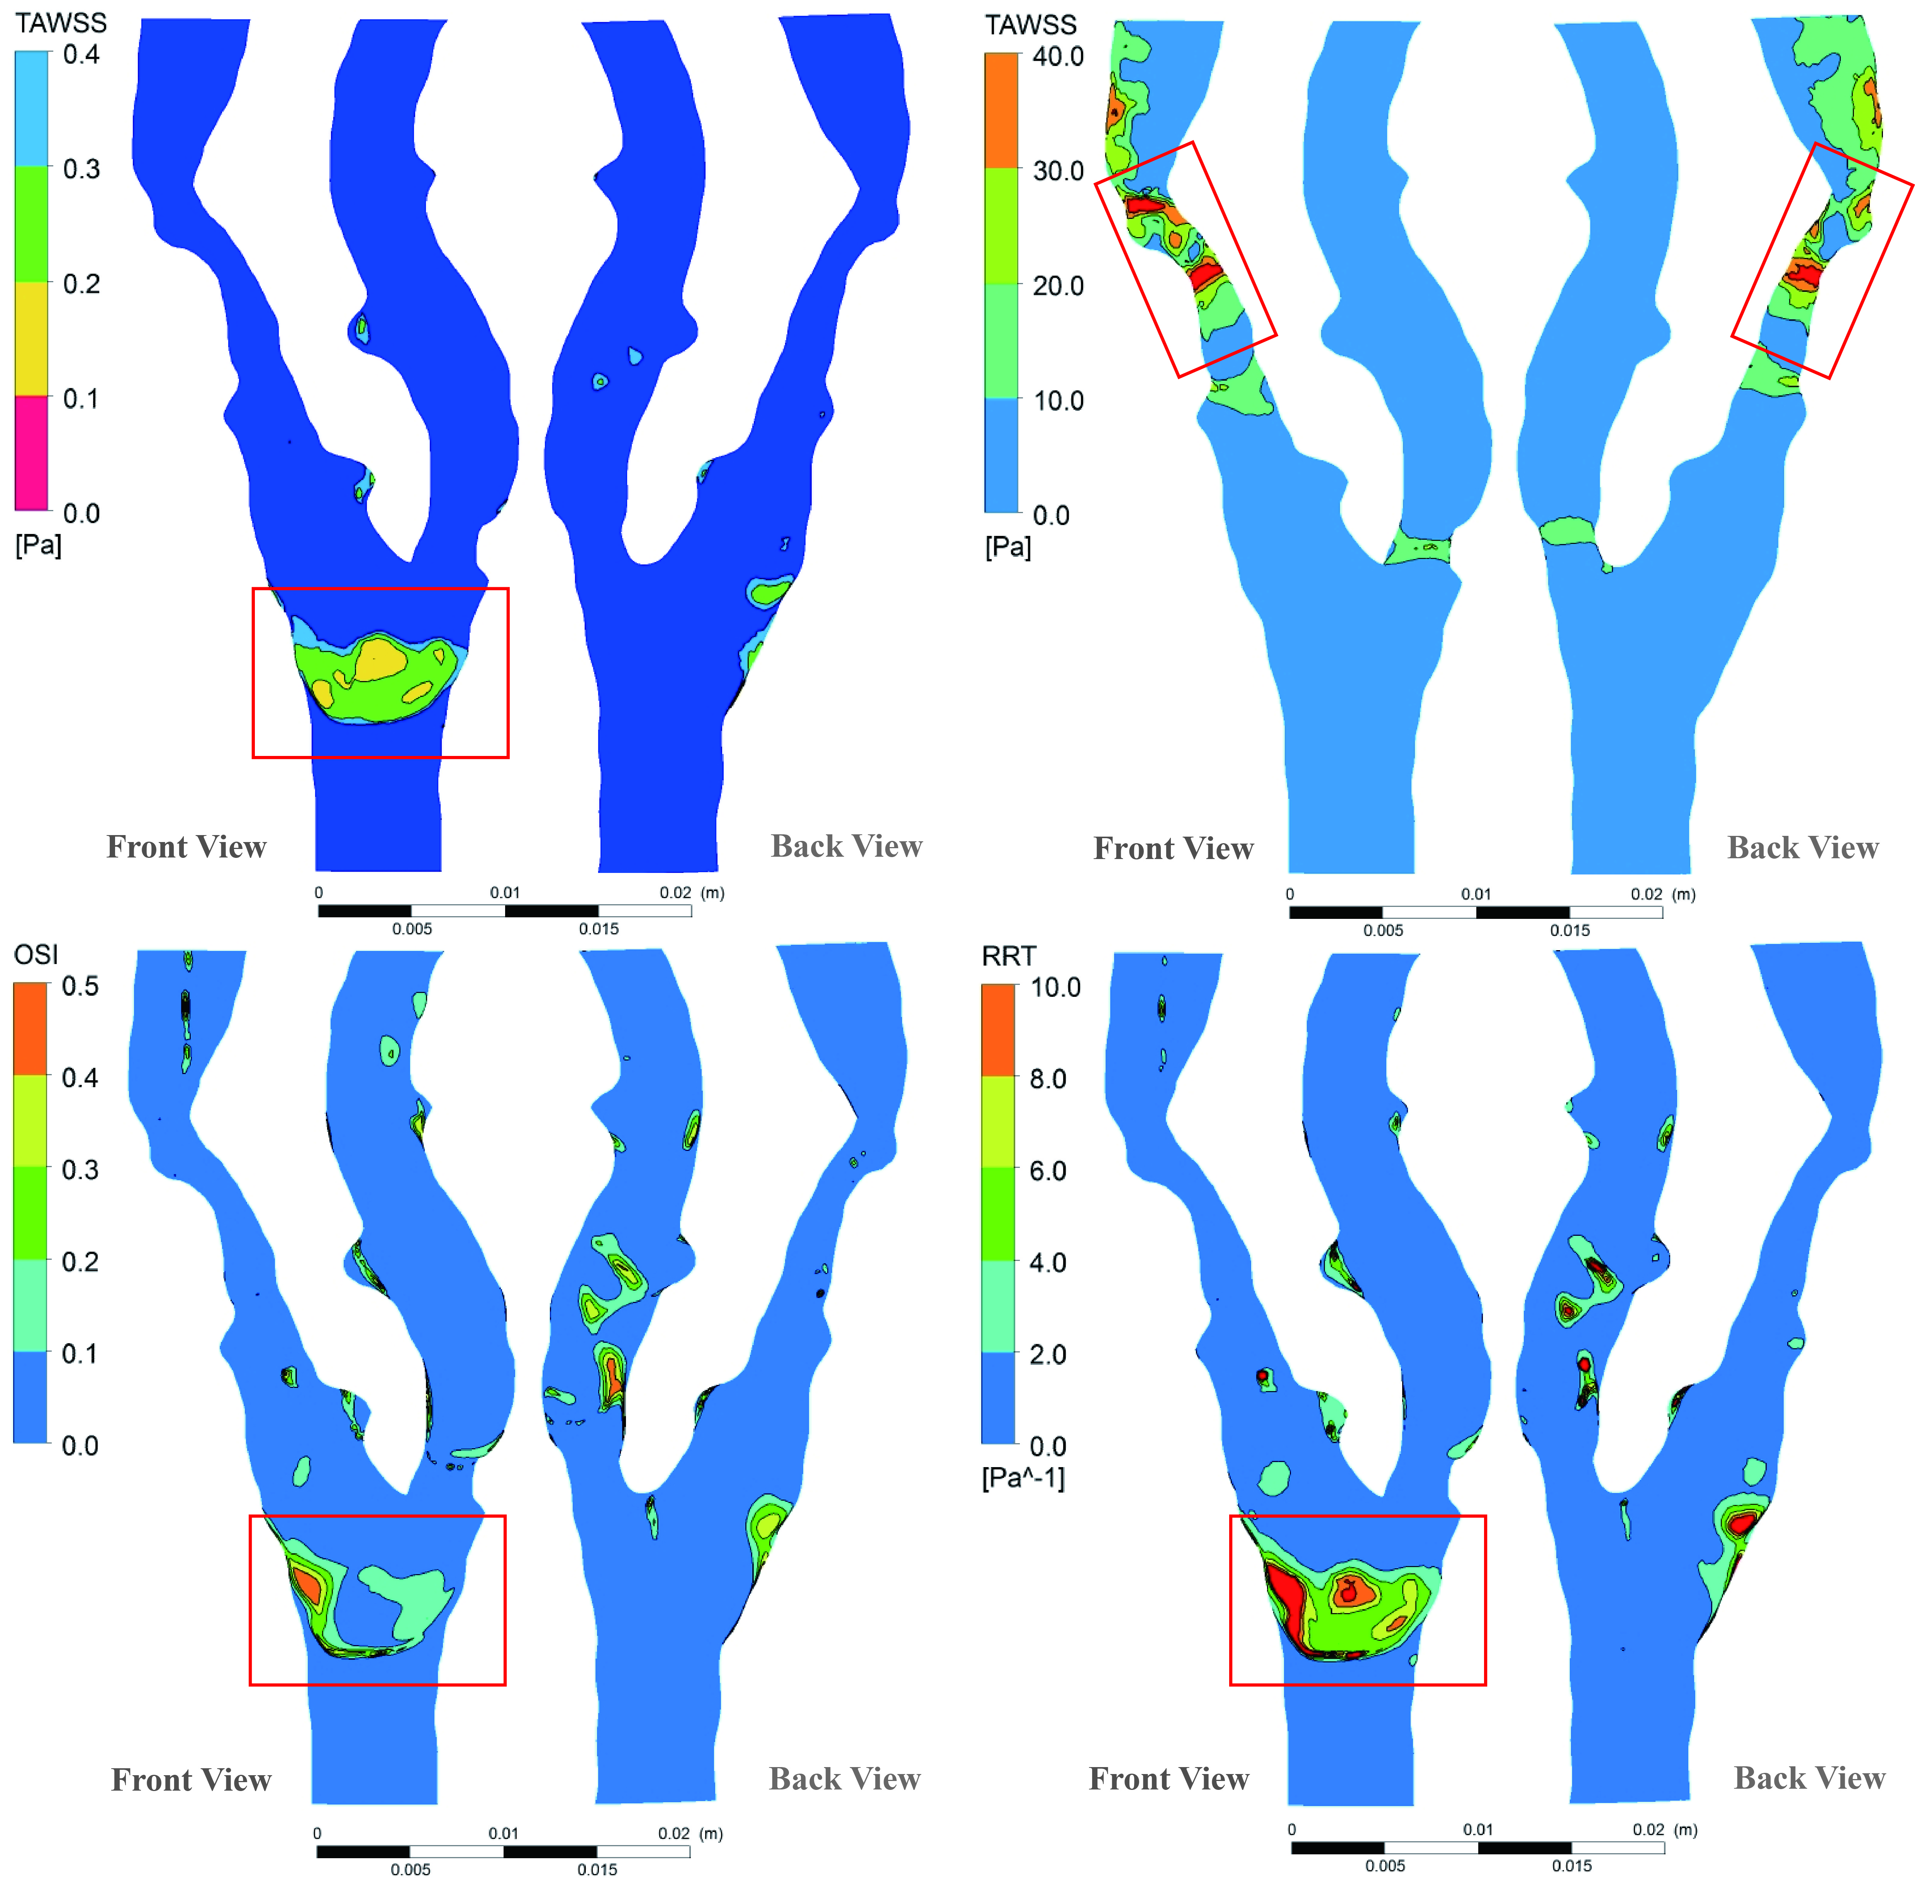

Figure 7. 8 Numerical results of the atherosclerotic carotid bifurcation hemodynamics with downstream peripheral impedance model.

The absolute difference of TAWSS magnitude between these two simulation results was also illustrated in Figure 7. 9. It is found that the main differences are concentrated at the stenosis regions of both ICA and ECA, especially at the throat of the ICA stenosis, where a 6.3 Pa difference can be found, and the corresponding percentage difference is 9.8% with respect to the peak value (64.3 Pa) at the same location of the DPVI model.

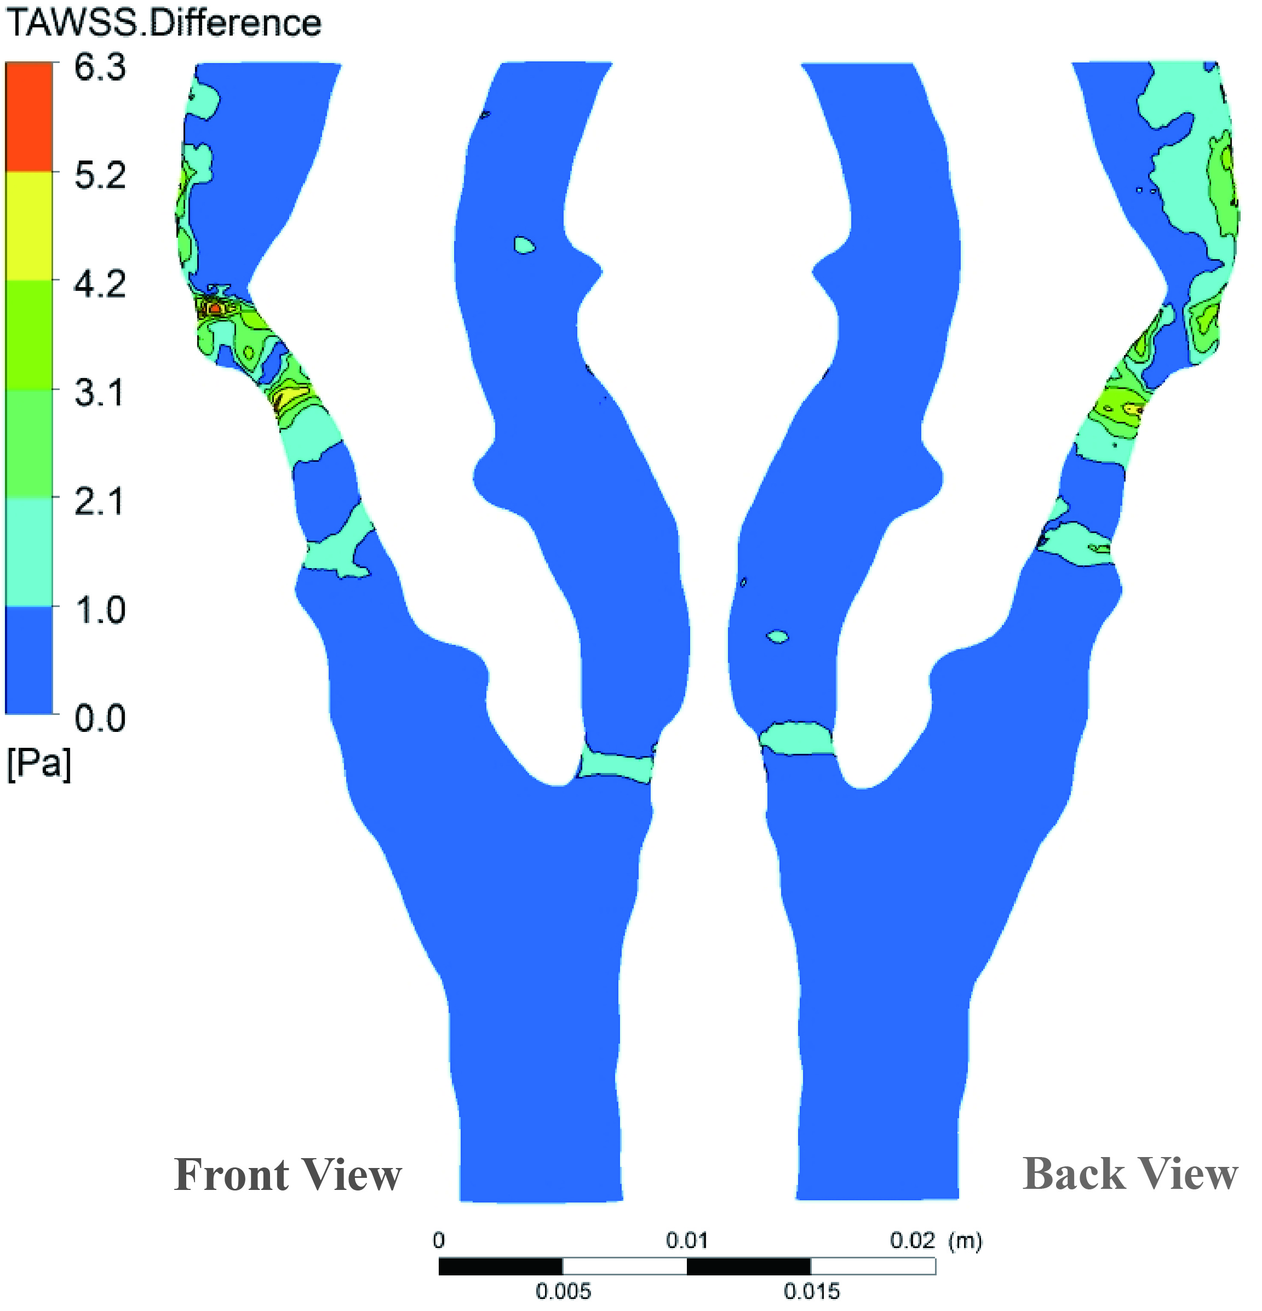

Figure 7. Absolute TAWSS difference of the diseased carotid bifurcation simulations based on fixed flow division and downstream peripheral impedance model.

The transient flow division profile of the diseased carotid bifurcation with the DPVI model was compared against that of the healthy carotid artery, together with the assumed constant flow division line, all of them were presented in Figure 7. 10. It is shown that the diseased flow division profile (ICA/ECA) is constantly below the healthy condition throughout the whole cardiac cycle, but the time-variation characteristics remain almost the same. That is mainly due to the more severe stenosis of the ICA as compared to the ECA, which contributes to the overall vascular impedance of ICA to be greater than that of ECA. On the contrary, it is found that the introduced constant flow division assumption underestimates the ratio of ICA to ECA, and also could not take transient flow division effect into consideration. Therefore, the numerical results of the carotid bifurcation under constant flow division will deviate from the physiological realism, and cannot be used for accurate hemodynamics prediction and evaluation.

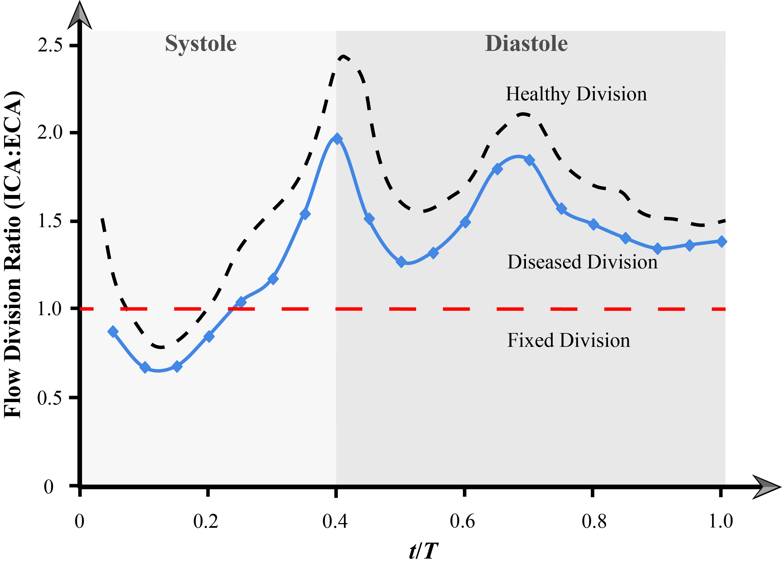

Figure 7. 10 Transient flow division variation for the atherosclerotic carotid bifurcation.

## 7. Conclusion

The accuracy of the isolated three-dimensional patient-specific carotid bifurcation haemodynamics highly depends on the application of the boundary conditions. If the most desirable invasive measurement cannot be available, a special treatment is required. Porous medium with transient permeability can reflect the characteristic of the downstream vascular impedance well, and the haemodynamics accuracy was also verified with the prescribed boundary treatment. This vascular impedance model can be used as a research tool in pre-evaluation and prediction of the planned vascular intervention.

The carotid bulb is a common athroprotective location for both the healthy case study and the diseased case study because of the commonly formed disturbed flow at this region; The studied diseased carotid bifurcation experiences a high TAWSS at the throat of the ICA stenosis, which gives a warning of stroke, and the blood transportation is also disturbed as the flow division value deviates from normal situation constantly. Therefore, a vascular intervention is required. Furthermore, the fixed flow division is not comprehensive for carotid bifurcation haemodynamics as it is unable to account for the variable downstream vascular bed impedance.

One limitation of this work is that the vessel compliance due to the neglectance of blood vessel interaction, and can be elevated by implementing fluid solid interaction in the future. Despite this, the downstream vascular bed impedance mimicking model is a very efficient and robust tool for computational haemodynamics simulation without using complex multi-scale modelling. This model can be used for providing a reliable pre-assessment of the diseased intravascular blood flow and give prediction of the proposed surgical plan by virtually intervention method. Consequently, it will provide evidential approaches to cardiovascular treatment using case-based analysis with the professional clinical knowledge, so as to develop a more appropriate screening and early detection strategies.

# CHAPTER 8

# Image-based Computational Haemodynamics Evaluation of Atherosclerotic Carotid Arteries

Widely accepted treatment for carotid artery stenosis includes stenting as well as carotid endoarterectomy (CEA), despite complications associated with distal embolism. Therefore pre-screening for evaluating the extent of a stenosis is critically important before undertaking surgical procedures. This study presents and evaluates the feasibility of implementing a virtual computational haemodynamics platform for clinical use to determine the severity of a stenosis and give guidance for surgical decision making. The virtual platform incorporates high-resolution three-dimensional angiography results with Computational Fluid Dynamics modelling to determine clinical related indicators. This includes wall shear stress (WSS), the spatial and temporal hemodynamic changes of blood flow within patient-specific carotid bifurcations, pressure drop coefficient, and severity stratification. The turn-around time for each computational modelling stage was examined which showed that the total time cost is practical and the proposed haemodynamics evaluation platform is reasonably efficient for clinical diagnosis. Furthermore the virtual platform may be used to detect the hemodynamic consequence of atherogenesis, which can then be addressed and quantified based on the distribution of WSS related flow indicators on the abnormal luminal fractions. Additional functional evidence and data can be used by the overseeing physician to enrich and complement the anatomical information for more in-depth evaluation of stenosis in reasonable time duration.

## 8. Introduction

As atherosclerosis can remain asymptomatic for decades (Ross, 1993), accurate prevalence and incidence rates of carotid artery stenosis (CAS) are difficult to ascertain. Therefore, the consequence of CAS can be easily underestimated as many patients do not seek medical attention despite having CS for a prolonged period.

The diagnosis of symptomatic CAS relies on a combination of history, clinical examination and imaging derived from CT, MR imaging, ultrasonographic and angiographic images. The evaluation of angiographic images is limited to the geometric measurement determining the degree of stenosis, leaving the ultimate stenosis evaluation to the experience of the treating physician. For symptomatic patients who undertake carotid endarterectomy, the risk of fatal stroke to a severe CAS is reduced to 13% over two years (European Carotid Surgery Trialists' (ECST) Collaboratvie Group, 1991). The report by the ECST Group concluded that while a strong correlation exists between severe CAS and stroke incidence, using anatomical stenosis geometry as a single indicator of risk of stroke is poorly justified. In addition, even a thorough clinical history record can further assist the physician to assess stroke risk. Due to the wide range of treatment options, a reliable way has to be found to select the most appropriate option for each patient.

Taxon (Taxon, 1995) has shown that frequent occurrence of localized atherosclerotic plaques in curvature, bifurcation, and branching of arterial vessel regions suggest that fluid dynamics and vessel geometry may have an influence in plaque formation. Computational fluid dynamic (CFD) methods can offer additional functional information from a haemodynamics point of view to complement the vessel geometry information, detailed in-vivo angiographic imaging or in-vitro experimental velocimetry measurements.

Many numerical hemodynamic studies have been performed to investigate the hemodynamic influence on CAS progression, which has established that the magnitude and gradient of blood flow near the vessel wall, or the wall shear stress, is a source of pathogenesis of CAS (Chien, 2008, Lee et al., 2008, Tang et al., 2008). Vessels exposed to low wall shear stress appear to be more prone to plaque development based on an MR imaging based study using 21 carotid arteries (Tang et al., 2008). Researchers determined that the investigations of local risk indicators such as time-averaged wall shear stress (TAWSS) and oscillatory shear index (OSI) in atherosclerosis did not rely on all the surrogate geometric markers of disturbed flow (Lee et al., 2008). While atherosclerotic disease is a multifactorial disease, hemodynamic forces and wall shear stress mapping can provide a complementary determinant among a multidisciplinary approach for early atherosclerosis detection. Therefore obtaining such data must be prompt in order for it to be of clinical use.

Although numerous studies of carotid artery bifurcations have been performed, most have concentrated on analyzing the blood flow pattern within the stenotic district through various modeling assumptions, such as steady flow (Gijsen et al., 1999), pulsatile flow (Schirmer and Malek, 2011), rigid vessel (Tambasco and Steinman, 2003), compliant vessel (Lee et al., 2004), Newtonian flow (Tu et al., 2011), Non-Newtonian flow (Perktold et al., 1991, Fan et al., 2009), and anatomical effects, including artery branching (Zhao et al., 1999), bifurcation angles (Perktold et al., 1991, Wells et al., 1996) and wall curvature (Kleinstreuer et al., 2001). LaDisa et al. (LaDisa et al., 2010) have numerically examined the influence of WSS and OSI in progression of plaques in a clinically reasonable timeframe. However, the haemodynamic burden (effect on blood flow transportation) caused by the existence of the plaque was not investigated, which is an important practical indicator in helping the treating physician to choose clinical treatment properly.

In order to reveal the stenotic lesion burden and its influence exerting on the blood flow transport in an efficient time, as many assumptions as possible should be accounted for while omitting those that are less relevant and are time consuming. In this chapter, a robust and time-efficient computational haemodynamics method is proposed, and clinical related indicators are introduced for data processing and severity stratification of CAS. Ten carotid artery bifurcations were reconstructed from MR scans, and intravascular flow patterns were predicted using CFD analysis with a fine structured mesh and a non-Newtonian viscosity model. The stenosis-induced flow performance and the flow disturbance in pre-stenosis and post-stenotic regions were examined and this was integrated with high resolution anatomical measurements for direct and long-term plaque burden evaluation. Each step in the workflow was monitored for reproducing reasonable results with a minimized time cost. This proposed framework is a step towards an e-health platform that can assist both doctors and patients to have a better understanding of CAS disease and to provide better guidance for clinical treatment.

## 8. Methodology

Patient-specific realistic carotid bifurcation models were reconstructed from MR image data and their corresponding stenosis severity were anatomically assessed. Then, a computational haemodynamics approach was proposed and performed on these patient-specific carotid bifurcation models. Finally, the haemodynamics performance and computational efficiency were examined for clinical diagnostic purposes.

### 8.2. Imaging

High resolution MR imaging of carotid bifurcations was performed on patients using a 1.5 T General Electric scanner. All human experiments were approved by the Monash Medical Center and an Institutional Review Board. The MR imaging was first performed on four patients, which constitute a total of eight models that pertain to their left and right carotid bifurcations. Then another two additional carotid bifurcation models were scanned from two additional patients of which only one artery from each pair of carotid arteries were selected. Altogether, ten patient-specific models were imaged from six patients. For each carotid artery, a total of 112 contiguous slices were generated from the high-resolution T-1 weighted spoiled gradient echo with parameters as follows: TR, 35 ms; TE, 7 ms; flip angle, 35º; field of view, 24 cm; voxel size 0.63mm × 0.73mm × 0.63 mm.

### 8.2. Arterial model reconstruction

Based on the MR imaging data, the computational model was reconstructed using a commercial software Mimics (Materialise HQ, Belgium). The specific structures of interest were extracted out based on a thresholding range of gray scale values in the segmentation process. This approach separates the luminal area from the rest of the tissues. Though this is a simple technique, still there are some factors that can complicate the thresholding operation, for example, non-stationary and correlated noise, ambient illumination, busyness of gray levels within the object and its background, inadequate contrast, and object size not commensurate with the scene. All these factors require considerable manual operation during the segmentation process. A 3D model is then exported as a ‘.stl’ (stereolithography) file. Figure 8. 1 shows the ten patient-specific carotid artery models that were produced. The common carotid artery (CCA), internal carotid artery (ICA) and external carotid artery (ECA) are labeled for each model.

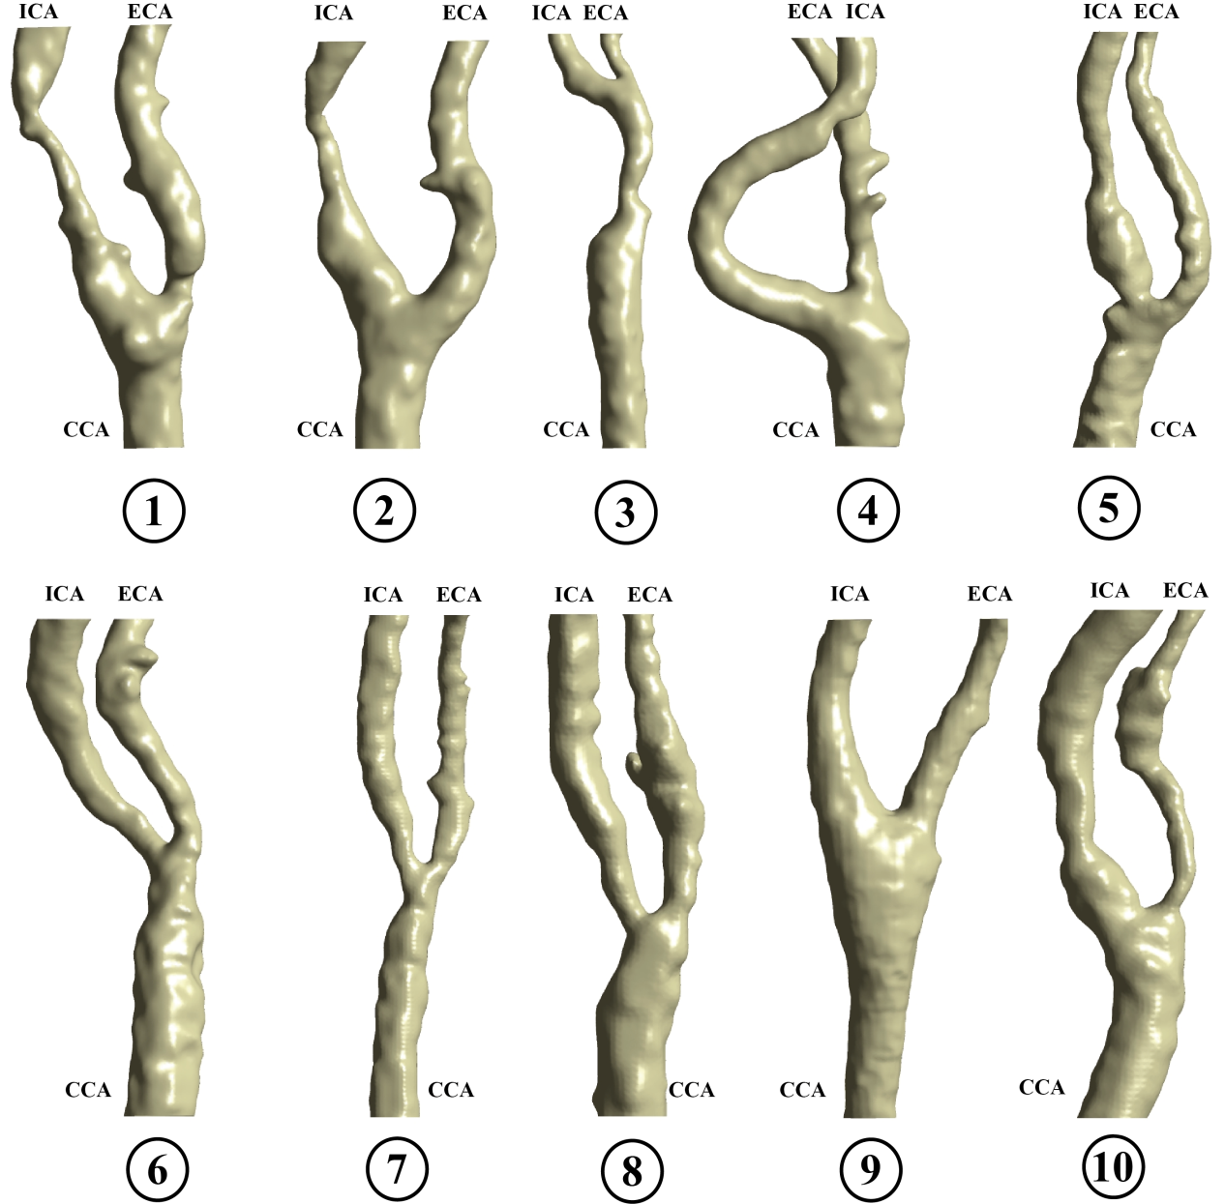

Figure 8. Reconstructed patient-specific carotid artery models.

### 8.2. Anatomical assessment

Anatomical measurements to obtain two characteristic parameters, stenosis diameter A and distal diameter B were performed on each model and the values presented in Table 8. 1. A schematic diagram of an artery stenotic region is shown in Figure 8. 2 to highlight the characteristic parameters.

Table 8. 1 Anatomical measurements of studied patient-specific carotid artery models.

|  |  |  |  |  |  |  |  |
| --- | --- | --- | --- | --- | --- | --- | --- |
| ID | Stenosis location | | Stenosis diameter *A* (mm) | Distal diameter *B* (mm) | Distal diameter reduction (DDR)  (1 -*A*/*B*)×100% | Stenotic surface area *S*Diseased (mm2) | Total surface area *S*Total (mm2) |
| 1 | 1 | **I** | 1.88 | 5.64 | 66.67% | 138.11 | 1299.11 |
| **II** | 2.65 | 4.41 | 39.91% | 61.06 |
| 2 | 2 | **I** | 1.58 | 5.56 | 71.58% | 132.02 | 1144.76 |
| 3 | 3 | **I** | 1.92 | 4.07 | 52.83% | 79.89 | 879.86 |
| 4 | 4 | **I** | 2.73 | 3.64 | 25.00% | 56.41 | 1231.04 |
| 5 | 5 | **I** | 3.73 | 5.89 | 36.67% | 67.41 | 1189.25 |
| **II** | 2.57 | 3.75 | 31.47% | 72.58 |
| 6 | 6 | **I** | 2.56 | 5.70 | 55.09% | 119.29 | 1381.07 |
| 7 | 7 | **I** | 2.82 | 3.98 | 29.15% | 72.80 | 1405.45 |
| 8 | 8 | **I** | 2.74 | 4.25 | 35.53% | 88.19 | 1005.20 |
| 9 | 9 | **—** | **—** | **—** | **—** | **—** | 1620.42 |
| 10 | 10 | **I** | 1.75 | 2.19 | 20.09% | 38.57 | 1211.42 |
| **II** | 2.99 | 4.85 | 38.35% | 180.35 |

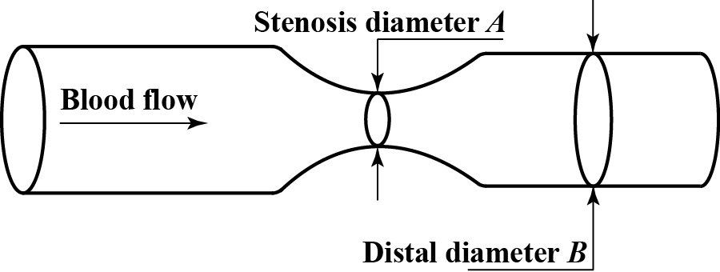

Figure 8. Simplified schematic diagram of artery stenotic region.

In clinical trials, one way to estimate the degree of carotid stenosis is to calculate distal diameter reduction (DDR) through comparing the diameter of the residual lumen at the site of the stenosis (variable *A* in Table 8. 1) to the diameter of the distal unaffected lumen (variable *B* in Table 8. 1) (Sprouse et al., 2005), and the degree of stenosis for the studied carotid models examined by DDR method are shown in Table 8. 1. It is found that nine models were experiencing one or two sites of stenosis except model 9, which exhibited no significant diameter variation in its radial direction. In terms of pathological location, six models (model 2, 4, 5, 6, 7, and 8) suffered stenotic lesions on the ICA; two models (model 1 and 10) presented stenotic lesions on both ICA and ECA, while only one model (model 3) had a CCA stenosis. In terms of stenosis severity, four carotid models (model 1, 2, 3, 6) experienced larger than 50% DDR in their stenosis lesions, and model 2 was suffering a DDR of 71.58% at its ICA branch, which is the most severe case among all models.

However, the generated anatomical information does not represent a dynamic stenosis burden under transient blood flow, and a further analysis of stenosis-induced influence on arterial blood flow transportation will be much more functional in clinical applications. Therefore, a computational haemodynamics approach is needed to investigate the stenosis effects on intravascular blood flow patterns and blood transportation performances.

### 8.2. Computational mesh generation

The carotid bifurcation CFD models were generated with a structured hexahedral mesh using a multi-block O-grid method within ICEM CFD (ANSYS, US). A structured mesh reduces numerical diffusion and requires lower cell counts than unstructured meshes. A near wall grid refinement was imposed on each model to provide better resolution for near wall quantities, such as WSS. Mesh results of a patient-specific model 2 with a 71.58% ICA stenosis are shown in Figure 8. 3. Due to the complexity and diversity of patient-specific models, customized multi-block topology was needed to fit the rapid vessel geometrical variation and all the regions with high curvature or stenosis into refined blocks, which requires additional time costs.

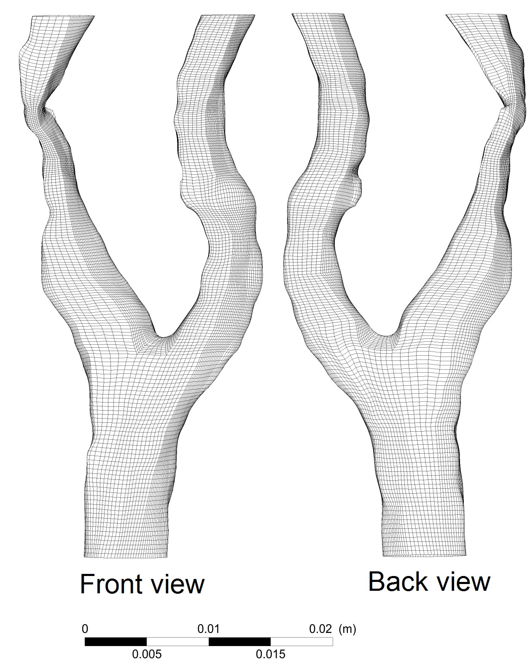

Figure 8. 3 Structured mesh result of the patient-specific model 2.

### 8.2. Boundary conditions and fluid properties

As the inlet flow waveforms corresponding to each model were unavailable since the patient could not be re-traced, a representative ensemble flow waveform from 17 healthy models reported by Holdsworth et al. (Holdsworth et al., 1999) is adopted (Figure 8. 4). This boundary condition is imposed on the inlet of each model using a temporally varying Womersley velocity profile. This type of velocity profile describes the characteristic of oscillatory flow (presumed to be laminar and incompressible) in a tube arising in the solution of the linearized Navier-Stokes equations. The analytical solution to this problem is given by Zamir (Zamir, 2000) in the following form:

 (Eq. 8. 1)

where *t* is time; *r* is the radial coordinate; *a* is the radius of artery;  is the steady-state part of the pressure gradient;  is the Bessel function of order zero of the first kind; *ω* are angular frequencies after Fourier Transformation; and  is the complex frequency parameter. For flows with low frequency (1 or less), the solution can be further simplified using a series expansion of the Bessel function:

 (Eq. 8. 2)

This means the frequency of pulsations is sufficiently low and that a parabolic velocity profile has sufficient time to develop during each cycle. The flow becomes nearly in phase with the pressure gradient, and the relation between flow and pressure can be treated instantaneously the same as in the case of a steady Poiseuille flow.

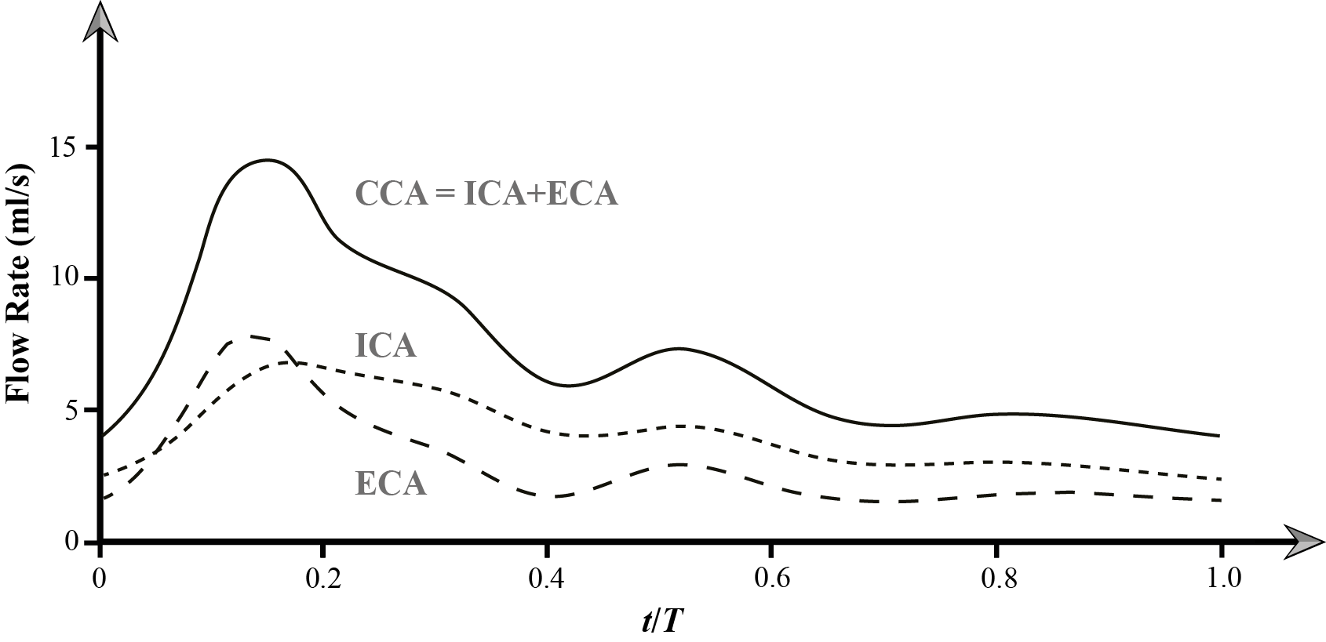

Figure 8. 4 Volume flow rates of a healthy carotid model.

The downstream peripheral vascular impedance (DPVI) model was adopted for the outlet boundary. The main purpose of this method is establishing a feasible and efficient haemodynamics framework through connecting two porous domains with different transient permeability configurations to outlets of truncated carotid bifurcation models (Figure 8. 5). This method has been introduced and implemented in previous chapter and additional details can be obtained from Chapter 7.

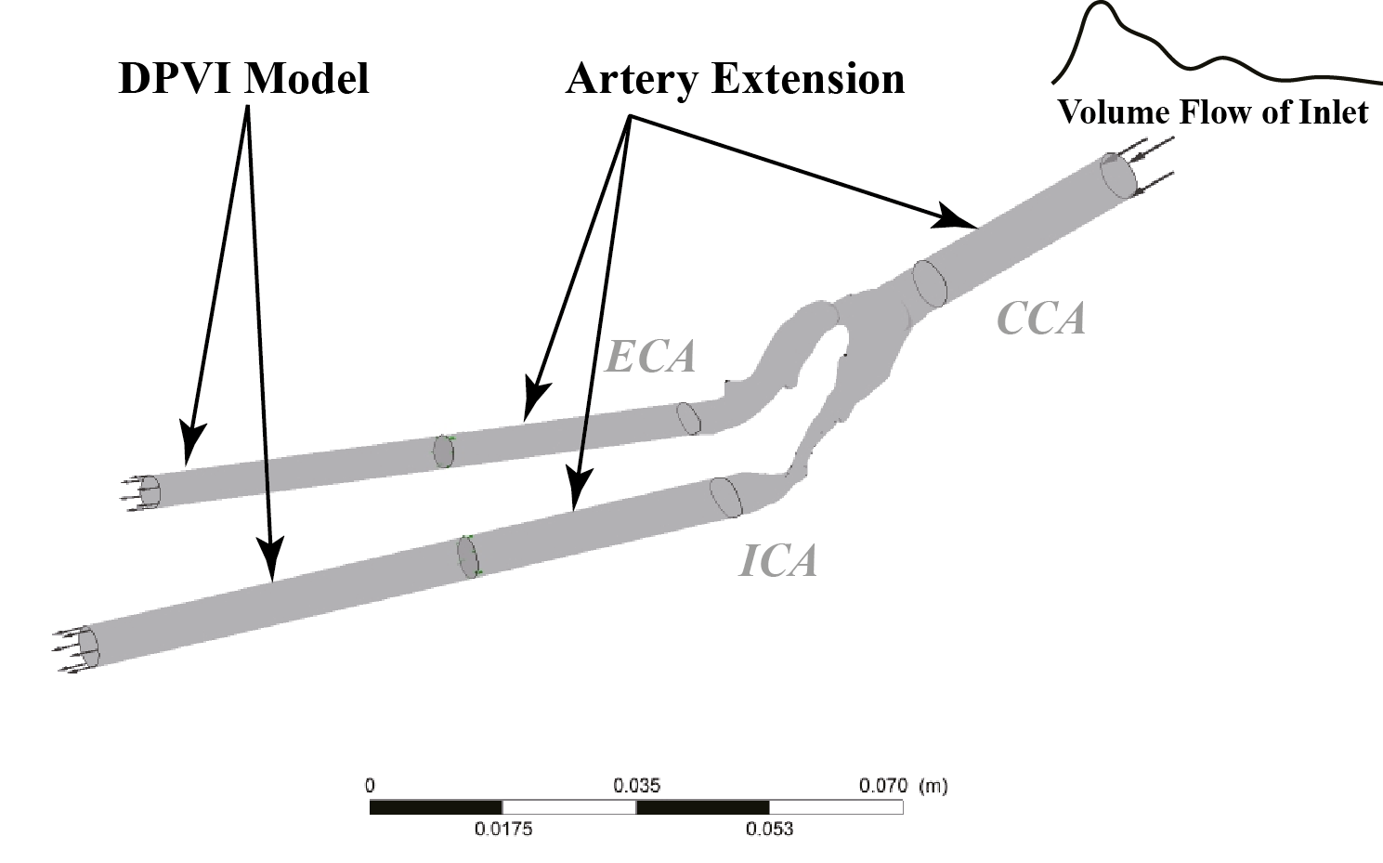

Figure 8. A schematic diagram of the DPVI modeling method.

The shear thinning and viscoelasticity of blood are closely relevant to its microscopic structures, such as aggregation, deformation and alignment of the red blood cells, where the red blood cells mainly determine the rheological behaviour of blood. However, Gijsen et al. (Gijsen et al., 1999) have demonstrated that viscoelasticity can be ignored for the prediction of velocity since the shear thinning behaviour dominates the non-Newtonian property of the blood flow. In this chapter, the shear thinning behaviour is governed by the Carreau-Yasuda model (Lou and Yang, 1993), and the relationship between blood viscosity *η* and shear rate *γ* is:

 (Eq. 8. 3)

where *η*∞ is the viscosity for an infinite shear rate, and *η*0 is the plasma viscosity at zero shear rate. *λ*, *n*, and *a* are fitting parameters, which are borrowed from the experimental data based on a well-tested blood-mimicking fluid (Gijsen et al., 1999). These parameters have the following values:

*η*∞ = 3.7×10-3 Pa s, *η*0 = 3.14×10-2 Pa s, *λ* = 2.517 s, *n* = 0.5736, *a* = 2, and *ρ* = 1060 kg m-3.

### 8.2. Turbulence modelling

In general, the blood flow in large arteries can be treated as laminar if all vessels are typically normal and healthy in geometry without any significant constrictions. However, where atherosclerosis is present in arteries, these regions of severe constrictions will experience a vastly different biomechanical environment that exhibits the presence of transitional and turbulent flow in comparison with healthy vessels (Kefayati and Poepping, 2013). The WSS within the stenotic region is usually high because the area reduction accelerates the blood flow within the stenosis, while in the post-stenotic region, low oscillatory WSS is formed due to the existence of flow separation and an oscillatory vortex. The high WSS and the presence of turbulence may damage the endothelial cells (Fry, 1968, Hellums, 1977), which can induce plaque rupture and generate thrombosis (Ramstack et al., 1979, Gertz and Roberts, 1990). In addition, high temporal shear gradients are also shown to stimulate endothelial cell proliferation (White et al., 2001).

During past decades, many in-vitro measurements (Deshpande and Giddens, 1980, Lieber and Giddens, 1990) and numerical studies using turbulence models (Younis and Berger, 2004, Birchall et al., 2006) were performed on stenotic arterial vessels, which have provided visualization of the flow characteristics in proximal and post-stenotic regions. The flow is significantly influenced by the vessel geometry and is far from being laminar in character. In order to capture various types of transition mechanisms and to evaluate the numerical accuracy against comparable experiment, the ‘transitional SST model’ developed by Menter et al. (Menter et al., 2006) is used. This model is based on two additional transport equations to solve the turbulence kinetic energy *k* and the specific dissipation *ω*: the first is an intermittency equation (*γ*-equation), used to trigger the transition process; and the second is the transition onset momentum thickness Reynolds number equation (Reθt-equation), which is forced to follow experimentally-determined correlations. The model uses a new empirical correlation to cover standard bypass transition as well as flows in low free-stream turbulence environments.

Each computational mesh was imported into ANSYS-CFX (ANSYS, US), which uses a finite volume method to solve the unsteady incompressible Navier-Stokes equations. The discretization used a second order implicit backward Euler method. Grid independence was performed which found that the mesh element character length was set as 0.4 mm and the choice of transient simulation time step was fixed at 0.005s referred from (Dong et al., 2013). Vessel walls were assumed to be rigid for all simulations (Hoi et al., 2010); the convergence criterion for the relative residual of all dependent variables was set as 1×10−4 for each time step. For the simulation, two full cardiac cycles were required to damp out the initial transient errors. Therefore, a total of three full cardiac cycle calculations were performed with the last cycle used for data analysis (Ghalichi and Deng, 2003).

## 8. Results and Discussion

### 8.3. Haemodynamics assessment with WSS based parameters

Two widely adopted flow indicators TAWSS (time-averaged wall shear stress) and OSI (oscillatory shear index) are used to evaluate the total shear stress exerted on the wall throughout a cardiac cycle (Dong et al., 2013). In particular, the OSI can be regarded as the fraction of angle and magnitude change between the instantaneous WSS and the time-averaged WSS. It ranges from 0 to 0.5, where 0 represents a unidirectional WSS and the theoretical maximum value (0.5) describes a purely unsteady, oscillatory flow with zero WSS. Areas of high OSI are predisposed to endothelial dysfunction and atherogenesis (Ku et al., 1985, Davies, 2009), while abnormally high TAWSS (higher than 40 Pa) values can cause direct endothelial injury and increase the risk of getting thrombosis (Lee et al., 2009).

The TAWSS during one cardiac cycle was quantified and is shown in Figure 8. 6. It is found that high WSS is concentrated at the stenosis regions and all the stenotic models experienced abnormally high WSS (larger than 40 Pa) at their lesion sites, which may lead to fissuring and affect macrophage distribution leading to plaque destabilization and rupture (Slager et al., 2005).

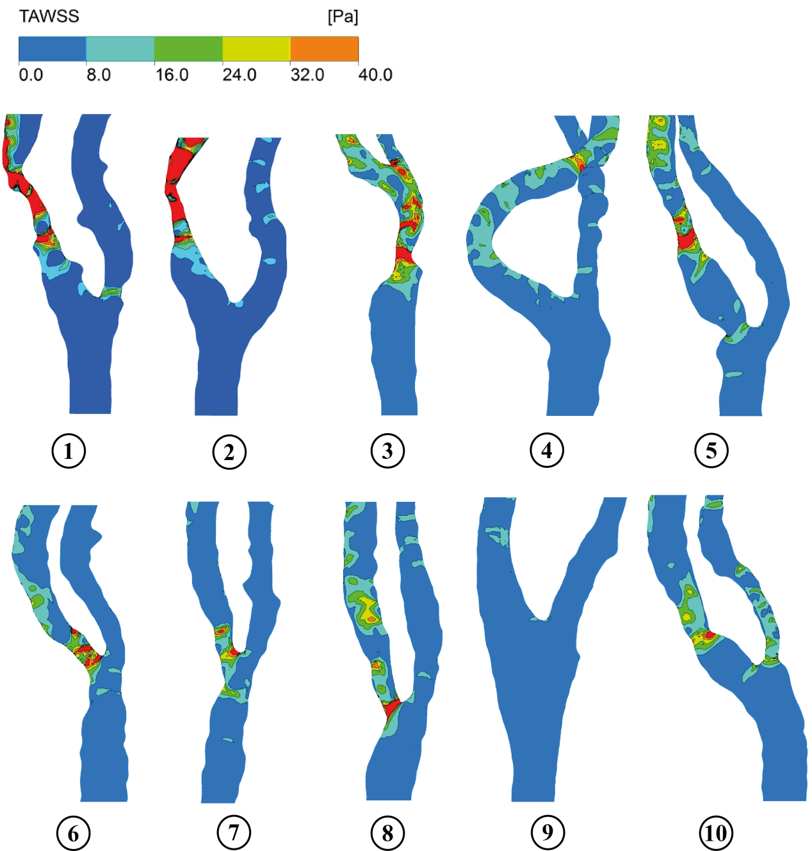

Figure 8. Time-averaged WSS distributions of the ten studied carotid bifurcation models.

The OSI distribution for each case is shown in Figure 8. 7, where most of the high OSI regions (highlighted by boxes with solid lines) are found at the bifurcation bulge (model ID 1, 2, 4, 9). This confirms that the bifurcation is one of the most susceptible sites to experience disturbed flow and low unhealthy shear stress, which can lead to endothelial dysfunction and atherogensis (Suo et al., 2008) while the other susceptible anatomical locations are curved regions in the branches.

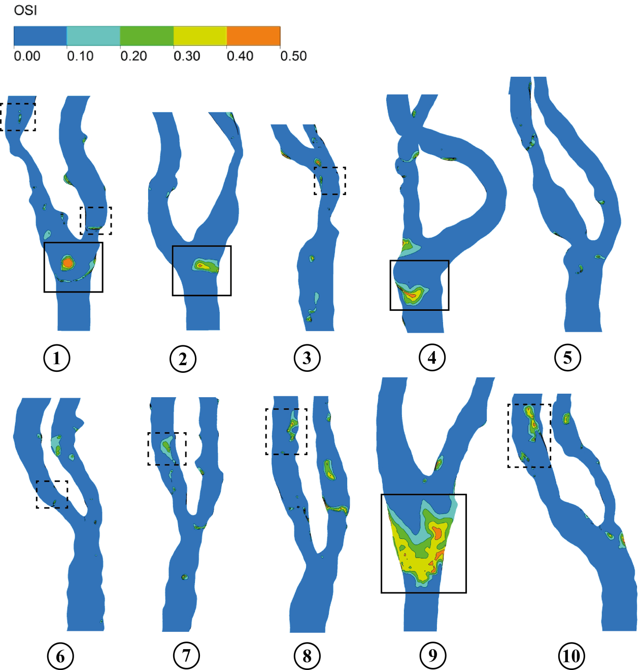

Figure 8. OSI distributions of the ten studied carotid bifurcation models. Boxes with a solid line indicate high OSI regions, while boxes with dashed lines indicate disturbed flow induced by stenotic lesions.

As a developing atherosclerotic lesion can itself alter the local blood flow patterns after a substantial stenosis is formed, an elevated velocity of blood flow through the narrowed luminal space can lead to flow separation (disturbed flow which can be quantified by OSI) occurring immediately downstream of the stenosis. These disturbed flow regions induced by stenotic lesions are highlighted by boxes with dashed lines in Figure 8. 6. The disturbed flow regions impose similar implications to the downstream endothelial cells as seen in the carotid bifurcation bulge, but at a reduced scale (model ID 1, 3, 6, 7, 8, 10). Eventually, the lesion-induced flow disturbances may contribute to a continuous stream-wise growth of the lesion over time, as many studies of endothelial cells have demonstrated that such a haemodynamic environment promotes pro-inflammatory gene and protein expression which is conducive to increased atherosclerosis susceptibility (Garcia-Cardena et al., 2001).

Further assessment of the lesion burden on the carotid bifurcation is analysed by determining the luminal surface area that experiences high WSS (larger than 40 Pa), given as SHWSS, and the proportion of the high WSS affected area over the total carotid surface area given as PHWSS and is shown in Figure 8. 8. Models 1, 2, 3 suffered larger regions of high WSS compared with models 4, 5, 6, 7, 8 and 10. Models 1, 2, and 3 exhibited 77.54 mm2, 94.87 mm2 and 33.05 mm2 luminal surface area respectively, where high risk of direct endothelial injury and plaque erosion exists due to the abnormally high wall shear. In addition, the variation of PHWSS presented a similar trend as SHWSS distribution. Models 1, 2, 3 also exhibited a greater high WSS load (5.80%, 8.08% and 3.03%, respectively) when compared with the rest of the stenotic carotid models.

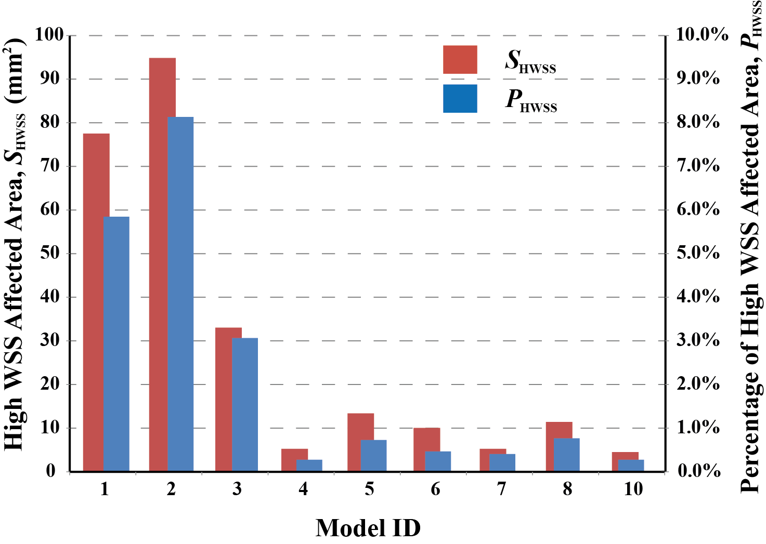

Figure 8. High WSS influence on the studied stenosed carotid bifurcations.

### 8.3. Haemodynamics assessment with clinical trials used indicators

Pressure probe wire based fractional flow reserve (FFR) is widely used to evaluate the physiological significance of the stenosis (Pijls et al., 1995, Gould, 2006). For a stenotic artery as shown by Figure 8. 2, the FFR is defined as the ratio of maximum blood flow in a stenotic artery to the normal maximum flow in the same vessel. It can be determined by the mean pressure value taken distal to the stenosis compared with the mean proximal pressure at peak vasodilation. Therefore, the FFR has a lower and upper limit of 0 and 1, which represent complete vessel occlusion, and no obstruction, respectively. For diagnosis of coronary artery stenosis, if the FFR value is less than 0.75, angioplasty of the diseased artery vessel is recommended (Chamuleau et al., 2003, Spaan et al., 2006).

However, the presence of a physical probe wire also reduces the intravascular flow and alters the pressure drop, which in turn leads to false FFR values (Rajabi-Jaghargh et al., 2011). This can impede on the decision making for the clinicians in the assessment of a stenosis. The current CFD simulation can be a useful technique to overcome this drawback and enable clinicians to carry out better analysis over different clinical situations, instead of complicated in-vivo measurements.

In this chapter, one pressure drop based diagnostic parameter, pressure drop coefficient (CDPe), developed by Banerjee et al. (Banerjee et al., 2008) is introduced for stenosis severity stratification. The CDPe is defined as the ratio of mean trans-stenotic pressure drop,  (superscript ‘~’ indicates temporal average quantity) to the proximal dynamic pressure and is give as:

 (Eq. 8. 4)

where *ρ* is blood density,  is spatial and temporal mean blood flow velocity in the proximal vessel.

The FFR-CDPe correlation is depicted in Figure 8. 9, and this linear relation is obtained from a three points’ strains statistical reasoning. This linear relation can be written into the following equation as:

 (Eq. 8. 5)

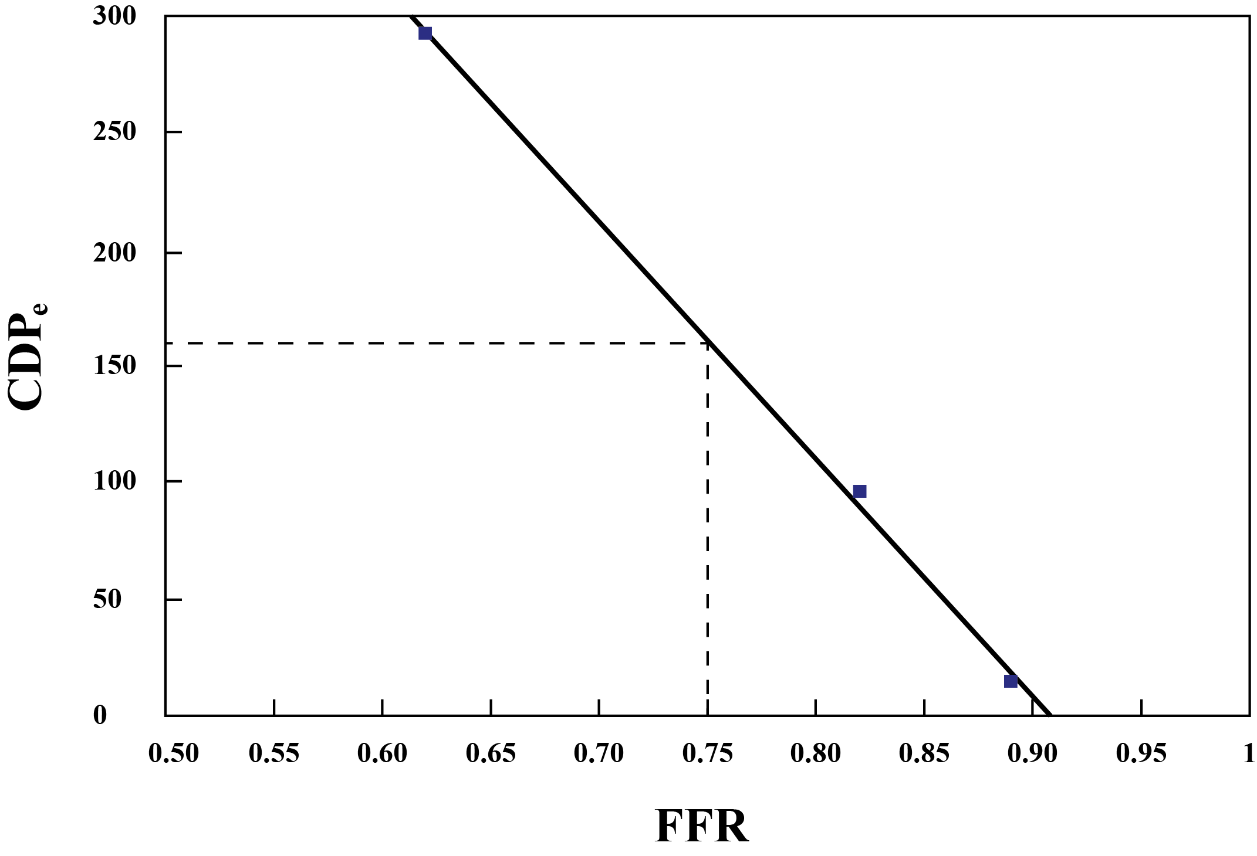

Figure 8. 9 Linear relation between CDPe and FFR.

Unlike FFR, CDPe is not limited between small ranges. In detail, the variation range of FFR is 0.6 ~ 0.9, where the corresponding value range of CDPe is 0 ~ 300. Therefore, a larger and more accurate threshold value can be established for CDPe in human clinical trials. According to the threshold of FFR in clinical applications (Chamuleau et al., 2003), if the CDPe value is larger than 161.41, proper vascular interventions should be recommended.

The CDPe values for all the nine stenotic carotid models were calculated and shown in Table 8. 2. Their corresponding FFR values were also examined based on Eq. 8.5. It should be noted that the CDPe values in Table 8. 2 only included the most severe lesion value if the studied carotid bifurcation model suffered a multi-site stenosis. It can be found that only one carotid artery (model 2) experienced an abnormally high CDPe value 235.67, which exceeds the prescribed threshold 161.41 for 46%, therefore the maximum blood flow in this stenotic branch can only account for 67.69% of its normal situation. This result also confirms with the anatomical assessment conclusion that model 2 was suffering the most severe stenosis degree (71.58% of DDR) among all carotid models. In contrast, the pressure drop coefficients for the other 8 stenotic models were much lower than 161.41, hence the occlusion effect on the blood flow transportation due to the present of the stenosis lesions was less than 20%.

Table 8. Numerical simulation based CDPe and FFR values of the studied stenotic models.

|  |  |  |  |  |  |  |  |  |  |
| --- | --- | --- | --- | --- | --- | --- | --- | --- | --- |
| ID | 1 | 2 | 3 | 4 | 5 | 6 | 7 | 8 | 10 |
| CDPe | 54.30 | 235.67 | 8.96 | 2.86 | 16.84 | 1.14 | 0.75 | 0.21 | 17.99 |
| FFR | 85.54% | 67.69% | 90.00% | 90.61% | 89.23% | 90.78% | 90.82% | 90.87% | 89.12% |

### 8.3. Computational efficiency assessment

In order to evaluate the efficiency of the proposed modelling strategy for research or clinical use, the computational cost was monitored for each work stage (Figure 8. 10). The total time cost for a complete computational haemodynamics work of each single carotid bifurcation model was approximately around 19 hours. The CFD simulation for each carotid bifurcation model was performed by a HP XW6600 workstation, 6 CPU (E5440 2.83 GHz) were assigned for local parallel run mode, and the total simulation time is around 10 hours. The second most time consuming (4.3hrs) work is geometry reconstruction, due to manual operation for segmentation of the geometry from MR images. Structured meshing (2.1hrs) is also very user-intensive as the block shape varies among individuals due to different branch curvature and stenosis severity. The configuration of boundary conditions only cost 1 hour, which is the shortest portion among all work stages. In order to extract and process the generated data, simulation results quantification took 2 hours per patient-specific model.

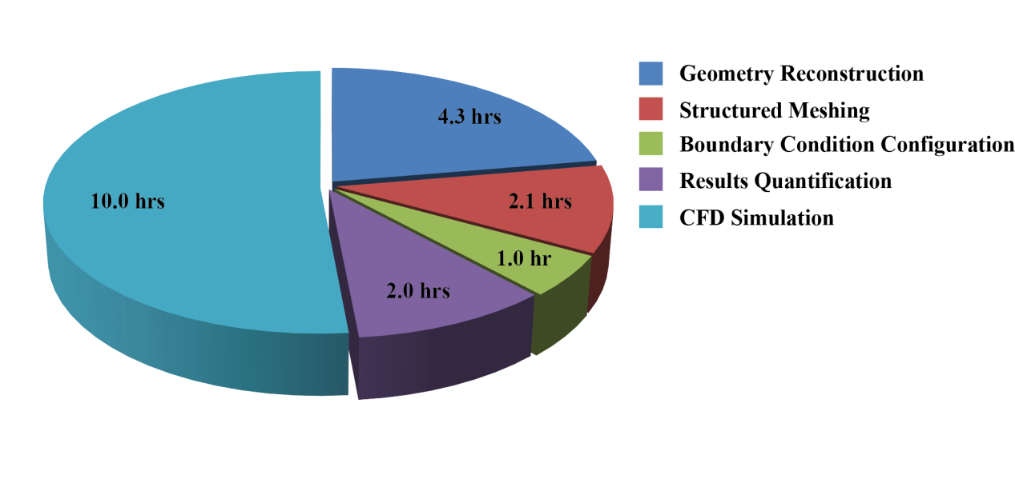

Figure 8. Time cost summary for each work stage of the computational haemodynamics.

Overall, the time cost by manual work involved in the CFD preparation and results analysis is 9.4 hours for each carotid model. It is envisioned that the progression towards a more automated segmentation and meshing algorithm, the analysis stage could be reduced by half the time (e.g. 2hrs). Furthermore where high fidelity accuracy is not needed, then an unstructured mesh which can be produced automatically would reduce the meshing time down to around 0.5hrs. Therefore by optimizing the work flow the manual work for a single patient carotid artery could be as quick as 5hrs work. Furthermore with the use of high performance computing clusters, the CFD simulation time could be reduced right down to just one hour. Therefore, through the time efficiency of the proposed numerical platform is highly depended on computer hardware configuration and intensive user involvement, the total time for a computational haemodynamics platform to report its findings from MR scans, could be as quick as 6hrs turnaround which is highly feasible for clinical use. In addition, in some particular cases, if the vascular morphology is relatively maintained in healthy condition, and plaque burden analysis is not necessary, the overall time cost can be further shortened.

## 8. Conclusion

Image-based anatomical evaluations alone can approximately determine the artery stenosis burden, but cannot provide further detailed evidence to quantify the stenosis severity in addition to geometry occlusion measurement. In this chapter, after the numerical accuracy was validated with published experimental results of two representative carotid bifurcations, a systematic methodology of high performance computational haemodynamics of atherosclerotic carotid bifurcation artery was proposed and performed on ten selected patient-specific realistic carotid bifurcation models. As TAWSS based analysis of the stenotic carotid bifurcation models can capture the abnormally high WSS lesion sites as well as the disturbed flow regions quantified by high OSI, therefore, the risk of direct endothelial injury and the consequent progression of plaque could be assessed and predicted. Based on the simulation results, it was found that the presence of plaque increases the WSS due to the accelerated blood flow, which can cause plaque erosion and thrombosis leading to stroke. Meanwhile, disturbed flow regions are established downstream of the stenosis lesion, where the endothelial cells are predisposed to dysfunction and atherogenesis. Eventually, the lesion-induced flow disturbances may contribute to a continuous stream-wise growth of the lesion over time.

In order to reveal the effects of the plaque existence on blood transportation performance, the pressure drop coefficient was introduced through adopting a linear relationship with fractional flow reserve, which further accesses the occlusion percentage of blood transportation based on generated numerical simulation results. In addition, the influence of the presence of probe wire can also be prevented. Associating with the widely adopted clinical criteria, the severity of the stenosis can be easily stratified and modeled to proper treatment strategy. Some research assumptions of this work may restrict the accuracy of results. First, the influence of the vessel compliance is not taken into account, and this can be improved by implementing fluid structure interaction in the future. Another is the use of the representative inflow waveform. In clinical diagnosis, using Doppler ultrasound or phase-contrast MR imaging can measure the flow directly. However, these assumptions simplify the research when the time costs become important or even critical for the treating physician in practice. Therefore, the presented research applied with limitations can still provide evidential approaches to cardiovascular treatment in a quick time-frame. Although the current turn-around time cost for each stenotic model was 19 hours, through optimization techniques within the work flow, this can be reduced down to 6 hours which could prove to be of high clinical relevance.

# CHAPTER 9

# Fluid-structure interaction analysis of the left coronary artery with variable angulation

The aim of this chapter is to elucidate the correlation between coronary artery branch angulation, local mechanical and hemodynamic forces at the vicinity of bifurcation. Using a coupled Fluid-Structure interaction (FSI) modelling approach, five idealized left coronary artery models with various angles ranging from 70º to 110º were developed to investigate the influence of branch angulations. In addition, one CT image-based model was reconstructed to further demonstrate the medical application potential of the proposed FSI coupling method. The results show that the angulation strongly alters its mechanical stress distribution, and the instantaneous wall shear stress distributions are substantially moderated by the arterial wall compliance. As high tensile stress is hypothesised to cause stenosis, the left circumflex side bifurcation shoulder is indicated to induce atherosclerotic changes with high tendency for wide-angled models.

## 9. Introduction

Coronary heart disease is a leading cause of death worldwide with 6.2 million reported in 1990 and is estimated to nearly double by 2020 (World Health Organization, 2002). It is primarily caused by atherosclerosis due to the formation, development, and rupture of plaques (Ohayon et al., 2008). Plenty of evidence implicates mechanical forces and intravascular haemodynamics that result from blood flow (e.g. high circumferential tensile stress and low wall shear stress (WSS)) can chronically affect and regulate blood vessel structure (Caro et al., 1969, Malek et al., 1999, Slager et al., 2005). Atherosclerotic plaques typically occur in arterial regions that display complex geometry resulting in “disturbed” blood flow behaviour (Ku et al., 1985, Cecchi et al., 2011). However, the complex etiology of atherosclerosis is not fully understood due to unknown relationships between haemodynamics, mechanical factors and atherosclerotic changes of the arterial wall. Although WSS has been implicated in inducing endothelial wall cell responses (Stone et al., 2007), identifying WSS from flow patterns and mechanical forces in vivo is difficult (Vennemann et al., 2007).

Image-based computational fluid dynamics studies can provide more detailed flow patterns such as WSS distribution in arterial vessels that cannot be revealed directly from medical imaging. Flow indicators such as low mean WSS (Caro et al., 1971, Soulls et al., 2006, Gijsen et al., 2007, Cecchi et al., 2011) and oscillatory shear index (OSI) (Ku et al., 1985) are widely used to identify and correlate disturbed flow with atherosclerotic disease location. However, these studies are largely based on rigid wall assumptions neglecting the elasticity of the arterial wall.

The Fluid-Structure interaction (FSI) approach simultaneously models blood flow (Fluid) and arterial wall deformations (Structure) and has received growing interest because its potential impact in the medical field (Vigmostad et al., 2010, Heil and Hazel, 2011). It has been implemented in modelling abdominal aorta (Scotti et al., 2005, Leung et al., 2006), carotid bifurcation (Karner et al., 1999, Tada and Tarbell, 2005), and cerebral aneurysm (Torii et al., 2009, Tezduyar et al., 2011).

Torii et al. (Torii et al., 2009) studied the effects of wall compliance on a patient-specific right coronary artery with a severe stenosis, and found noticeable differences in the instantaneous WSS produced by the FSI and rigid wall models. Huo et al. (Huo et al., 2009) investigated the effect of vessel compliance on flow patterns in porcine epicardial right coronary artery through in vivo measurement and FSI analysis. They found the time-averaged wall shear stress gradient value predicted by the compliant FSI model was smaller than those found for rigid bifurcations. To improve the stress/strain prediction accuracy, cyclic bending and anisotropic vessel properties were added to FSI coronary plaque models by Tang et al. (Tang et al., 2009).

Malve et al. (Malve et al., 2012) showed that previous computational studies of the coronary artery often neglected both either the vessel compliance or the bifurcation. For example, Tang et al. (Tang et al., 2009) developed a complex model of a stenotic vessel segment, but the effect of bifurcations was neglected. This chapter presents an FSI study of an anatomically accurate human coronary artery model that incorporates both vessel compliance and artery bifurcation.

This chapter aims to elucidate the link between coronary artery angulation, coronary haemodynamics (OSI) and local mechanical forces (tensile stress) to enable a better understanding of the role of haemodynamics in atherosclerotic disease initiation and progression in vicinity of bifurcations. To fulfil this research objective, FSI coupling was applied on one anatomically accurate human coronary artery model and five idealized models with different bifurcation angulations (*θ*) between its two main branches.

## 9. Methods

### 9.2. Geometry reconstruction of arterial models

The anatomical replica model was reconstructed from multi-slice CT angiography of a left coronary segment conducted previously by the authors (Chaichana et al., 2011). Figure 9. 1 shows the CT image-based model which exhibits an angle of 90º generated from CT images (voxel size of 0.6 × 0.6 × 0.6 mm3) using Blender version 2.48 (Blender Institute, Amsterdam, Netherlands). In addition, a set of idealized models were developed based on 19 post-mortem casts of normal human coronary artery trees (Nerem and Seed, 1983), which averaged anatomical data for vessel diameter, length and curvature. An over view of the idealized model is shown in Figure 9. 2, and its basic dimensions are listed in Table 9. 1. To analyse the influence of bifurcation angulation (θ) on coronary artery haemodynamics, five idealized models were constructed with angles of 70º, 80º, 90º, 100º and 110º respectively, which are in the physiological range reported by Girasis et al. (Girasis et al., 2010). To isolate the effect of a single geometric factor, the angle formed by the left main stem (LM) and left anterior descending (LAD) was kept constant (Johnston and Kilpatrick, 1997).

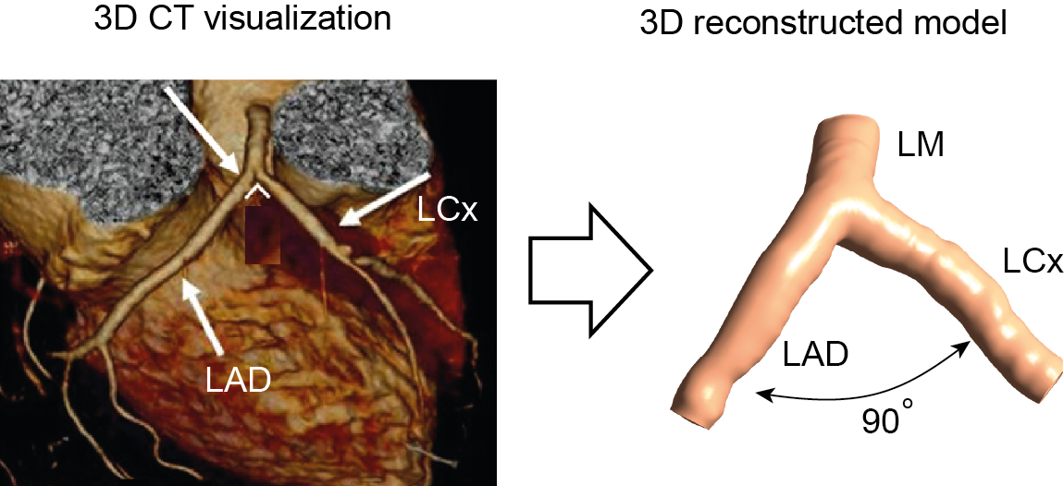

Figure 9. 1 3D CT visualization and reconstruction of the image-based model.

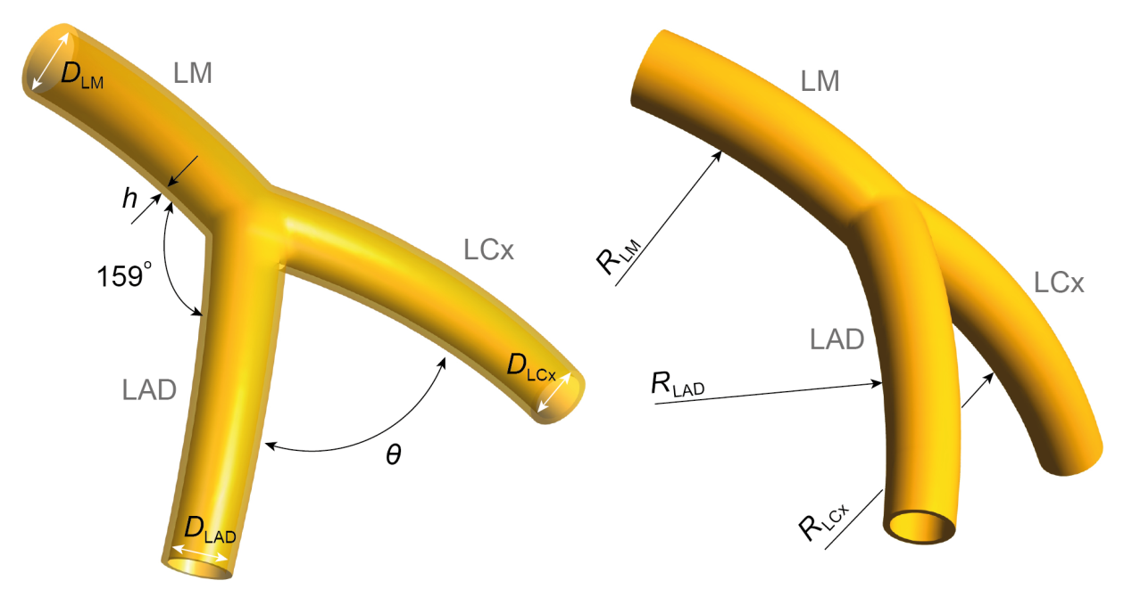

Figure 9. 2 Geometry configuration of the idealized artery model.

Table 9. Anatomical dimensions of the idealized model.

|  |  |
| --- | --- |
| Length of LM | 11.0 mm |
| Dia. of LM | 4.0 mm |
| Dia. of LAD | 3.4 mm |
| Dia. of LCx | 3.0 mm |
| Rad. of curvature of LAD | 42.8 mm |
| Rad. of curvature of LCx | 39.3 mm |
| Angulation between LM and LAD | 159º |

LM—left main stem, LAD—left anterior descending, LCx—Left circumflex

### 9.2. Mesh generation and physiological boundary conditions

For each coronary artery model, both fluid and structural domains were meshed with hexahedral cells to minimize numerical diffusion and lower the number of elements. A near wall grid refinement was imposed on each model to provide better resolution for near wall quantities. Mesh results for fluid domain and structural domain of the image-based model and the idealized model (*θ* = 90º) are depicted in Figure 9. 3. Since it is difficult to obtain the outer wall boundary of the artery from CT images, the vessel wall was artificially constructed with a constant thickness (Colombo et al., 2010) *h* = 0.4 mm. Although arterial wall is known to be a composite tissue including collagen fibers, its heterogeneous and anisotropic structure properties was simplified by adopting a nine parameter Mooney-Rivlin hyperelastic model (Koshiba et al., 2007) due to lack of in vivo data.

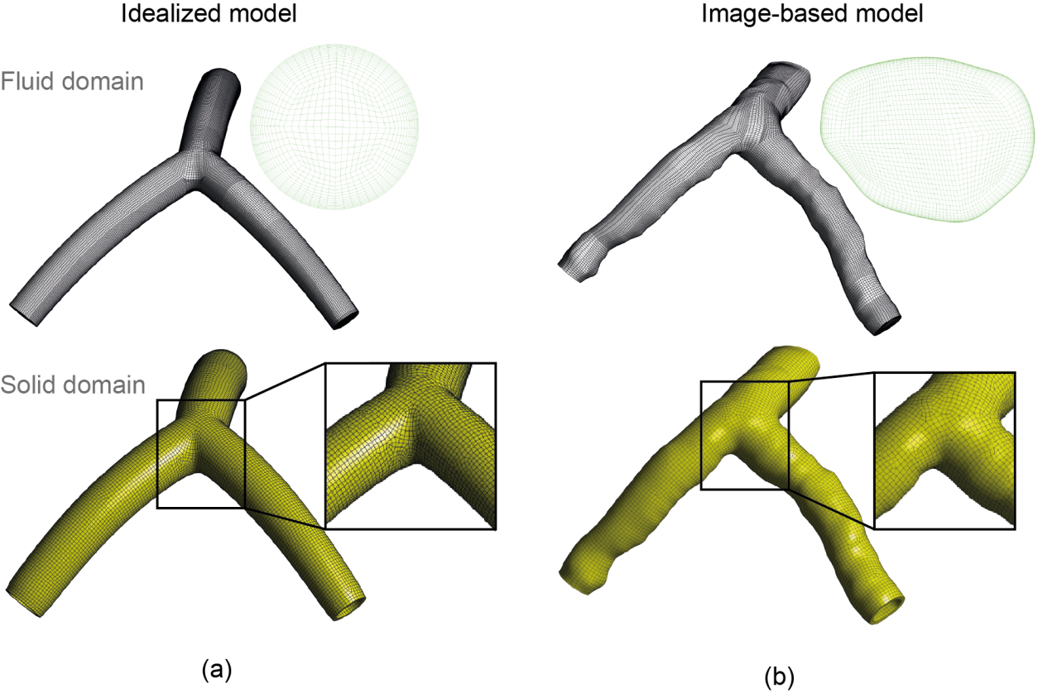

Figure 9. 3 Structure mesh results of idealized (a) and image-based (b) models.

The inlet and outlet boundary conditions shown in Figure 9. 4 (a) are based on a physiological pulsatile flow rate and pressure at the aorta (Nichols and O'Rourke, 2005), reconstructed using a Fourier series in Matlab (Math Works Inc., Natick, MA, USA). This Fourier series was inputted into ANSYS CFX Command Language programming to define boundary conditions. The blood flow distribution in the bifurcation adopts the method by Boutsianis et al. (Boutsianis et al., 2004), where 71% is directed through left anterior descending (LAD) and 29% through left circumflex (LCx), and this is maintained unchanged through the entire cardiac cycle. Pulsatile aortic pressure was applied as an inlet boundary condition at the left main stem (LM), and pulsatile velocity conditions were imposed on both the LAD and the LCx outlet boundaries (Figure 9. 4 (b)). As this study focuses on the local hemodynamic changes under different branch angulations, global coronary wall motion due to its attachment to the moving myocardium is neglected to isolate the effects of wall compliance (Torii et al., 2009, Malve et al., 2012).

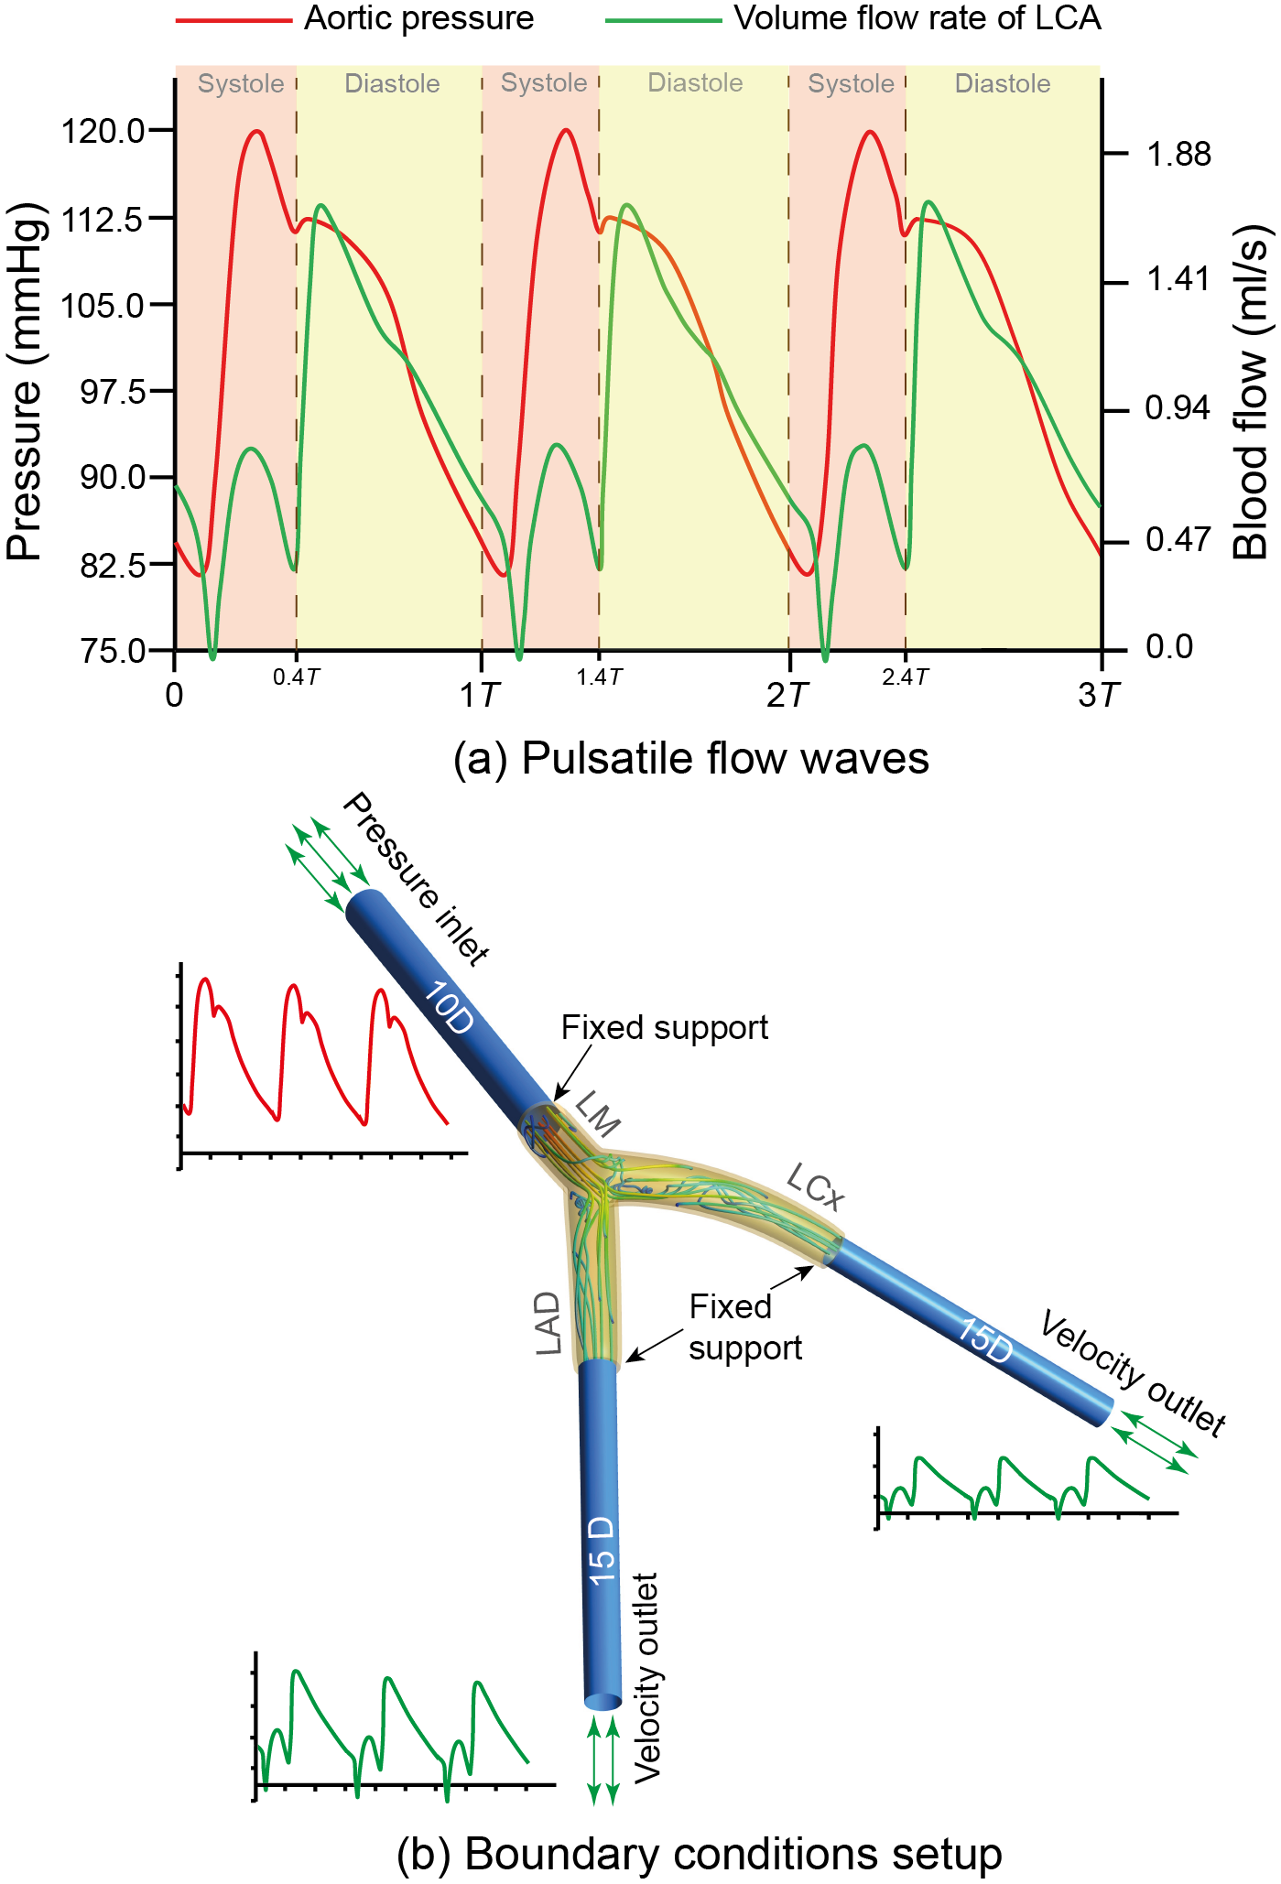

Figure 9. 4 Pulsatile blood flow waves used in this study.

The blood was assumed to be Newtonian since the shear rate is large enough in coronary arteries (larger than 100 s-1) to maintain a flow regime with nearly constant viscosity (Joshi et al., 2004, Gijsen et al., 2007). The density and viscosity of the blood are 1060 kg/m3 and 0.0035 Pa•s (Chaichana T et al., 2012). The blood flow was treated as laminar and no-slip condition was applied at arterial walls. To eliminate the local fluid dynamic effects on the reconstructed fluid domain and ensure fully developed outlet flow conditions, a 10-diameter length inlet extension and 15-diameter length outlet extensions were added (Joshi et al., 2004).

Mesh independence was conducted on the idealized model (θ = 100º) using three mesh sizes, and the peak diastole wall shear stress values at the bifurcation apex were compared (Table 9. 2). Comparing with the finest mesh, the coarse mesh has the largest value difference percentage (5.47%) costing the shortest computational time (13h), while the fine mesh has a closer prediction performance with a value difference percentage of 1.09% under acceptable computational time duration (21h). Hence fine mesh size (0.15mm) was chosen to conduct the rest of the simulations from accuracy and efficiency points of view.

Table 9. 2 Mesh independence study of three different mesh refinements.

|  |  |  |  |
| --- | --- | --- | --- |
|  | Coarse Mesh | Fine Mesh | Finest Mesh |
| Number of elements | 398,178 | 818,714 | 1,997,318 |
| Average Δx | 0.21mm | 0.15mm | 0.09mm |
| WSS at the apex | 2.02 Pa* | 2.11 Pa* | 2.14 Pa* |
| Difference percentage | 5.61% | 1.40% | — |
| Computational time | 13h | 21h | 35h |

*Values were extracted at the peak of diastole phase

### 9.2. Fluid-Structure interaction simulation

The governing equations for the incompressible Navier-Stokes equations with arbitrary Lagrangian-Eulerian formulation are

+ [((*u*-*u*g) ∙)*u*] = - $∂p+ μ∂^{2}u$, $∇$ ∙ *u* = 0 (Eq. 9. 1)

with boundary conditions

${\left.p\right|}_{inlet}$ = $p_{in}\left(t\right)$, ${\left.p\right|}_{outlet}$ = $p_{out}\left(t\right)$ (Eq. 9. 2)

where *u* is the flow velocity, *ug* is the mesh velocity, *p* is the pressure, *μ* and $ρ_{b}$ stand for the blood viscosity and density, respectively.

The arterial wall motion is governed by

$ρ_{w}v_{i,tt}= σ_{ij,j}$, $i,j=1, 2, 3;$ sum over j (Eq. 9. 3)

with boundary condition ${\left.σ_{ij,j}∙ n_{j}\right|}_{outer wall}=0$, where $v$ is the displacement vector, $σ$ is the stress tensor, and $t$ denotes time.

The interaction between the Fluid and Structure is

${\left.σ_{ij}^{f}∙ n_{j}\right|}_{Γ}={\left.σ_{ij}^{s}∙ n_{j}\right|}_{Γ}$ (Eq. 9. 4)

where *𝚪* represents the inner wall the vessel, *f* and *s* stand for fluid part and structure part, respectively. The fully coupled FSI models were solved in commercial software packages ANSYS CFX and ANSYS Mechanical (ANSYS Inc., Canonsburg, USA). For each coronary artery model, transient flow simulations over three cardiac cycles were performed, and results at the last cycle were used for mechanical and hemodynamic analysis.

## 9. Results

### 9.3. Mechanical results analysis

First principal stress is used for stress distribution analysis, as it represents the maximum tensile stress included in the vessel wall due to the pulsatile loading of blood flow. Figure 9. 5 illustrates the first principal stress distribution for the idealized (*θ* = 90º) and the image-based models at peak systole phase. For the idealized model, high first principal stress value concentrates at the bifurcation area. The maximum value 0.28 MPa occurs at the bifurcation apex, followed by the bifurcation shoulders on LCx side (0.22 MPa) and LAD side (0.15 MPa) respectively. Similarly, the first principal stress distribution of the image-based model shows a similar result when compared with the idealized model (*θ* = 90º). Due to its irregular vascular luminal shape, a fraction of left main stem (LM) luminal region experiences slightly stronger stress value than their corresponding locations on the idealized model.

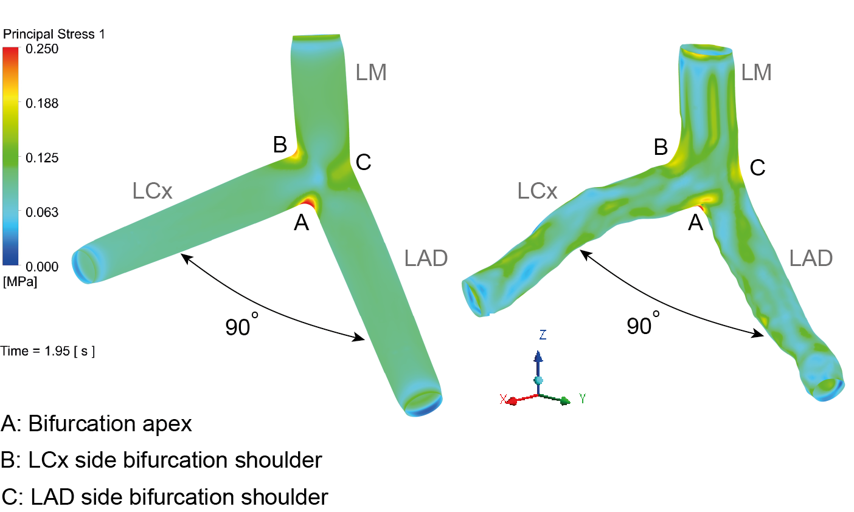

Figure 9. Comparison of first principal stress at peak systole (*t* = 1.95 s).

To reveal the bifurcation angulation influence on stress distribution, the variations of first principal stress at three reference locations indicated by three red dots, the LAD side bifurcation shoulder (Figure 9. 6), the bifurcation apex (Figure 9. 7), and the LCx side bifurcation shoulder (Figure 9. 8) are reviewed. In general, the first principal stress shows a similar profile with aortic pressure, which demonstrates the stress variation is mainly driven by the pulsatile aortic pressure. Since the angle formed by LM and LAD is kept constant (159º), the stress variation profiles at the LAD side bifurcation shoulder are similar for all models (Figure 9. 6), and hence the bifurcation angle variation does not affect the stress distribution in this region.

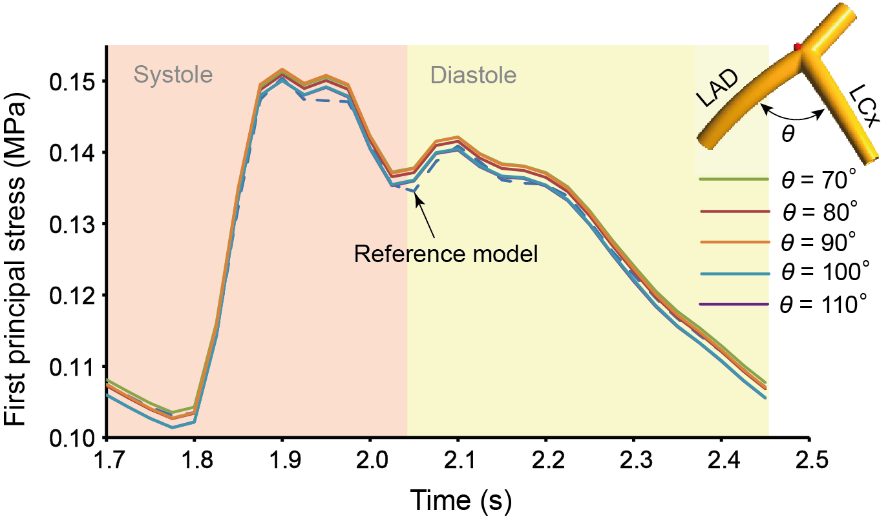

Figure 9. First principal stress profiles at the LAD side bifurcation shoulder.

Figure 9. 7 depicts the stress variation at the bifurcation apex, where the bifurcation angle is found to negatively correlate with the first principal stress value. For the narrowest idealized model (*θ* = 70º), its maximum stress $σ_{max}$ = 0.41 MPa occurs at the peak systole phase, while the widest idealized model (*θ* = 110º) experiences $σ_{max}$ = 0.24 MPa at the same time. This represents a value reduction of 41.5% due to bifurcation angle increase.

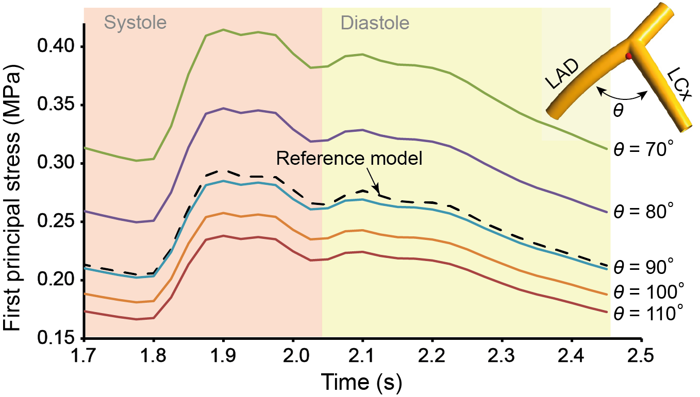

Figure 9. First principal stress profiles at the bifurcation apex.

In contrast, a positive correlation is found between the first principal stress at the LCx side bifurcation shoulder and the bifurcation angle (Figure 9. 8). As the angle increases, the maximum stress also increases 50% from 0.18 MPa (*θ* = 70º) to 0.27 MPa (*θ* = 110º) at peak systole phase. Furthermore, the overall stress value at the bifurcation apex (Figure 6) is stronger than that of the LCx side shoulder (Figure 9. 7) when *θ* < 100º. When *θ* = 100º, the stress difference between these two locations is significantly reduced. For the idealized model with *θ* = 110º, the maximum stress occurs at the LCx side bifurcation shoulder ( $σ_{max}$ = 0.27 MPa) rather than the bifurcation apex ( $σ_{max}$ = 0.24 MPa).

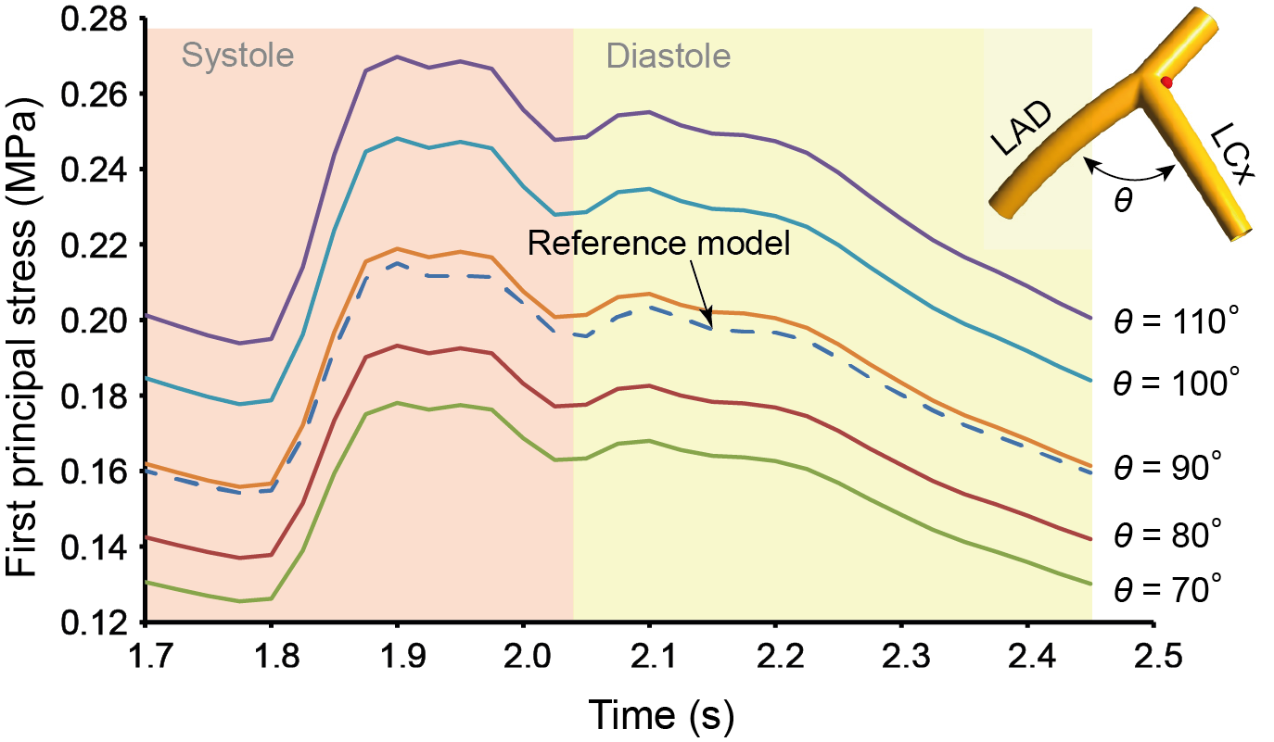

Figure 9. First principal stress at the LCx side bifurcation shoulder.

The image-based model also displays a similar stress variation profile with the idealized model (*θ* = 90º) both on the bifurcation apex and the LCx side bifurcation shoulder. Along with the results shown in Figure 9. 5, it can be demonstrated that the idealized models are capable of representing key FSI results for further analysis.

### 9.3. Hemodynamic results analysis

The widely adopted flow indicator, WSS-based oscillatory shear index (OSI) is used to evaluate the total shear stress exerted on the arterial wall (Figure 9. 9). It can be regarded as the fraction of angle and magnitude change between the instantaneous WSS and the time-averaged WSS ranging from 0 to 0.5. High OSI indicates unsteady and oscillatory flow with low WSS which leads to a predisposition of endothelial dysfunction and atherogenesis (Ku et al., 1985, Davies, 2009, Dong J et al., 2013). Generally, high OSI regions are concentrated at the origins and proximal LCx branches with no significant differences among idealized models. This indicates the affected regions are susceptible to progress atherosclerotic changes due to the presence of disturbed flow. As a reference, the image-based model shows a similar OSI distribution except in the distal LAD branch, where a locally high OSI is found caused by a moderate bulge section. Due to this luminal expansion, local flow separation and disturbance appear as a result.

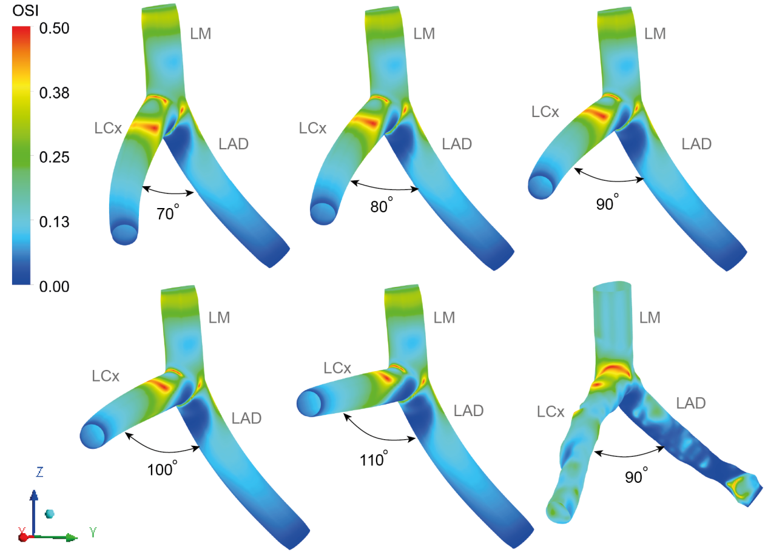

Figure 9. 9 Comparison of OSI distribution for different idealized models.

Wall shear stress results predicted by FSI and rigid model are compared in Figure 9. 10 (a). The rigid model predicts a greater distribution of higher WSS values at the peak of diastole phase (*t* = 2.05 s) both at the bifurcation apex and the narrowed lumen site downstream of the LAD branch. In contrast, the FSI model produces lower WSS value at these locations due to considerable vessel expansion driven by the pulsatile blood flow, which is in agreement with previous studies (Torii et al., 2009, Malve et al., 2012). Instantaneous WSS variation at the bifurcation apex is shown in Figure 9. 10 (b). At the systole phase, the WSS predicted by the rigid model is slightly larger than the FSI model. However, the WSS magnitude difference becomes greater in the diastole phase. The averaged WSS predicted by the FSI model is smaller than the rigid model by 32%. This significant difference is mainly caused by the increased mass flow rate occurring at the diastole phase than systole. Since WSS is proportional to the velocity gradient in the near wall region, and if the arterial wall is assumed to be rigid, then the blood flow will be further accelerated leading to a greater velocity gradient in the near wall region than in an FSI modelling approach.

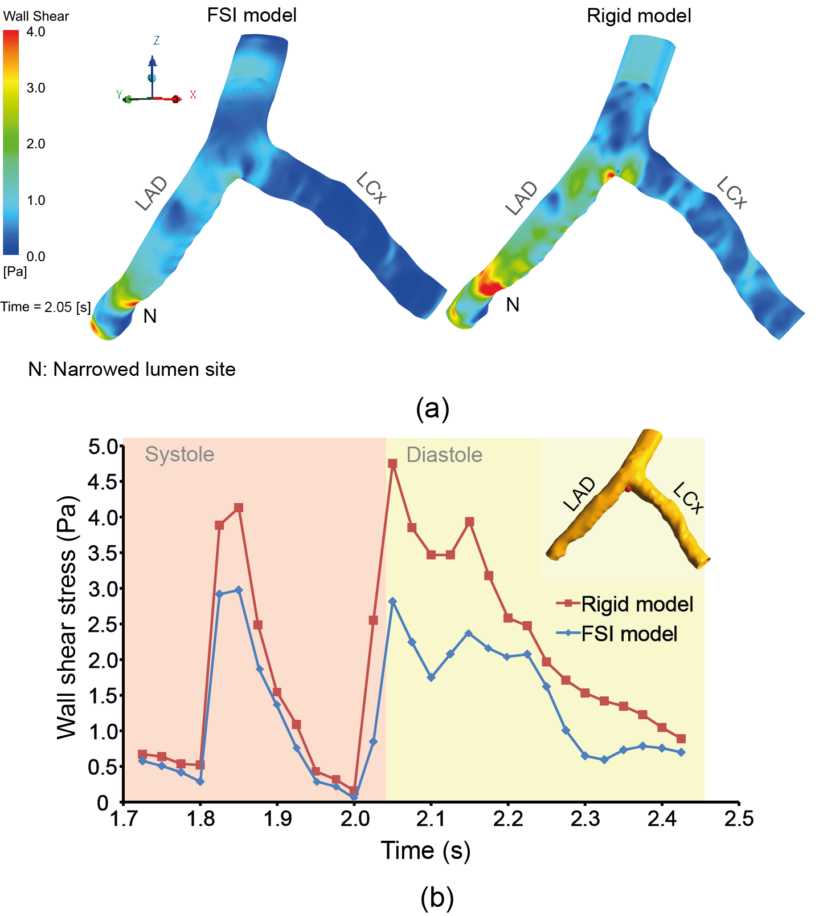

Figure 9. Comparison of FSI and Rigid models for the image-based model: (a) WSS distribution at peak diastole (*t* = 2.05 s); (b) WSS variation over the last cardiac cycle at the bifurcation apex.

## 9. Discussion and Conclusion

The results demonstrate that the variation of branch angle significantly influences the artery mechanical deformation. Wider-angled models lead the LCx side bifurcation shoulder to be continuously exposed under strong first principal stress and high oscillatory shear index during the whole cardiac cycle.

First principal stress results of the image-based model shows a close agreement with the idealized model (*θ* = 90º). Therefore, the medical application potential of the proposed FSI coupling method to investigate intravascular flow environment of realistic model is demonstrated.

It is well established that endothelial cells, which form an important part of the vasculature, are involved in promoting an atheroprotective environment by complementary actions of endothelial cell-derived vasoactive factors. Disruption of vascular homeostasis can lead to the development of endothelial dysfunction which in turn contributes to the early and late stages of atherosclerosis (Lerman and Zeiher, 2005). Endothelial cells experience two major hemodynamic forces in vivo: fluid shear stress (*τ*), which is a frictional force imposed per unit area from blood flow parallel to the vessel wall; and tensile stress (*P*), which is a normal stretch force resulting from the expansion effect of blood pressure on the vessel (Hahn and Schwartz, 2008). Both fluid shear stress and tensile stress play important roles in maintaining the homeostasis of the blood vessel, but they can also become pathophysiological factors in the complex pathogenesis of atherosclerosis (Chien et al., 1998, Lehoux and Tedgui, 1998). For endothelial cells subjected to disturbed flow, endothelial dysfunction occurs when pro-inflammatory phenotype is triggered and developed, and the affected cells are unable to adapt to disturbed flow (Ku et al., 1985, Malek et al., 1999). Therefore, low mean shear stress and marked oscillations in the direction of wall shear stress play critical roles in the development of atherosclerosis.

Vascular smooth muscle cells, serving as the second layer of the vessel from the inner side, appear mainly to respond to tensile stress (Hahn and Schwartz, 2008) which is dependent on lumen radius and wall thickness. This stress has been suggested as a main source of mechanical stimuli to promote atherosclerotic plaque formation. Furthermore, it may invoke various signal transductions (i.e. calcium/natrium ion channels, renin-angiotensin systems, integrins) in vascular smooth muscle cells and to stimulate extracellular matrix formation (Osol, 1995, Wilson et al., 1995). Accordingly, shear stress and tensile stress are believed to be pathophysiologic stimuli in atherosclerosis (Chatzizisis et al., 2007, Chatzizisis and Giannoglou, 2009). Therefore, arterial districts involved by elevated tensile forces and low shear stress environment suggest a high potential of developing atherosiclerosis (Thubrikar and Robicsek, 1995).

This study provides the insights of the connection between bifurcation angle and the development of coronary atherosclerosis from mechanical and haemodynamics point of view, which differs from angiography assessment conventionally used by clinical study. The clinical study by Sun Z et al. (Sun and Cao, 2011) reports that the mean diameter of LCx in patients with a bifurcation angle *θ* > 80º was significantly larger than that measured in patients with bifurcation angle *θ* < 80º due to the presence of atherosclerotic plaques, and wider bifurcation angles are closely related to the development of atherosclerosis, thus leading to coronary artery disease. Results from this study are consistent with their reports as high tensile stress and low oscillatory wall shear stress simultaneously occur at the LCx side bifurcation shoulder in wider-angled models, high tendency of inducing atherosclerotic changes are indicated.

Lastly, comparison of numerical results between FSI and rigid models showed not only remarkable qualitative discrepancies in the WSS distributions over two regions (the bifurcation apex and the moderate narrow lumen site downstream of the LAD branch), but also apparent quantitative differences in the WSS profiles at the bifurcation apex over the diastole phase. Therefore, the effect of the arterial wall compliance on coronary artery haemodynamics plays an important role in the numerical simulation accuracy, and it cannot be neglected for clinical diagnostic purpose (Kabinejadian and Ghista, 2012).

Some limitations in this study should be considered. Firstly, no pathological changes such as coronary stenosis are simulated, since the aim of this chapter is to investigate the influence of branch angulation changes on coronary haemodynamics, and therefore the effects of stenosis is not studied in this work. Secondly, despite the assumption that a Newtonian model is reasonable in coronary artery simulation based on previous studies (Joshi et al., 2004, Gijsen et al., 2007), the approach limits the biological effects of prolonged contact of blood flow with the cells of vascular wall. Thirdly, the angle formed by LM and LAD was set into a constant (Johnston and Kilpatrick, 1997) for the purpose of isolating the effect of single geometric factor, while the sequence of angle variation between LAD and LM was neglected. Lastly, due to the lack of patient-specific data and extremely time-consuming model reconstruction procedure, only one CT image-based coronary artery model was selected in this study, and no sub-branches were included during model reconstruction. As mentioned, the numerical predictions compare well with reported clinical studies, and the results of the image-based model are consistent with the idealized model, the reliability of the research findings can be validated.

In conclusion, the branch angulation strongly alters its mechanical stress distribution under pulsatile blood pressure. High tensile and low oscillatory shear stress simultaneously occurs at the LCx side bifurcation shoulder in wider-angled models. Along with the reported clinical findings, a high tendency of inducing atherosclerosis is suggested for the bifurcation shoulder on LCx branch side for wider-angled models. The functional mechanical and hemodynamic indices yielded from this study can facilitate clinicians to have a better understanding of the role of haemodynamics in atherosclerotic disease initiation and progression in vicinity of bifurcations. Implementations of the proposed research framework over patient-specific models can enable clinicians to noninvasively detect and analyse plaques at early stages, especially in asymptomatic and low-risk patients, which can improve risk stratification without including more invasive procedures.

# CHAPTER 10

# Closing Remarks

## 10. Conclusions

Atherosclerosis and its related cardiovascular diseases cost a huge expense in modern society, and its occurrence frequency as well as the complications severity are increasing rapidly. Thus, the increasing incidents of major vascular syndromes are consuming a major and steadily increasing portion of worldwide healthcare costs for clinical treatment and rehabilitation.

In fact, long before any symptoms are clinically evident, vascular disease begins as a malfunction of specialized cells that line our arteries. These cells, called endothelial cells, are the key to atherosclerosis and underlying endothelial dysfunction is the central feature of this dreaded disease. The investigation of arterial haemodynamics has already lead to substantial advancements in the fields of pathology and intervention, both experimentally and numerically. However, uncertainties still remain. For example, although plenty of experimental measurements have made great progress in resolving complex blood flow patterns, they are still inadequate to achieve a complete mechanistic understanding of complex diseases due to the limited field resolution and oversimplified phantom geometry. Even numerous numerical studies have been conducted for arterial bifurcations, majority of them adopt simplified outlet conditions, rigid vessel wall assumptions, and less clinically relevant analysis.

To narrow down the research gaps as mentioned, the present thesis presents an accurate and efficient computational haemodynmics approach, in regards to better understanding of fluid dynamics within healthy and atherosclerotic artery bifurcation models. Overall, this thesis is composed by four main parts of work, which are:

1. Validation of the proposed numerical approach against PIV measurements using identical idealised carotid artery bifurcation models;
2. Developing a flow resistance model to represent the downstream flow resistance influence due to the existence of peripheral vascular tree.
3. Implementation of the proposed numerical approach to more image-based carotid bifurcation models for atherosclerosis severity stratification.
4. Investigation of the relationship between artery bifurcation angle and mechanical loading within arterial vessel, and its roles in the pathology of atherosclerosis.

### 10.1. Validation against PIV measurements outcomes

The accuracy and performance of the proposed computational haemodynamics approach was successfully validated by means of PIV measurements, and the predicted stream-wise flow patterns are in satisfactory agreement with the measured data.

Compared with the PIV data, flow separation and recirculation regions due to the abrupt cross-sectional area expansion at the ICA sinus region of the healthy model were successfully predicted by the numerical simulation based on a laminar model. For the diseased model, the velocities predicted at the stenotic site were over-predicted for both Reynolds number conditions, and a great disagreement occurs at the stenosis throat (plane B-B’), where the velocity is considerably over-predicted by the numerical simulation with a maximal discrepancy of approximately 27.8% when Re = 800. While for the rest regions of this model, good agreement with the experimental data can be found. Nonetheless, this order of error is comparable to published works. The diseased model was also simulated using a laminar model which produced slightly worse comparisons with the experimental data. Therefore, the basic numerical configurations used in this paper are capable of providing more accurate information of the intravascular flow field for both healthy and stenotic carotid bifurcation models.

### 10.1. Development of downstream vascular impedance model outcomes

The accuracy of the isolated three-dimensional patient-specific carotid bifurcation haemodynamics highly depends on the application of the boundary conditions. If the most desirable invasive measurement cannot be available, a special treatment is required. Porous medium with transient permeability can reflect the characteristic of the downstream vascular impedance well, and the haemodynamics accuracy was also verified with the prescribed boundary treatment. This vascular impedance model can be used as a research tool in pre-evaluation and prediction of the planned vascular intervention.

The carotid bulb is a common athroprotective location for both the healthy case study and the diseased case study because of the commonly formed disturbed flow at this region; The studied diseased carotid bifurcation experiences a high TAWSS at the throat of the ICA stenosis, which gives a warning of stroke, and the blood transportation is also disturbed as the flow division value deviates from normal situation constantly. Therefore, a vascular intervention is required. Furthermore, the fixed flow division is not comprehensive for carotid bifurcation haemodynamics as it is unable to account for the variable downstream vascular bed impedance.

One limitation of this work is that the vessel compliance due to the neglectance of blood vessel interaction, and can be elevated by implementing fluid solid interaction in the future. Despite this, the downstream vascular bed impedance mimicking model is a very efficient and robust tool for computational haemodynamics simulation without using complex multi-scale modelling. This model can be used for providing a reliable pre-assessment of the diseased intravascular blood flow and give prediction of the proposed surgical plan by virtually intervention method. Consequently, it will provide evidential approaches to cardiovascular treatment using case-based analysis with the professional clinical knowledge, so as to develop a more appropriate screening and early detection strategies.

### 10.1. Image-based computational haemodynamics analysis of carotid artery bifurcations outcomes

Image-based anatomical evaluations alone can approximately determine the artery stenosis burden, but cannot provide further detailed evidence to quantify the stenosis severity in addition to geometry occlusion measurement. In this chapter, after the numerical accuracy was validated with published experimental results of two representative carotid bifurcations, a systematic methodology of high performance computational haemodynamics of atherosclerotic carotid bifurcation artery was proposed and performed on ten selected patient-specific realistic carotid bifurcation models. As TAWSS based analysis of the stenotic carotid bifurcation models can capture the abnormally high WSS lesion sites as well as the disturbed flow regions quantified by high OSI, therefore, the risk of direct endothelial injury and the consequent progression of plaque could be assessed and predicted. Based on the simulation results, it was found that the presence of plaque increases the WSS due to the accelerated blood flow, which can cause plaque erosion and thrombosis leading to stroke. Meanwhile, disturbed flow regions are established downstream of the stenosis lesion, where the endothelial cells are predisposed to dysfunction and atherogenesis. Eventually, the lesion-induced flow disturbances may contribute to a continuous stream-wise growth of the lesion over time.

In order to reveal the effects of the plaque existence on blood transportation performance, the pressure drop coefficient was introduced through adopting a linear relationship with fractional flow reserve, which further accesses the occlusion percentage of blood transportation based on generated numerical simulation results. In addition, the influence of the presence of probe wire can also be prevented. Associating with the widely adopted clinical criteria, the severity of the stenosis can be easily stratified and modeled to proper treatment strategy. Some research assumptions of this work may restrict the accuracy of results. First, the influence of the vessel compliance is not taken into account, and this can be improved by implementing fluid structure interaction in the future. Another is the use of the representative inflow waveform. In clinical diagnosis, using Doppler ultrasound or phase-contrast MR imaging can measure the flow directly. However, these assumptions simplify the research when the time costs become important or even critical for the treating physician in practice. Therefore, the presented research applied with limitations can still provide evidential approaches to cardiovascular treatment in a quick time-frame. Although the current turn-around time cost for each stenotic model was 19 hours, through optimization techniques within the work flow, this can be reduced down to 6 hours which could prove to be of high clinical relevance.

### 10.1. Fluid-structure interaction analysis of left coronary artery outcomes

The results demonstrate that the variation of branch angle significantly influences the artery mechanical deformation. Wider-angled models lead the LCx side bifurcation shoulder to be continuously exposed under strong first principal stress and high oscillatory shear index during the whole cardiac cycle.

First principal stress results of the image-based model shows a close agreement with the idealized model (*θ* = 90º). Therefore, the medical application potential of the proposed FSI coupling method to investigate intravascular flow environment of realistic model is demonstrated.

It is well established that endothelial cells, which form an important part of the vasculature, are involved in promoting an atheroprotective environment by complementary actions of endothelial cell-derived vasoactive factors. Disruption of vascular homeostasis can lead to the development of endothelial dysfunction which in turn contributes to the early and late stages of atherosclerosis. Endothelial cells experience two major hemodynamic forces in vivo: fluid shear stress (*τ*), which is a frictional force imposed per unit area from blood flow parallel to the vessel wall, and tensile stress (*P*), which is a normal stretch force resulting from the expansion effect of blood pressure on the vessel. Both fluid shear stress and tensile stress play important roles in maintaining the homeostasis of the blood vessel, but they can also become pathophysiological factors in the complex pathogenesis of atherosclerosis. For endothelial cells subjected to disturbed flow, endothelial dysfunction occurs when pro-inflammatory phenotype is triggered and developed, and the affected cells are unable to adapt to disturbed flow. Therefore, low mean shear stress and marked oscillations in the direction of wall shear stress play critical roles in the development of atherosclerosis.

Vascular smooth muscle cells, serving as the second layer of the vessel from the inner side, appear mainly to respond to tensile stress, which is dependent on lumen radius and wall thickness. This stress has been suggested as a main source of mechanical stimuli to promote atherosclerotic plaque formation. Furthermore, it may invoke various signal transductions (i.e. calcium/natrium ion channels, renin-angiotensin systems, integrins) in vascular smooth muscle cells and to stimulate extracellular matrix formation. Accordingly, shear stress and tensile stress are believed to be pathophysiologic stimuli in atherosclerosis. Therefore, arterial districts involved by elevated tensile forces and low shear stress environment suggest a high potential of developing atherosclerosis.

This chapter provides the insights of the connection between bifurcation angle and the development of coronary atherosclerosis from mechanical and haemodynamics point of view, which differs from angiography assessment conventionally used by clinical study. The clinical study by Sun Z et al. (Sun and Cao, 2011) reports that the mean diameter of LCx in patients with a bifurcation angle *θ* > 80º was significantly larger than that measured in patients with bifurcation angle *θ* < 80º due to the presence of atherosclerotic plaques, and wider bifurcation angles are closely related to the development of atherosclerosis, thus leading to coronary artery disease. Results from this study are consistent with their reports as high tensile stress and low oscillatory wall shear stress simultaneously occur at the LCx side bifurcation shoulder in wider-angled models, high tendency of inducing atherosclerotic changes are indicated.

Lastly, comparison of numerical results between FSI and rigid models showed not only remarkable qualitative discrepancies in the WSS distributions over two regions (the bifurcation apex and the moderate narrow lumen site downstream of the LAD branch), but also apparent quantitative differences in the WSS profiles at the bifurcation apex over the diastole phase. Therefore, the effect of the arterial wall compliance on coronary artery haemodynamics plays an important role in the numerical simulation accuracy, and it cannot be neglected for clinical diagnostic purpose.

In summary, the branch angulation strongly alters its mechanical stress distribution under pulsatile blood pressure. High tensile and low oscillatory shear stress simultaneously occurs at the LCx side bifurcation shoulder in wider-angled models. Along with the reported clinical findings, a high tendency of inducing atherosclerosis is suggested for the bifurcation shoulder on LCx branch side for wider-angled models. The functional mechanical and hemodynamic indices yielded from this study can facilitate clinicians to have a better understanding of the role of haemodynamics in atherosclerotic disease initiation and progression in vicinity of bifurcations. Implementations of the proposed research framework over patient-specific models can enable clinicians to noninvasively detect and analyse plaques at early stages, especially in asymptomatic and low-risk patients, which can improve risk stratification without including more invasive procedures.

## 10. Future Directions

This work has presented a novel and versatile computational haemodynamics approach for in vitro investigation of arterial haemodynamics, especially for blood flow within artery bifurcations. The numerical investigation performed in this thesis can contribute to a better understanding of the pathogenesis and consequences of atherosclerosis from fluid and structure dynamics points of view. Since significant progress in computational modelling has been made in the last few decades, these advances along with increased computational power will further enable modelling realistic physiological scenarios of haemodynamic flows.

### 10.2. Multiphase Flow

Blood at physiologic conditions is a dense suspension of cells and platelets but dominated by red blood cells. In most cases, they are the blood component principally responsible for its rheology. The flow regime is termed sub-Stokesian where the local environment remains predominately viscous. However at these flows, the red blood cells are significantly distorted due to their flexibility leading to a change in its effective viscosity and frictional resistance.

The term multiphase flow suggests that the red blood cells can be treated as a deformable discrete phase moving through a flowing continuous phase in the form of plasma. The discrete red blood cells can be treated in a Lagrangian approach, tracked individually, while the continuous phase is in the Eulerian approach. Zhao et al. (Zhao et al., 2012) used this approach to produce a suspension of red blood cells and platelets flowing between two flat plates of a micro-channel of height 34µm (Figure 10. 1).

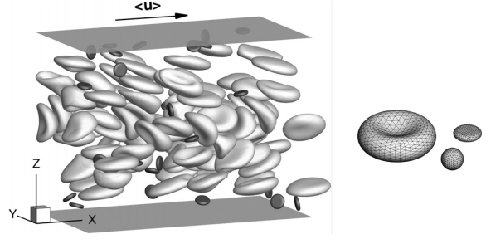

Figure 10. 1 Modelling red blood cells and platelets in a micro-channel of 34µm in height. *(Image from Zhao et al 2012)*

This research direction can accurately model the shear thinning properties of blood, and its related wall shear stress distribution. However, for major artery bifurcations, such as carotid artery bifurcation, literature suggests only minor differences can be found. Therefore, in the present work, the blood flow is assumed to be single phase, and the Carreau-Yasuda model is used to represent the Non-Newtonian rheology for numerical simulations with local flow disturbance (e.g., flow separation and recirculation)

### 10.2. Imaging for physiological flow boundary conditions

The current thesis employs simplified flow boundary conditions, such as the constant flow division for numerical validation, the volume flow conditions for carotid artery simulation. Neither of them is patient-specific data, and limits the reliability of the results yield from this study.

The recent developments in the fields of CT and MRI mapping systems, velocity-encoded measurements, generate accurate time-resolved vector fields of up to three spatial dimensions. Phase-sensitive flow MRI (velocity mapping) or velocity-encoded cine magnetic resonance imaging (VEC-MR) are well-established methods for quantification of flow in the cardiovascular system.

Therefore, future investigations utilizing patient-specific flow data can considerably improve the reliability of the current numerical approach, and contribute to improved clinical diagnosis. In addition, in-plane field generated by in vivo measurement technologies can also be served as flow validation data for numerical modelling. All these data from different sources will give new dimensions to our understanding of the pathology and the impact of cardiovascular disease.

### 10.2. Simulations based surgical interventions

Image-based computational fluid dynamics provides great promise for evaluation of vascular devices and assessment of surgical procedures. However, many previous studies employ idealized arterial and device models or patient-specific models with a limited number of cases, since the model construction process is tedious and time-consuming. Moreover, in contrast to retrospective studies from existing image data, there is a pressing need of prospective analysis with the goal of surgical planning. Therefore, it is necessary to construct models with implanted devices in a fast, virtual and interactive way to provide a prediction of the proposed surgical interventions, such as stenting.

Development of the computational fluid dynamics (CFD) and finite element analysis (FEA) platforms demonstrates the potential to satisfy this requirement in the study of diseased vascular systems. As shown in Figure 10. 2, based on these already available research capabilities, the framework will provide a simulation-based virtual stenting environment for clinical management, simulation of flow conditions due to cardiovascular diseases, planning of stent designs and virtual treatment of the human vascular system. Each successful treatment of the diseased vessel can be saved into a database of patient records.

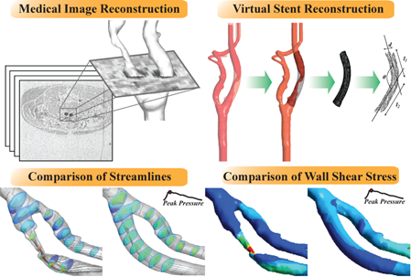

Figure 10. 2 Virtual stent design and its outcome prediction.

Given the recent advancements in CFD, it is necessary to develop a CFD-based virtual surgical intervention tool for outcome prediction and assessment of individual patients within the next decade. However, there is still much to learn about the nature of atherosclerosis and it will require a multi-disciplinary knowledge from computational scientists, clinicians, biologists, and engineers. Their collaborative effort is vital for developing more robust risk predictors, and ultimately unlocking the mystery of the complex artery disease.

# References

ALEXANDER, R. W. 1995. Hypertension and the Pathogenesis of Atherosclerosis - Oxidative Stress and the Mediation of Arterial Inflammatory Response - a New Perspective. *Hypertension,* 25**,** 155-161.

ANDERSON, C. S., TAYLOR, B. V., HANKEY, G. J., STEWARTWYNNE, E. G. & JAMROZIK, K. D. 1994. Validation of a Clinical Classification for Subtypes of Acute Cerebral Infarction. *Journal of Neurology Neurosurgery and Psychiatry,* 57**,** 1173-1179.

ASAKURA, T. & KARINO, T. 1990. Flow Patterns and Spatial-Distribution of Atherosclerotic Lesions in Human Coronary-Arteries. *Circulation Research,* 66**,** 1045-1066.

ASCHER, E., MARKEVICH, N., HINGORANI, A. P., KALLAKURI, S. & GUNDUZ, Y. 2002. Internal carotid artery flow volume measurement and other intraoperative duplex scanning parameters as predictors of stroke after carotid endarterectomy. *Journal of Vascular Surgery,* 35**,** 439-444.

AWOLESI, M. A., SESSA, W. C. & SUMPIO, B. E. 1995. Cyclic Strain up-Regulates Nitric-Oxide Synthase in Cultured Bovine Aortic Endothelial-Cells. *Journal of Clinical Investigation,* 96**,** 1449-1454.

BALAFAR, M. A., RAMLI, A. R., SARIPAN, M. I. & MASHOHOR, S. 2010. Review of brain MRI image segmentation methods. *Artificial Intelligence Review,* 33**,** 261-274.

BALOSSINO, R., PENNATI, G., MIGLIAVACCA, F., FORMAGGIA, L., VENEZIANI, A., TUVERI, M. & DUBINI, G. 2009. Computational models to predict stenosis growth in carotid arteries: Which is the role of boundary conditions? *Computer Methods in Biomechanics and Biomedical Engineering,* 12**,** 113-123.

BAMFORD, J., SANDERCOCK, P., DENNIS, M., BURN, J. & WARLOW, C. 1991. Classification and Natural-History of Clinically Identifiable Subtypes of Cerebral Infarction. *Lancet,* 337**,** 1521-1526.

BANERJEE, R. K., ASHTEKAR, K. D., HELMY, T. A., EFFAT, M. A., BACK, L. H. & KHOURY, S. F. 2008. Hemodynamic diagnostics of epicardial coronary stenoses: in-vitro experimental and computational study. *Biomedical Engineering Online,* 7.

BARBATO, J. E. & TZENG, E. 2004. Nitric oxide and arterial disease. *Journal of Vascular Surgery,* 40**,** 187-193.

BARFOD, C., AKGOREN, N., FABRICIUS, M., DIRNAGL, U. & LAURITZEN, M. 1997. Laser-Doppler measurements of concentration and velocity of moving blood cells in rat cerebral circulation. *Acta Physiologica Scandinavica,* 160**,** 123-132.

BERGEL, D. H. 1961. Static Elastic Properties of Arterial Wall. *Journal of Physiology-London,* 156**,** 445-457.

BERTOLOTTI, C., DEPLANO, V., FUSERI, J. & DUPOUY, P. 2001. Numerical and experimental models of post-operative realistic flows in stenosed coronary bypasses. *Journal of Biomechanics,* 34**,** 1049-1064.

BHAGYALAKSHMI, A. & FRANGOS, J. A. 1989. Mechanism of Shear-Induced Prostacyclin Production in Endothelial-Cells. *Biochemical and Biophysical Research Communications,* 158**,** 31-37.

BHARADVAJ, B. K., MABON, R. F. & GIDDENS, D. P. 1982. Steady Flow in a Model of the Human Carotid Bifurcation .2. Laser-Doppler Anemometer Measurements. *Journal of Biomechanics,* 15**,** 363-378.

BIRCHALL, D., ZAMAN, A., HACKER, J., DAVIES, G. & MENDELOW, D. 2006. Analysis of haemodynamic disturbance in the atherosclerotic carotid artery using computational fluid dynamics. *European Radiology,* 16**,** 1074-1083.

BIRD, R. B., ARMSTRONG, R. C. & HASSAGER, O. 1987. *Dynamics of Polymer Liquids,* New York, Wiley.

BITTERMAN, H., BROD, V., WEISZ, G., KUSHNIR, D. & BITTERMAN, N. 1996. Effects of oxygen on regional hemodynamics in hemorrhagic shock. *American Journal of Physiology-Heart and Circulatory Physiology,* 271**,** H203-H211.

BOUTSIANIS, E., DAVE, H., FRAUENFELDER, T., POULIKAKOS, D., WILDERMUTH, S., TURINA, M., VENTIKOS, Y. & ZUND, G. 2004. Computational simulation of intracoronary flow based on real coronary geometry. *European journal of cardio-thoracic surgery,* 26**,** 248-256.

BUCHMANN, N. A. 2010. *Development of particle image velocimetry for in vitro studies of arterial haemodynamics.* PhD, University of Canterbury.

BUCHMANN, N. A., ATKINSON, C., JEREMY, M. C. & SORIA, J. 2011. Tomographic particle image velocimetry investigation of the flow in a modeled human carotid artery bifurcation. *Experiments in Fluids,* 50**,** 1131-1151.

CARO, C., FITZ-GERALD, J. & SCHROTER, R. 1971. Atheroma and arterial wall shear. Observation, correlation and proposal of a shear dependent mass transfer mechanism for atherogenesis. *Proceedings of the Royal Society of London B: Biological Sciences,* 177**,** 109-159.

CARO, C. G., FITZGERA.JM & SCHROTER, R. C. 1969. Arterial Wall Shear and Distribution of Early Atheroma in Man. *Nature,* 223**,** 1159-&.

CEBRAL, J. R., YIM, P. J., LOHNER, R., SOTO, O. & CHOYKE, P. L. 2002. Blood flow modeling in carotid arteries with computational fluid dynamics and MR imaging. *Academic Radiology,* 9**,** 1286-1299.

CECCHI, E., GIGLIOLI, C., VALENTE, S., LAZZERI, C., GENSINI, G., ABBATE, R. & MANNINI, L. 2011. Role of hemodynamic shear stress in cardiovascular disease. *Atherosclerosis,* 214**,** 249-256.

CHAICHANA T, SUN Z & JEWKES J 2012. Computational fluid dynamics analysis of the effect of plaques in the left coronary artery. *Computational and mathematical methods in medicine,* 2012.

CHAICHANA, T., SUN, Z. & JEWKES, J. 2011. Computation of hemodynamics in the left coronary artery with variable angulations. *Journal of biomechanics,* 44**,** 1869-1878.

CHAMULEAU, S. A. J., SIEBES, M., MEUWISSEN, M., KOCH, K. T., SPAAN, J. A. E. & PIEK, J. J. 2003. Association between coronary lesion severity and distal microvascular resistance in patients with coronary artery disease. *American Journal of Physiology-Heart and Circulatory Physiology,* 285**,** H2194-H2200.

CHANIOTIS, A. K., KAIKTSIS, L., KATRITSIS, D., EFSTATHOPOULOS, E., PANTOS, I. & MARMARELLIS, V. 2010. Computational study of pulsatile blood flow in prototype vessel geometries of coronary segments. *Physica Medica,* 26**,** 140-156.

CHATZIZISIS, Y. & GIANNOGLOU, G. 2009. Myocardial bridges are free from atherosclerosis: Overview of the underlying mechanisms. *The Canadian journal of cardiology,* 25**,** 219-222.

CHATZIZISIS, Y. S., COSKUN, A. U., JONAS, M., EDELMAN, E. R., FELDMAN, C. L. & STONE, P. H. 2007. Role of endothelial shear stress in the natural history of coronary atherosclerosis and vascular remodeling - Molecular, cellular, and vascular behavior. *Journal of the American College of Cardiology,* 49**,** 2379-2393.

CHEN, Z. P., MILNER, T. E., SRINIVAS, S., WANG, X. J., MALEKAFZALI, A., VANGEMERT, M. J. C. & NELSON, J. S. 1997. Noninvasive imaging of in vivo blood flow velocity using optical Doppler tomography. *Optics Letters,* 22**,** 1119-1121.

CHIEN, S. 2008. Effects of disturbed flow on endothelial cells. *Annals of Biomedical Engineering,* 36**,** 554-562.

CHIEN, S., LI, S. & SHYY, Y. 1998. Effects of mechanical forces on signal transduction and gene expression in endothelial cells. *Hypertension,* 31**,** 162-169.

CHIEN, S., USAMI, S., DELLENBA.RJ & GREGERSE.MI 1970. Shear-Dependent Deformation of Erythrocytes in Rheology of Human Blood. *American Journal of Physiology,* 219**,** 136-&.

CLINGAN, P. A. & FRIEDMAN, M. H. 2000. The effect of celiac and renal artery outflows on near-wall velocities in the porcine iliac arteries. *Annals of Biomedical Engineering,* 28**,** 302-308.

COLOMBO, A., ZAHEDMANESH, H., TONER, D., CAHILL, P. & LALLY, C. 2010. A method to develop mock arteries suitable for cell seeding and in-vitro cell culture experiments. *Journal of the mechanical behavior of biomedical materials,* 3**,** 470-477.

CUNNINGHAM, K. S. & GOTLIEB, A. I. 2005. The role of shear stress in the pathogenesis of atherosclerosis. *Laboratory Investigation,* 85**,** 9-23.

DAVIES, P. F. 2009. Hemodynamic shear stress and the endothelium in cardiovascular pathophysiology. *Nat Clin Pract Cardiovasc Med,* 6**,** 16-26.

DAVIGNON, J. & GANZ, P. 2004. Role of endothelial dysfunction in atherosclerosis. *Circulation,* 109**,** 27-32.

DAY, S. W. & MCDANIEL, J. C. 2005. PIV measurements of flow in a centrifugal blood pump: Steady flow. *Journal of Biomechanical Engineering-Transactions of the Asme,* 127**,** 244-253.

DECKING, U. K. M., PAI, V. M., BENNETT, E., TAYLOR, J. L., FINGAS, C. D., ZANGER, K., WEN, H. & BALABAN, R. S. 2004. High-resolution imaging reveals a limit in spatial resolution of blood flow measurements by microspheres. *American Journal of Physiology-Heart and Circulatory Physiology,* 287**,** H1132-H1140.

DESHPANDE, M. D. & GIDDENS, D. P. 1980. Turbulence Measurements in a Constricted Tube. *Journal of Fluid Mechanics,* 97**,** 65-89.

DING, Z. R., WANG, K. Q., LI, J. & CONG, X. S. 2001. Flow field and oscillatory shear stress in a tuning-fork-shaped model of the average human carotid bifurcation. *Journal of Biomechanics,* 34**,** 1555-1562.

DOKUNIN, A. V. 1958. A modification of the method of differential manometry for registration of the volume velocity of the blood flow. *Bulletin of Experimental Biology and Medicine,* 46**,** 1414-1417.

DONG J, WONG KKL & TU J 2013. Hemodynamics analysis of patient-specific carotid bifurcation: A CFD model of downstream peripheral vascular impedance. *International journal for numerical methods in biomedical engineering,* 29**,** 476-491.

DONG, J. L., WONG, K. K. L. & TU, J. Y. 2013. Hemodynamics analysis of patient-specific carotid bifurcation: A CFD model of downstream peripheral vascular impedance. *International Journal for Numerical Methods in Biomedical Engineering,* 29**,** 476-491.

ELHAWARY, A. M. & PANG, C. C. Y. 1995. Renal Vascular and Tubular Actions of Calcitonin-Gene-Related Peptide - Effect of N-G-Nitro-L-Arginine Methyl-Ester. *Journal of Pharmacology and Experimental Therapeutics,* 273**,** 56-63.

ENE-IORDACHE, B. & REMUZZI, A. 2012. Disturbed flow in radial-cephalic arteriovenous fistulae for haemodialysis: low and oscillating shear stress locates the sites of stenosis. *Nephrology Dialysis Transplantation,* 27**,** 358-368.

EUROPEAN CAROTID SURGERY TRIALISTS' (ECST) COLLABORATVIE GROUP 1991. MRC European Carotid Surgery Trial: interim results for symptomatic patients with severe (70-99%) or with mild (0-29%) carotid stenosis. European Carotid Surgery Trialists' Collaborative Group. *Lancet,* 337**,** 1235-1243.

FAN, Y. B., JIANG, W. T., ZOU, Y. W., LI, J. C., CHEN, J. K. & DENG, X. Y. 2009. Numerical simulation of pulsatile non-Newtonian flow in the carotid artery bifurcation. *Acta Mechanica Sinica,* 25**,** 249-255.

FRY, D. L. 1968. Acute Vascular Endothelial Changes Associated with Increased Blood Velocity Gradients. *Circulation Research,* 22**,** 165-&.

GARCIA-CARDENA, G., COMANDER, J. I., BLACKMAN, B. R., ANDERSON, K. R. & GIMBRONE, M. A. 2001. Mechanosensitive endothelial gene expression profiles - Scripts for the role of hemodynamics in atherogenesis? *Atherosclerosis Vi,* 947**,** 1-6.

GERSTENBERGER, A. & WALL, W. A. 2008. Enhancement of fixed-grid methods towards complex fluid-structure interaction applications. *International Journal for Numerical Methods in Fluids,* 57**,** 1227-1248.

GERTZ, S. D. & ROBERTS, W. C. 1990. Hemodynamic Shear Force in Rupture of Coronary Arterial Atherosclerotic Plaques. *American Journal of Cardiology,* 66**,** 1368-1372.

GHALICHI, F. & DENG, X. Y. 2003. Turbulence detection in a stenosed artery bifurcation by numerical simulation of pulsatile blood flow using the low-Reynolds number turbulence model. *Biorheology,* 40**,** 637-654.

GIDDENS, D. P., ZARINS, C. K. & GLAGOV, S. 1993. The Role of Fluid-Mechanics in the Localization and Detection of Atherosclerosis. *Journal of Biomechanical Engineering-Transactions of the Asme,* 115**,** 588-594.

GIJSEN, F. J. H., VAN DE VOSSE, F. N. & JANSSEN, J. D. 1999. The influence of the non-Newtonian properties of blood on the flow in large arteries: steady flow in a carotid bifurcation model. *Journal of Biomechanics,* 32**,** 601-608.

GIJSEN, F. J. H., WENTZEL, J. J., THURY, A., LAMERS, B., SCHUURBLERS, J. C. H., SERRUYS, P. W. & VAN DER STEEN, A. F. 2007. A new imaging technique to study 3-D plaque and shear stress distribution in human coronar arter bifurcations in vivo. *Journal of Biomechanics,* 40**,** 2349-2357.

GIMBRONE, M. A., TOPPER, J. N., NAGEL, T., ANDERSON, K. R. & GARCIA-CARDENA, G. 2000. Endothelial dysfunction, hemodynamic forces, and atherogenesis. *Atherosclerosis V: The Fifth Saratoga Conference,* 902**,** 230-240.

GIRASIS, C., SERRUYS, P., ONUMA, Y., COLOMBO, A., HOLMES DR, J., FELDMAN, T., BASS, E., LEADLEY, K., DAWKINS, K. & MORICE, M. 2010. 3-Dimensional bifurcation angle analysis in patients with left main disease: a substudy of the SYNTAX trial (SYNergy Between Percutaneous Coronary Intervention with TAXus and Cardiac Surgery). *JACC: Cardiovascular interventions,* 3**,** 41-48.

GOULD, K. L. 2006. Physiological severity of coronary artery stenosis. *Am J Physiol Heart Circ Physiol,* 291**,** H2583-5.

GRAU, V., MEWES, A. U. J., ALCANIZ, M., KIKINIS, R. & WARFIELD, S. K. 2004. Improved watershed transform for medical image segmentation using prior information. *Ieee Transactions on Medical Imaging,* 23**,** 447-458.

GROEN, H. C., GIJSEN, F. J. H., VAN DER LUGT, A., FERGUSON, M. S., HATSUKAMI, T. S., VAN DER STEEN, A. F. W., YUAN, C. & WENTZEL, J. J. 2007. Plaque rupture in the carotid artery is localized at the high shear stress region - A case report. *Stroke,* 38**,** 2379-2381.

GROEN, H. C., SIMONS, L., VAN DEN BOUWHUIJSEN, Q. J. A., BOSBOOM, E. M. H., GIJSEN, F. J. H., VAN DER GIESSEN, A. G., VAN DE VOSSE, F. N., HOFMAN, A., VAN DER STEEN, A. F. W., WITTEMAN, J. C. M., VAN DER LUGT, A. & WENTZEL, J. J. 2010. MRI-based quantification of outflow boundary conditions for computational fluid dynamics of stenosed human carotid arteries. *Journal of Biomechanics,* 43**,** 2332-2338.

HAHN, C. & SCHWARTZ, M. 2008. The role of cellular adaptation to mechanical forces in atherosclerosis. *Arteriosclerosis, thrombosis, and vascular biology,* 28**,** 2101-2107.

HARRISON, D. G. 2005. The shear stress of keeping arteries clear. *Nature Medicine,* 11**,** 375-376.

HE, X. J. & KU, D. N. 1996. Pulsatile flow in the human left coronary artery bifurcation: Average conditions. *Journal of Biomechanical Engineering-Transactions of the Asme,* 118**,** 74-82.

HE, Y. & TABRIZCHI, R. 1997. Effects of niflumic acid on alpha(1)-adrenoceptor-induced vasoconstriction in mesenteric artery in vitro and in vivo in two-kidney one-clip hypertensive rats. *European Journal of Pharmacology,* 328**,** 191-199.

HEIL, M. & HAZEL, A. 2011. Fluid-structure interaction in internal physiological flows. *Annual review of fluid mechanics,* 43**,** 141-162.

HELLUMS, J. D. 1977. Resistance to Oxygen-Transport in Capillaries Relative to That in Surrounding Tissue. *Microvascular Research,* 13**,** 131-136.

HOI, Y. M., WASSERMAN, B. A., LAKATTA, E. G. & STEINMAN, D. A. 2010. Effect of Common Carotid Artery Inlet Length on Normal Carotid Bifurcation Hemodynamics. *Journal of Biomechanical Engineering-Transactions of the Asme,* 132.

HOLDSWORTH, D. W., NORLEY, C. J. D., FRAYNE, R., STEINMAN, D. A. & RUTT, B. K. 1999. Characterization of common carotid artery blood-flow waveforms in normal human subjects. *Physiological Measurement,* 20**,** 219-240.

HOLME, P. A., ORVIM, U., HAMERS, M. J. A. G., SOLUM, N. O., BROSSTAD, F. R., BARSTAD, R. M. & SAKARIASSEN, K. S. 1997. Shear-induced platelet activation and platelet microparticle formation at blood flow conditions as in arteries with a severe stenosis. *Arteriosclerosis Thrombosis and Vascular Biology,* 17**,** 646-653.

HSIEH, H. J., LI, N. Q. & FRANGOS, J. A. 1991. Shear-Stress Increases Endothelial Platelet-Derived Growth-Factor Messenger-Rna Levels. *American Journal of Physiology,* 260**,** H642-H646.

HUO, Y. L., CHOY, J. S., SVENDSEN, M., SINHA, A. K. & KASSAB, G. S. 2009. Effects of vessel compliance on flow pattern in porcine epicardial right coronary arterial tree. *Journal of Biomechanics,* 42**,** 594-602.

IBA, T. & SUMPIO, B. E. 1991. Morphological Response of Human Endothelial-Cells Subjected to Cyclic Strain Invitro. *Microvascular Research,* 42**,** 245-254.

IIDA, N. 1995. Different Flow Regulation Mechanisms between Celiac and Mesenteric Vascular Beds in Conscious Rats. *Hypertension,* 25**,** 260-265.

JOHNSON, K., SHARMA, P. & OSHINSKI, J. 2008. Coronary artery flow measurement using navigator echo gated phase contrast magnetic resonance velocity mapping at 3.0 T. *Journal of Biomechanics,* 41**,** 595-602.

JOHNSTON, P. & KILPATRICK, D. The Effect of Branch Angle on Human Coronary Artery Blood Flow. *In:* MCDONALD AD & MCALEER M, eds. International Congress on Modelling and Simulation, 12/1997 1997 Hobart, Tasmania. 1029-1034.

JOSHI, A., LEASK, R., MYERS, J., OJHA, M., BUTANY, J. & ETHIER, C. 2004. Intimal thickness is not associated with wall shear stress patterns in the human right coronary artery. *Arteriosclerosis, thrombosis, and vascular biology,* 24**,** 2408-2413.

KABINEJADIAN, F. & GHISTA, D. 2012. Compliant model of a coupled sequential coronary arterial bypass graft: effects of vessel wall elasticity and non-Newtonian rheology on blood flow regime and hemodynamic parameters distribution. *Medical engineering and physics,* 34**,** 860-872.

KARINO, T. 1986. Microscopic Structure of Disturbed Flows in the Arterial and Venous Systems, and Its Implication in the Localization of Vascular Diseases. *International Angiology,* 5**,** 297-313.

KARNER, G., PERKTOLD, K., HOFER, M. & LIEPSCH, D. 1999. Flow characteristics in an anatomically realistic compliant carotid artery bifurcation model. *Computer methods in biomechanics and biomedical engineering,* 2**,** 171-185.

KEFAYATI, S. & POEPPING, T. L. 2013. Transitional flow analysis in the carotid artery bifurcation by proper orthogonal decomposition and particle image velocimetry. *Medical Engineering & Physics,* 35**,** 898-909.

KIM, Y. H., KIM, J. E., ITO, Y., SHIH, A. M., BROTT, B. & ANAYIOTOS, A. 2008. Hemodynamic analysis of a compliant femoral artery bifurcation model using a fluid structure interaction framework. *Annals of Biomedical Engineering,* 36**,** 1753-1763.

KLEINSTREUER, C., HYUN, S., BUCHANAN, J. J., LONGEST, P., ARCHIE, J. J. & TRUSKEY, G. 2001. Hemodynamic parameters and early intimal thickening in branching blood vessels. *Critical Reviews in Biomedical Engineering,* 29**,** 1-64.

KOSHIBA, N., ANDO, J., CHEN, M. & HISADA, T. 2007. Multiphysics simulation of blood flow and LDL transport in a porohyperelastic arterial wall model. *Journal of Biomechanical Engineering-Transactions of the Asme,* 129**,** 374-385.

KU, D. N., GIDDENS, D. P., ZARINS, C. K. & GLAGOV, S. 1985. Pulsatile Flow and Atherosclerosis in the Human Carotid Bifurcation - Positive Correlation between Plaque Location and Low and Oscillating Shear-Stress. *Arteriosclerosis,* 5**,** 293-302.

KUCHAN, M. J. & FRANGOS, J. A. 1993. Shear-Stress Regulates Endothelin-1 Release Via Protein-Kinase-C and Cgmp in Cultured Endothelial-Cells. *American Journal of Physiology,* 264**,** H150-H156.

LADISA, J. F., BOWERS, M., HARMANN, L., PROST, R., DOPPALAPUDI, A. V., MOHYUDDIN, T., ZAIDAT, O. & MIGRINO, R. Q. 2010. Time-efficient patient-specific quantification of regional carotid artery fluid dynamics and spatial correlation with plaque burden. *Medical Physics,* 37**,** 784-792.

LAGANA, K., BALOSSINO, R., MIGLIAVACCA, F., PENNATI, G., BOVE, E. L., DE LEVAL, M. R. & DUBINI, G. 2005. Multiscale modeling of the cardiovascular system: application to the study of pulmonary and coronary perfusions in the univentricular circulation. *Journal of Biomechanics,* 38**,** 1129-1141.

LAGANA, K., DUBINI, G., MIGLIAVACCA, F., PIETRABISSA, R., PENNATI, G., VENEZIANI, A. & QUARTERONI, A. 2002. Multiscale modelling as a tool to prescribe realistic boundary conditions for the study of surgical procedures. *Biorheology,* 39**,** 359-364.

LANDMESSER, U., HORNIG, B. & DREXLER, H. 2004. Endothelial function - A critical determinant in atherosclerosis? *Circulation,* 109**,** 27-33.

LEE, B. K., KWON, H. M., HONG, B. K., PARK, B. E., SUH, S. H., CHO, M. T., LEE, C. S., KIM, M. C., KIM, C. J., YOO, S. S. & KIM, H. S. 2001. Hemodynamic effects on atherosclerosis-prone coronary artery: Wall shear stress/rate distribution and impedance phase angle in coronary and aortic circulation. *Yonsei Medical Journal,* 42**,** 375-383.

LEE, K. W., WOOD, N. B. & XU, X. Y. 2004. Ultrasound image-based computer model of a common carotid artery with a plaque. *Medical Engineering & Physics,* 26**,** 823-840.

LEE, S. H., KANG, S., HUR, N. & JEONG, S. K. 2012. A fluid-structure interaction analysis on hemodynamics in carotid artery based on patient-specific clinical data. *Journal of Mechanical Science and Technology,* 26**,** 3821-3831.

LEE, S. W., ANTIGA, L., SPENCE, J. D. & STEINMAN, D. A. 2008. Geometry of the carotid bifurcation predicts its exposure to disturbed flow. *Stroke,* 39**,** 2341-2347.

LEE, S. W., ANTIGA, L. & STEINMAN, D. A. 2009. Correlations Among Indicators of Disturbed Flow at the Normal Carotid Bifurcation. *Journal of Biomechanical Engineering-Transactions of the Asme,* 131.

LEHOUX, S. & TEDGUI, A. 1998. Signal transduction of mechanical stresses in the vascular wall. *Hypertension,* 32**,** 338-345.

LEI, M., KLEINSTREUER, C. & TRUSKEY, G. A. 1995. Numerical Investigation and Prediction of Atherogenic Sites in Branching Arteries. *Journal of Biomechanical Engineering-Transactions of the Asme,* 117**,** 350-357.

LERMAN, A. & ZEIHER, A. 2005. Endothelial Function: Cardiac Events. *Circulation,* 111**,** 363-368.

LEUNG, J., WRIGHT, A., CHESHIRE, N., CRANE, J., THOM, S., HUGHES, A. & XU, Y. 2006. Fluid structure interaction of patient specific abdominal aortic aneurysms: a comparison with solid stress models. *Biomedical engineering online,* 5.

LIEBER, B. B. & GIDDENS, D. P. 1990. Poststenotic Core Flow Behavior in Pulsatile Flow and Its Effects on Wall Shear-Stress. *Journal of Biomechanics,* 23**,** 597-605.

LIEPSCH, D., PFLUGBEIL, G., MATSUO, T. & LESNIAK, B. 1998. Flow visualization and 1- and 3-D laser-Doppler-anemometer measurements in models of human carotid arteries. *Clinical Hemorheology and Microcirculation,* 18**,** 1-30.

LIM, W. L., CHEW, Y. T., CHEW, T. C. & LOW, H. T. 2001. Pulsatile flow studies of a porcine bioprosthetic aortic valve in vitro: PIV measurements and shear-induced blood damage. *Journal of Biomechanics,* 34**,** 1417-1427.

LIU, J. & AGARWAL, S. 2010. Mechanical Signals Activate Vascular Endothelial Growth Factor Receptor-2 To Upregulate Endothelial Cell Proliferation during Inflammation. *Journal of Immunology,* 185**,** 1215-1221.

LLOYD-JONES 2009. Heart Disease and Stroke Statistics-2009 Update: A Report From the American Heart Association Statistics Committee and Stroke Statistics Subcommittee (vol 119, pg e21, 2009). *Circulation,* 119**,** E424-E424.

LOU, Z. & YANG, W. J. 1993. A Computer-Simulation of the Non-Newtonian Blood-Flow at the Aortic Bifurcation. *Journal of Biomechanics,* 26**,** 37-49.

MALEK, A. M., ALPER, S. L. & IZUMO, S. 1999. Hemodynamic shear stress and its role in atherosclerosis. *Jama-Journal of the American Medical Association,* 282**,** 2035-2042.

MALEK, A. M., GIBBONS, G. H., DZAU, V. J. & IZUMO, S. 1993. Fluid Shear-Stress Differentially Modulates Expression of Genes Encoding Basic Fibroblast Growth-Factor and Platelet-Derived Growth Factor-B Chain in Vascular Endothelium. *Journal of Clinical Investigation,* 92**,** 2013-2021.

MALVE, M., GARCIA, A., OHAYON, J. & MARTINEZ, M. 2012. Unsteady blood flow and mass transfer of a human left coronary artery bifurcation: FSI vs. CFD. *International communications in heat and mass transfer,* 39**,** 745-751.

MARKL, M., WEGENT, F., ZECH, T., BAUER, S., STRECKER, C., SCHUMACHER, M., WEILLER, C., HENNIG, J. & HARLOFF, A. 2010. In Vivo Wall Shear Stress Distribution in the Carotid Artery Effect of Bifurcation Geometry, Internal Carotid Artery Stenosis, and Recanalization Therapy. *Circulation-Cardiovascular Imaging,* 3**,** 647-655.

MARSHALL, I., PAPATHANASOPOULOU, P. & WARTOLOWSKA, K. 2004. Carotid flow rates and flow division at the bifurcation in healthy volunteers. *Physiological Measurement,* 25**,** 691-697.

MAURITS, N. M., LOOTS, G. E. & VELDMAN, A. E. P. 2007. The influence of vessel wall elasticity and peripheral resistance on the carotid artery flow wave form: A CFD model compared to in vivo ultrasound measurements. *Journal of Biomechanics,* 40**,** 427-436.

MENTER, F. R., LANGTRY, R. B., LIKKI, S. R., SUZEN, Y. B., HUANG, P. G. & VOLKER, S. 2006. A correlation-based transition model using local variables - Part I: Model formulation. *Journal of Turbomachinery-Transactions of the Asme,* 128**,** 413-422.

MICHAELS, A. D. & CHATTERJEE, K. 2002. Angioplasty versus bypass surgery for coronary artery disease. *Circulation,* 106**,** E187-E190.

MICHIELS, C. 2003. Endothelial cell functions. *Journal of Cellular Physiology,* 196**,** 430-443.

MICHLER, C., HULSHOFF, S. J., VAN BRUMMELEN, E. H. & DE BORST, R. 2004. A monolithic approach to fluid-structure interaction. *Computers & Fluids,* 33**,** 839-848.

MIGLIAVACCA, F., BALOSSINO, R., PENNATI, G., DUBINI, G., HSIA, T. Y., DE LEVAL, M. R. & BOVE, E. L. 2006. Multiscale modelling in biofluidynamics: Application to reconstructive paediatric cardiac surgery. *Journal of Biomechanics,* 39**,** 1010-1020.

MILNER, J. S., MOORE, J. A., RUTT, B. K. & STEINMAN, D. A. 1998. Hemodynamics of human carotid artery bifurcations: Computational studies with models reconstructed from magnetic resonance imaging of normal subjects. *Journal of Vascular Surgery,* 28**,** 143-156.

MORBIDUCCI, U., GALLO, D., MASSAI, D., CONSOLO, F., PONZINI, R., ANTIGA, L., BIGNARDI, C., DERIU, M. A. & REDAELLI, A. 2010. Outflow Conditions for Image-Based Hemodynamic Models of the Carotid Bifurcation: Implications for Indicators of Abnormal Flow. *Journal of Biomechanical Engineering-Transactions of the Asme,* 132.

MOYLE, K. R., ANTIGA, L. & STEINMAN, D. A. 2006. Inlet conditions for image-based CFD models of the carotid bifurcation: Is it reasonable to assume fully developed flow? *Journal of Biomechanical Engineering-Transactions of the Asme,* 128**,** 371-379.

MYERS, J. G., MOORE, J. A., OJHA, M., JOHNSTON, K. W. & ETHIER, C. R. 2001. Factors influencing blood flow patterns in the human right coronary artery. *Annals of Biomedical Engineering,* 29**,** 109-120.

NAGEL, T., RESNICK, N., DEWEY, C. F. & GIMBRONE, M. A. 1999. Vascular endothelial cells respond to spatial gradients in fluid shear stress by enhanced activation of transcription factors. *Arteriosclerosis Thrombosis and Vascular Biology,* 19**,** 1825-1834.

NEREM, R. & SEED, W. 1983. *Coronary artery geometry and its fluid mechanical implications, in Fluid dynamics as a localizing factor for atherosclerosis*, Springer-Verlag Press.

NGUYEN, C. V. & WELLS, J. C. 2006. Direct measurement of fluid velocity gradients at a wall by PIV image processing with stereo reconstruction. *Journal of Visualization,* 9**,** 199-208.

NICHOLS, W. & O'ROURKE, M. 2005. *McDonald's blood flow in arteries,* London, Hodder Arnold.

OHAYON, J., FINET, G., GHARIB, A., HERZKA, D., TRACQUI, P., HEROUX, J., RIOUFOL, G., KOTYS, M., ELAGHA, A. & PETTIGREW, R. 2008. Necrotic core thickness and positive arterial remodeling index: emergent biomechanical factors for evaluating the risk of plaque rupture. *American journal of physiology-heart and circulatory physiology,* 295**,** H717-727.

OLUFSEN, M. S., PESKIN, C. S., KIM, W. Y., PEDERSEN, E. M., NADIM, A. & LARSEN, J. 2000. Numerical simulation and experimental validation of blood flow in arteries with structured-tree outflow conditions. *Annals of Biomedical Engineering,* 28**,** 1281-1299.

OLUWOLE, B. O., DU, W., MILLS, I. & SUMPIO, B. E. 1997. Gene regulation by mechanical forces. *Endothelium-New York,* 5**,** 85-93.

OSOL, G. 1995. Mechanotransduction by vascular smooth muscle. *Journal of vascular research,* 32**,** 275-292.

PAGE, I. H., ALLEN, E. V., STAMLER, J., KEYS, A., STARE, F. J. & CHAMBERL.FL 1961. Dietary Fat and Its Relation to Heart Attacks and Strokes - Report by Central Committee for Medical and Community Program of American Heart Association. *Circulation,* 23**,** 133-&.

PATEL, D. J., GREENFIE.JC, AUSTEN, W. G., MORROW, A. G. & FRY, D. L. 1965. Pressure-Flow Relationships in Ascending Aorta and Femoral Artery of Man. *Journal of Applied Physiology,* 20**,** 459-&.

PEARSON, J. D. 1999. Endothelial cell function and thrombosis. *Best Practice & Research Clinical Haematology,* 12**,** 329-341.

PERKTOLD, K., PETER, R., RESCH, M. & LANGS, G. 1991. Pulsatile non-Newtonian blood flow in three-dimensional carotid bifurcation models: a numerical study of flow phenomena under different bifurcation angles. *Journal of Biomechanical Engineering,* 13**,** 507-515.

PERKTOLD, K. & RESCH, M. 1990. Numerical Flow Studies in Human Carotid-Artery Bifurcations - Basic Discussion of the Geometric Factor in Atherogenesis. *Journal of Biomedical Engineering,* 12**,** 111-123.

PIJLS, N. H., VAN GELDER, B., VAN DER VOORT, P., PEELS, K., BRACKE, F. A., BONNIER, H. J. & EL GAMAL, M. I. 1995. Fractional flow reserve. A useful index to evaluate the influence of an epicardial coronary stenosis on myocardial blood flow. *Circulation,* 92**,** 3183-93.

PLENZ, G. & ROBENEK, H. 1998. Monocytes/macrophages in atherosclerosis. *European Cytokine Network,* 9**,** 701-703.

POEPPING, T. L., RANKIN, R. N. & HOLDSWORTH, D. W. 2010. Flow Patterns in Carotid Bifurcation Models Using Pulsed Doppler Ultrasound: Effect of Concentric Vs. Eccentric Stenosis on Turbulence and Recirculation. *Ultrasound in Medicine and Biology,* 36**,** 1125-1134.

PRIES, A. R., SECOMB, T. W. & GAEHTGENS, P. 1995. Design Principles of Vascular Beds. *Circulation Research,* 77**,** 1017-1023.

QIU, Y. C. & TARBELL, J. M. 2000. Numerical simulation of pulsatile flow in a compliant curved tube model of a coronary artery. *Journal of Biomechanical Engineering-Transactions of the Asme,* 122**,** 77-85.

RAJABI-JAGHARGH, E., KOLLI, K. K., BACK, L. H. & BANERJEE, R. K. 2011. Effect of guidewire on contribution of loss due to momentum change and viscous loss to the translesional pressure drop across coronary artery stenosis: An analytical approach. *Biomedical Engineering Online,* 10.

RAMSTACK, J. M., ZUCKERMAN, L. & MOCKROS, L. F. 1979. Shear-Induced Activation of Platelets. *Journal of Biomechanics,* 12**,** 113-125.

RIKHTEGAR, F., KNIGHT, J. A., OLGAC, U., SAUR, S. C., POULIKAKOS, D., MARSHALL, W., CATTIN, P. C., ALKADHI, H. & KURTCUOGLU, V. 2012. Choosing the optimal wall shear parameter for the prediction of plaque location-A patient-specific computational study in human left coronary arteries. *Atherosclerosis,* 221**,** 432-437.

ROSS, R. 1993. The pathogenesis of atherosclerosis: a perspective for the 1990s. *Nature,* 362**,** 801-809.

ROTHWELL, P. M., GIBSON, R., WARLOW, C. P. & CO, E. C. S. T. 2000. Interrelation between plaque surface morphology and degree of stenosis on carotid angiograms and the risk of ischemic stroke in patients with symptomatic carotid stenosis. *Stroke,* 31**,** 615-621.

RUBANYI, G. M., ROMERO, J. C. & VANHOUTTE, P. M. 1986. Flow-Induced Release of Endothelium-Derived Relaxing Factor. *American Journal of Physiology,* 250**,** 1145-1149.

SCHIRMER, C. & MALEK, A. 2011. Patient based computational fluid dynamic characterization of carotid bifurcation stenosis before and after endovascular revascularization. *Journal of Neurointerventional Surgery*.

SCHIRMER, C. M. & MALEK, A. M. 2012. Patient based computational fluid dynamic characterization of carotid bifurcation stenosis before and after endovascular revascularization. *Journal of Neurointerventional Surgery,* 4**,** 448-454.

SCOTTI, C., SHKOLNIK, A., MULUK, S. & FINOL, E. 2005. Fluid-structure interaction in abdominal aortic aneurysms: effects of asymmetry and wall thickness. *Biomedical engineering online,* 4.

SLAGER, C. J., WENTZEL, J. J., GIJSEN, F. J. H., THURY, A., VAN DER WAL, A. C., SCHAAR, J. A. & SERRUYS, P. W. 2005. The role of shear stress in the destabilization of vulnerable plaques and related therapeutic implications. *Nature Clinical Practice Cardiovascular Medicine,* 2**,** 456-464.

SOULLS, J. V., FARMAKIS, T. M., GIANNOGLOU, G. D. & LOURIDAS, G. E. 2006. Wall shear stress in normal left coronary artery tree. *Journal of Biomechanics,* 39**,** 742-749.

SPAAN, J. A. E., PIEK, J. J., HOFFMAN, J. I. E. & SIEBES, M. 2006. Physiological basis of clinically used coronary hemodynamic indices. *Circulation,* 113**,** 446-455.

SPROUSE, L. R., 2ND, MEIER, G. H., PARENT, F. N., DEMASI, R. J., LESAR, C. J., NELMS, C., CARTER, K., MARCINCZYK, M. J., GAYLE, R. G. & MENDOZA, B. 2005. Are we undertreating carotid stenoses diagnosed by ultrasound alone? *Vasc Endovascular Surg,* 39**,** 143-51.

STARY, H. C., CHANDLER, A. B., DINSMORE, R. E., FUSTER, V., GLAGOV, S., INSULL, W., ROSENFELD, M. E., SCHWARTZ, C. J., WAGNER, W. D. & WISSLER, R. W. 1995. A Definition of Advanced Types of Atherosclerotic Lesions and a Histological Classification of Atherosclerosis - a Report from the Committee on Vascular-Lesions of the Council on Arteriosclerosis, American-Heart-Association. *Circulation,* 92**,** 1355-1374.

STEIN, P. D. & SABBAH, H. N. 1974. Measured Turbulence and Its Effect on Thrombus Formation. *Circulation Research,* 35**,** 608-614.

STEINMAN, D. A., POEPPING, T. L., TAMBASCO, M., RANKIN, R. N. & HOLDSWORTH, D. W. 2000. Flow patterns at the stenosed carotid bifurcation: Effect of concentric versus eccentric stenosis. *Annals of Biomedical Engineering,* 28**,** 415-423.

STONE, P., COSKUN, A., KINLAY, S., POPMA, J., SONKA, M., WAHLE, A., YEGHIAZARIANS, Y., MAYNARD, C., KUNTZ, R. & FELDMAN, C. 2007. Regions of low endothelial shear stress are the sites where coronary plaque progresses and vascular remodelling occurs in humans: an in vivo serial study. *European heart journal,* 28**,** 705-710.

SUH, G. Y., LES, A. S., TENFORDE, A. S., SHADDEN, S. C., SPILKER, R. L., YEUNG, J. J., CHENG, C. P., HERFKENS, R. J., DALMAN, R. L. & TAYLOR, C. A. 2011. Quantification of Particle Residence Time in Abdominal Aortic Aneurysms Using Magnetic Resonance Imaging and Computational Fluid Dynamics. *Annals of Biomedical Engineering,* 39**,** 864-883.

SUMPIO, B. E. & BANES, A. J. 1988. Prostacyclin Synthetic Activity in Cultured Aortic Endothelial-Cells Undergoing Cyclic Mechanical Deformation. *Surgery,* 104**,** 383-389.

SUMPIO, B. E. & WIDMANN, M. D. 1990. Enhanced Production of an Endothelium-Derived Contracting Factor by Endothelial-Cells Subjected to Pulsatile Stretch. *Surgery,* 108**,** 277-282.

SUN, Z. & CAO, Y. 2011. Multislice CT angiography assessment of left coronary artery: correlation between bifurcation angle and dimensions and development of coronary artery disease. *European journal of radiology,* 79**,** e90-e95.

SUO, J., OSHINSKI, J. N. & GIDDENS, D. P. 2008. Blood flow patterns in the proximal human coronary arteries: relationship to atherosclerotic plaque occurrence. *Mol Cell Biomech,* 5**,** 9-18.

TABRIZCHI, R. & PUGSLEY, M. K. 2000. Methods of blood flow measurement in the arterial circulatory system. *Journal of Pharmacological and Toxicological Methods,* 44**,** 375-384.

TADA, S. & TARBELL, J. 2005. A computational study of flow in a compliant carotid bifurcation-stress phase angle correlation with shear stress. *Annals of biomedical engineering,* 33**,** 1202-1212.

TAMBASCO, M. & STEINMAN, D. A. 2003. Path-dependent hemodynamics of the stenosed carotid bifurcation. *Annals of Biomedical Engineering,* 31**,** 1054-1065.

TAN, F. P. P., SOLOPERTO, G., BASHFORD, S., WOOD, N. B., THOM, S., HUGHES, A. & XU, X. Y. 2008. Analysis of Flow Disturbance in a Stenosed Carotid Artery Bifurcation Using Two-Equation Transitional and Turbulence Models. *Journal of Biomechanical Engineering-Transactions of the Asme,* 130.

TANG, D., YANG, C., ZHENG, J., WOODARD, P. K., SAFFITZ, J. E., PETRUCCELLI, J. D., SICARD, G. A. & YUAN, C. 2005. Local maximal stress hypothesis and computational plaque vulnerability index for atherosclerotic plaque assessment. *Annals of Biomedical Engineering,* 33**,** 1789-1801.

TANG, D. L., YANG, C., KOBAYASHI, S., ZHENG, J., WOODARD, P. K., TENG, Z., BILLIAR, K., BACH, R. & KU, D. N. 2009. 3D MRI-Based Anisotropic FSI Models With Cyclic Bending for Human Coronary Atherosclerotic Plaque Mechanical Analysis. *Journal of Biomechanical Engineering-Transactions of the Asme,* 131.

TANG, D. L., YANG, C., MONDAL, S., LIU, F., CANTON, G., HATSUKAMI, T. S. & YUAN, C. 2008. A negative correlation between human carotid atherosclerotic plaque progression and plaque wall stress: In vivo MRI-based 2D/3D FSI models. *Journal of Biomechanics,* 41**,** 727-736.

TAXON, M. 1995. *Hemodynamic basis of atherosclerosis with critique of the cholesterol-heart disease hypothesis. ,* Wallingford, U.K., Begell House.

TAYLOR, C. A., HUGHES, T. J. R. & ZARINS, C. K. 1998a. Finite element modeling of blood flow in arteries. *Computer Methods in Applied Mechanics and Engineering,* 158**,** 155-196.

TAYLOR, C. A., HUGHES, T. J. R. & ZARINS, C. K. 1998b. Finite element modeling of three-dimensional pulsatile flow in the abdominal aorta: Relevance to atherosclerosis. *Annals of Biomedical Engineering,* 26**,** 975-987.

TENG, Z. Z., CANTON, G., YUAN, C., FERGUSON, M., YANG, C., HUANG, X. Y., ZHENG, J., WOODARD, P. K. & TANG, D. L. 2010. 3D Critical Plaque Wall Stress Is a Better Predictor of Carotid Plaque Rupture Sites Than Flow Shear Stress: An In Vivo MRI-Based 3D FSI Study. *Journal of Biomechanical Engineering-Transactions of the Asme,* 132.

TEZDUYAR, T., TAKIZAWA, K., BRUMMER, T. & CHEN, P. 2011. Space–time fluid–structure interaction modeling of patient-specific cerebral aneurysms. *International journal for numerical methods in biomedical engineering,* 27**,** 1665-1710.

THUBRIKAR, M. J. & ROBICSEK, F. 1995. Pressure-Induced Arterial-Wall Stress and Atherosclerosis. *Annals of Thoracic Surgery,* 59**,** 1594-1603.

TOKUDA, Y., SONG, M. H., UEDA, Y., USUI, A., AKITA, T., YONEYAMA, S. & MARUYAMA, S. 2008. Three-dimensional numerical simulation of blood flow in the aortic arch during cardiopulmonary bypass. *European Journal of Cardio-Thoracic Surgery,* 33**,** 164-167.

TORII, R., WOOD, N. B., HADJILOIZOU, N., DOWSEY, A. W., WRIGHT, A. R., HUGHES, A. D., DAVIES, J., FRANCIS, D. P., MAYET, J., YANG, G. Z., THOM, S. A. M. & XU, X. Y. 2009. Fluid-structure interaction analysis of a patient-specific right coronary artery with physiological velocity and pressure waveforms. *Communications in Numerical Methods in Engineering,* 25**,** 565-580.

TRAUB, O. & BERK, B. C. 1998. Laminar shear stress - Mechanisms by which endothelial cells transduce an atheroprotective force. *Arteriosclerosis Thrombosis and Vascular Biology,* 18**,** 677-685.

TU, J. Y., WONG, K. K. L., CHEUNG, S. C. P., BEARE, R. & PHAN, T. 2011. Analysis of Patient-Specific Carotid Bifurcation Models Using Computational Fluid Dynamics. *Journal of Medical Imaging and Health Informatics,* 1**,** 116-125.

URDZIK, J., BJERNER, T., WANDERS, A., DURAJ, F., HAGLUND, U. & NOREN, A. 2013. Magnetic resonance imaging flowmetry demonstrates portal vein dilatation subsequent to oxaliplatin therapy in patients with colorectal liver metastasis. *Hpb,* 15**,** 265-272.

VENNEMANN, P., LINDKEN, R. & WESTERWEEL, J. 2007. In vivo whole-field blood velocity measurement techniques. *Experiments in fluids,* 42**,** 495-511.

VIGMOSTAD, S., UDAYKUMAR, H., LU, J. & CHANDRAN, K. 2010. Fluid–structure interaction methods in biological flows with special emphasis on heart valve dynamics. *International journal for numerical methods in biomedical engineering,* 26**,** 435-470.

VIGNON-CLEMENTEL, I. E., FIGUEROA, C. A., JANSEN, K. E. & TAYLOR, C. A. 2006. Outflow boundary conditions for three-dimensional finite element modeling of blood flow and pressure in arteries. *Computer Methods in Applied Mechanics and Engineering,* 195**,** 3776-3796.

VIGNON-CLEMENTEL, I. E., FIGUEROA, C. A., JANSEN, K. E. & TAYLOR, C. A. 2010. Outflow boundary conditions for 3D simulations of non-periodic blood flow and pressure fields in deformable arteries. *Computer Methods in Biomechanics and Biomedical Engineering,* 13**,** 625-640.

WEBER, C. & NOELS, H. 2011. Atherosclerosis: current pathogenesis and therapeutic options. *Nature Medicine,* 17**,** 1410-1422.

WELLS, D. R., ARCHIE, J. P. J. & KLEINSTREUER, C. 1996. Effect of carotid artery geometry on the magnitude and distribution of wall shear stress gradients. *Journal of Vascular Surgery,* 23**,** 667-678.

WHITAKER, S. 1986. Flow in Porous-Media .1. A Theoretical Derivation of Darcys-Law. *Transport in Porous Media,* 1**,** 3-25.

WHITE, C. R., HAIDEKKER, M., BAO, X. P. & FRANGOS, J. A. 2001. Temporal gradients in shear, but not spatial gradients, stimulate endothelial cell proliferation. *Circulation,* 103**,** 2508-2513.

WILCOX, D. C. 1994. Simulation of Transition with a 2-Equation Turbulence Model. *Aiaa Journal,* 32**,** 247-255.

WILSON, E., SUDHIR, K. & IVES, H. 1995. Mechanical strain of rat vascular smooth muscle cells is sensed by specific extracellular matrix/integrin interactions. *The journal of clinical investigation,* 96**,** 2364-2372.

WORLD HEALTH ORGANIZATION 2002. The world health report 2002: reducing resks, promoting healthy life. Geneva: World Health Organization.

WOYWODT, A., BAHLMANN, F. H., DE GROOT, K., HALLER, H. & HAUBITZ, M. 2002. Circulating endothelial cells: life, death, detachment and repair of the endothelial cell layer. *Nephrology Dialysis Transplantation,* 17**,** 1728-1730.

YAN, J. Y., ZHAO, B. S., WANG, L., ZELENETZ, A. & SCHWARTZ, L. H. 2006. Marker-controlled watershed for lymphoma segmentation in sequential CT images. *Medical Physics,* 33**,** 2452-2460.

YOUNIS, B. A. & BERGER, S. A. 2004. A turbulence model for pulsatile arterial flows. *Journal of Biomechanical Engineering-Transactions of the Asme,* 126**,** 578-584.

ZAMIR, M. 2000. *The Physics of Pulsatile Flow,* Berlin, Springer-Verlag.

ZARINS, C. K., GIDDENS, D. P., BHARADVAJ, B. K., SOTTIURAI, V. S., MABON, R. F. & GLAGOV, S. 1983. Carotid Bifurcation Atherosclerosis Quantitative Correlation of Plaque Localization with Flow Velocity Profiles and Wall Shear-Stress. *Circulation Research,* 53**,** 502-514.

ZHANG, J. M., CHUA, L. P., GHISTA, D. N., ZHOU, T. M. & TAN, Y. S. 2008. Validation of numerical simulation with PIV measurements for two anastomosis models. *Medical Engineering & Physics,* 30**,** 226-247.

ZHAO, H., SHAQFEH, E. S. G. & NARSIMHAN, V. 2012. Shear-induced particle migration and margination in a cellular suspension. *Physics of Fluids,* 24.

ZHAO, S. Z., XU, X. Y., COLLINS, M. W., STANTON, A. V., HUGHES, A. D. & THOM, S. A. 1999. Flow in carotid bifurcations: effect of the superior thyroid artery. *Medical Engineering & Physics,* 21**,** 207-214.